Load Test Report

### Live assets

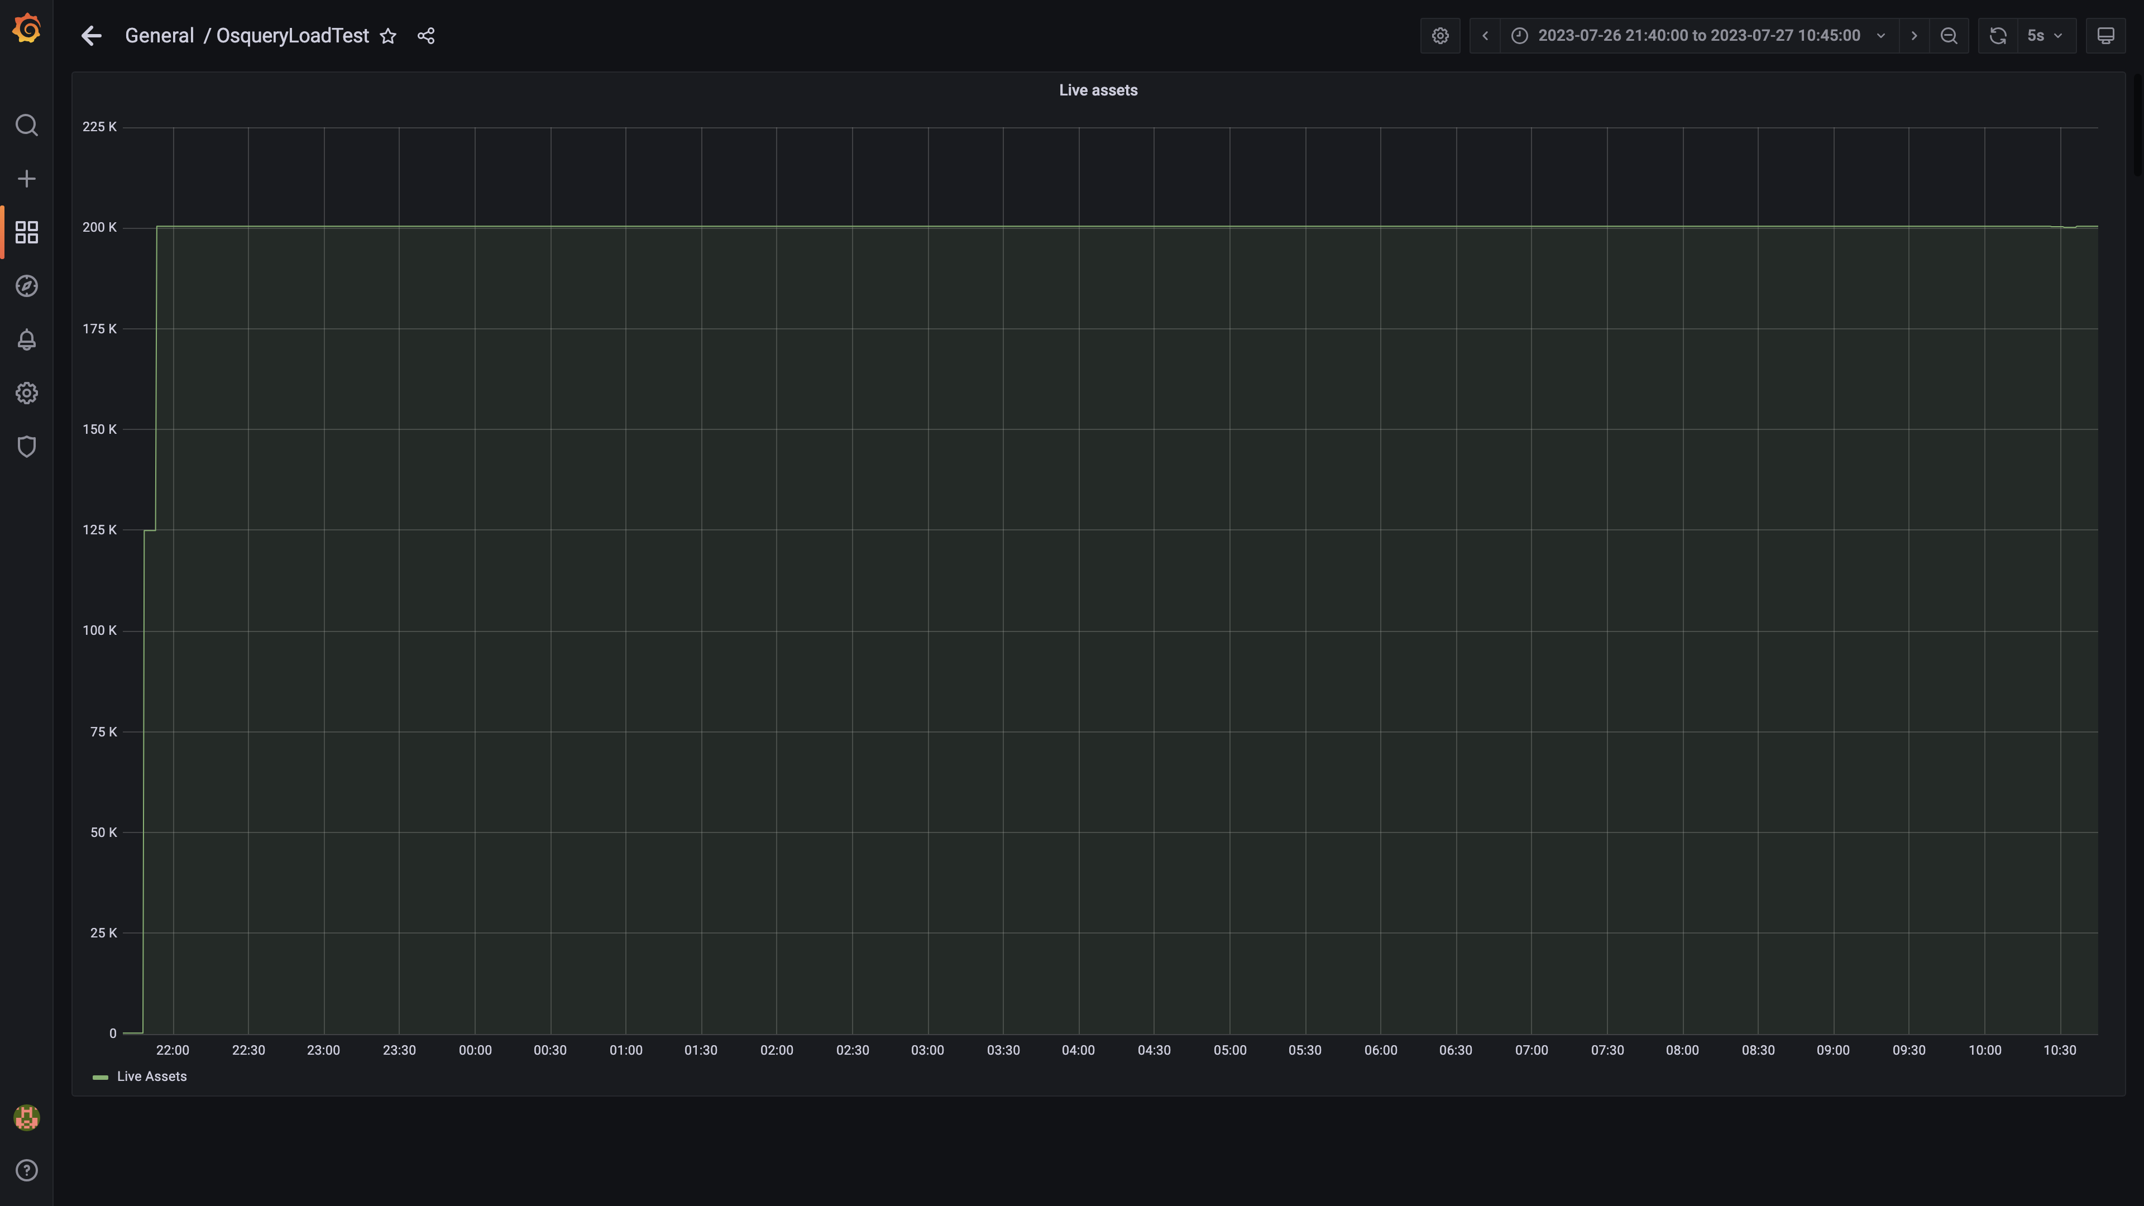

### Kafka lag for all groups

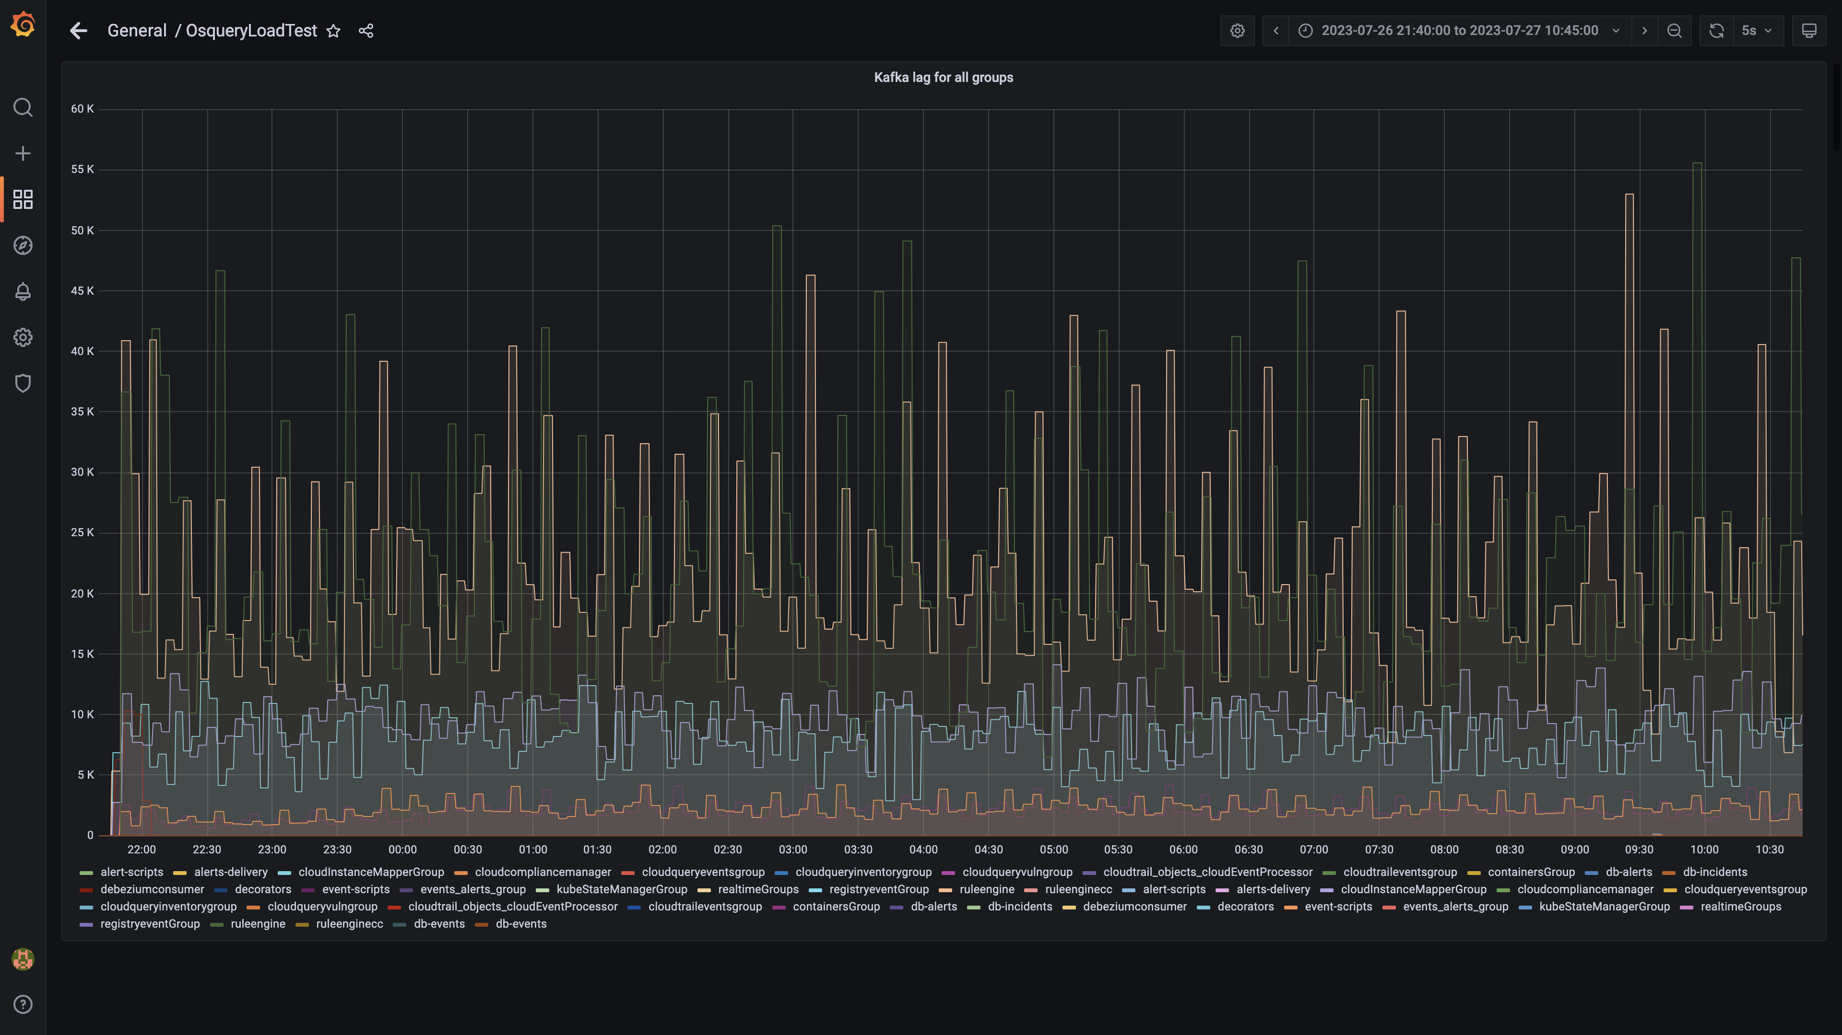

### Process node ram used percent

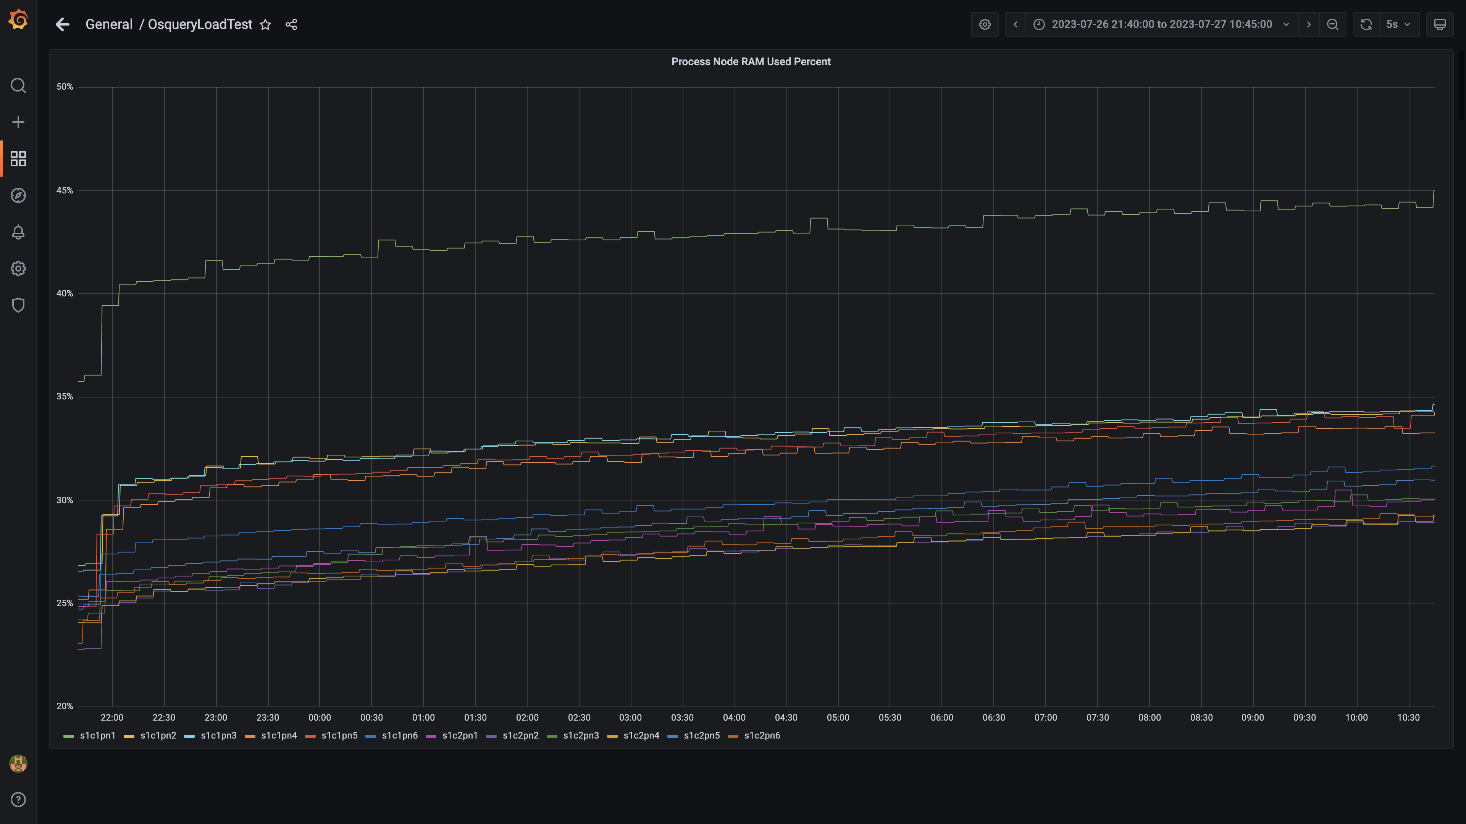

### Data node ram used percent

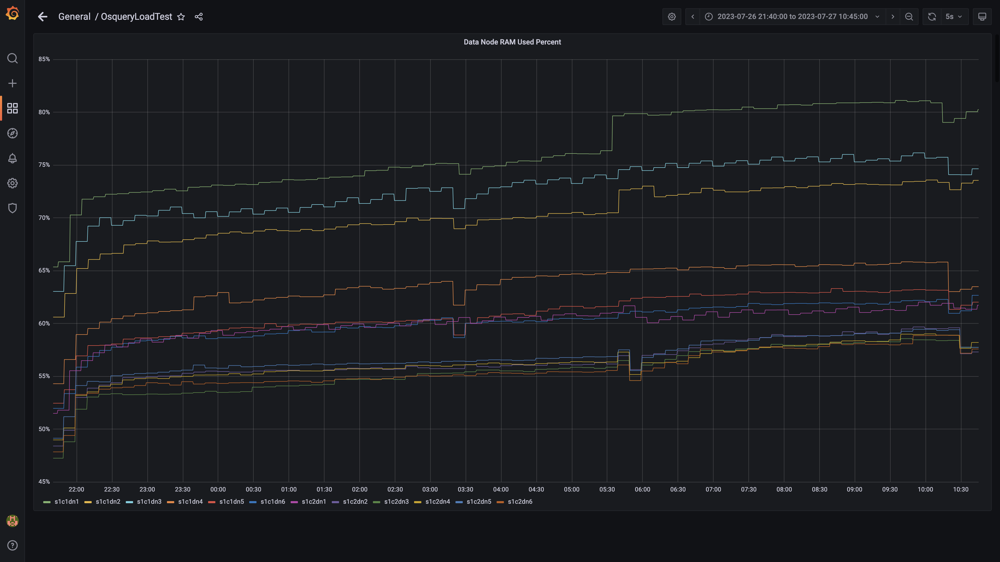

### Postgres node ram used percentage

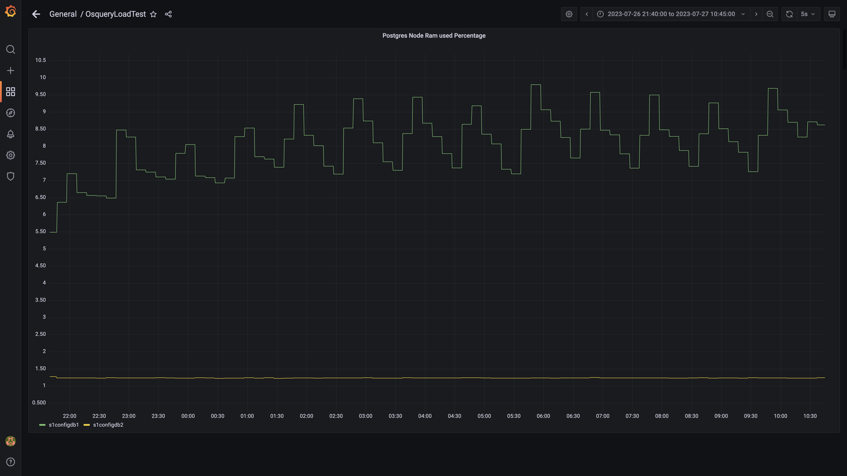

### Memory consumed by eventsdbingestion

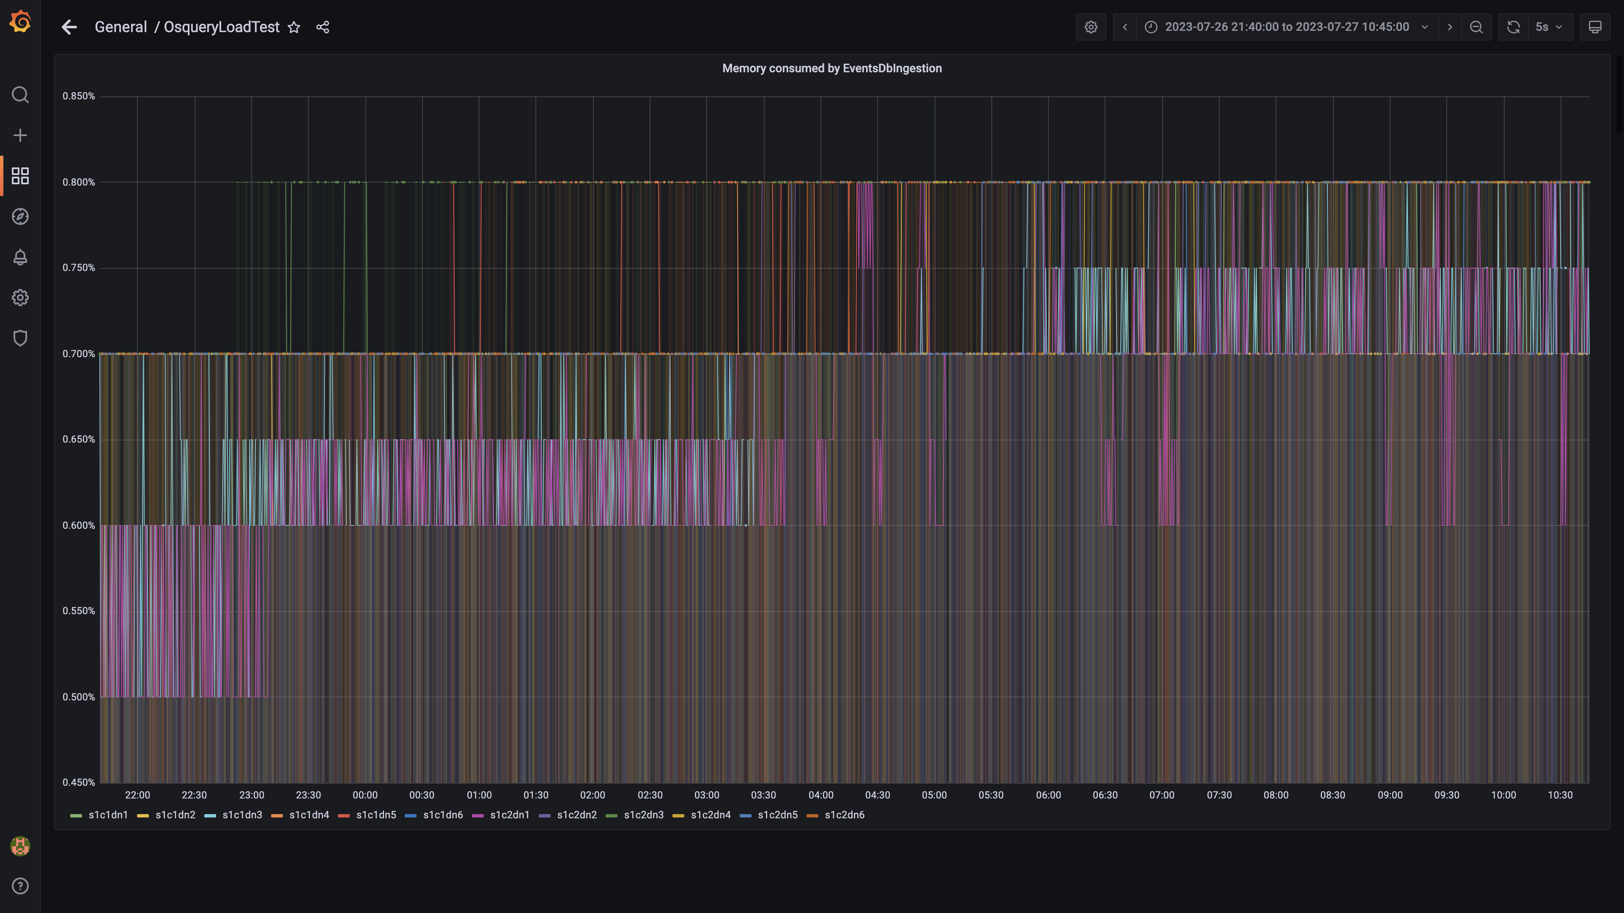

### Kafka disk used percentage

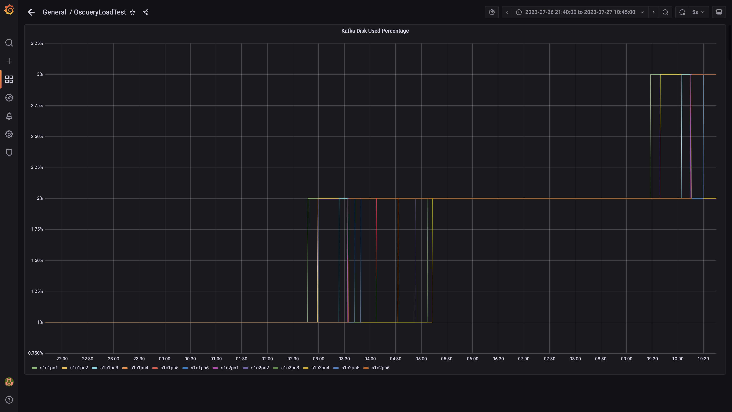

### Memory consumed by orc-compaction

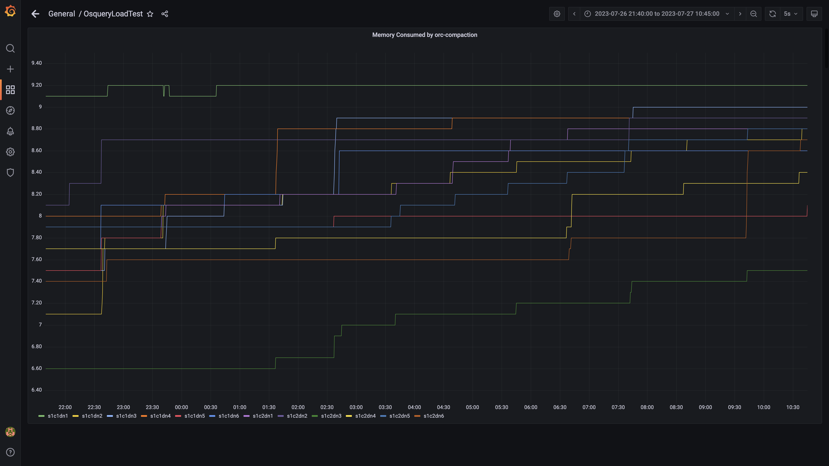

### Compliance summary consumer memory consumption

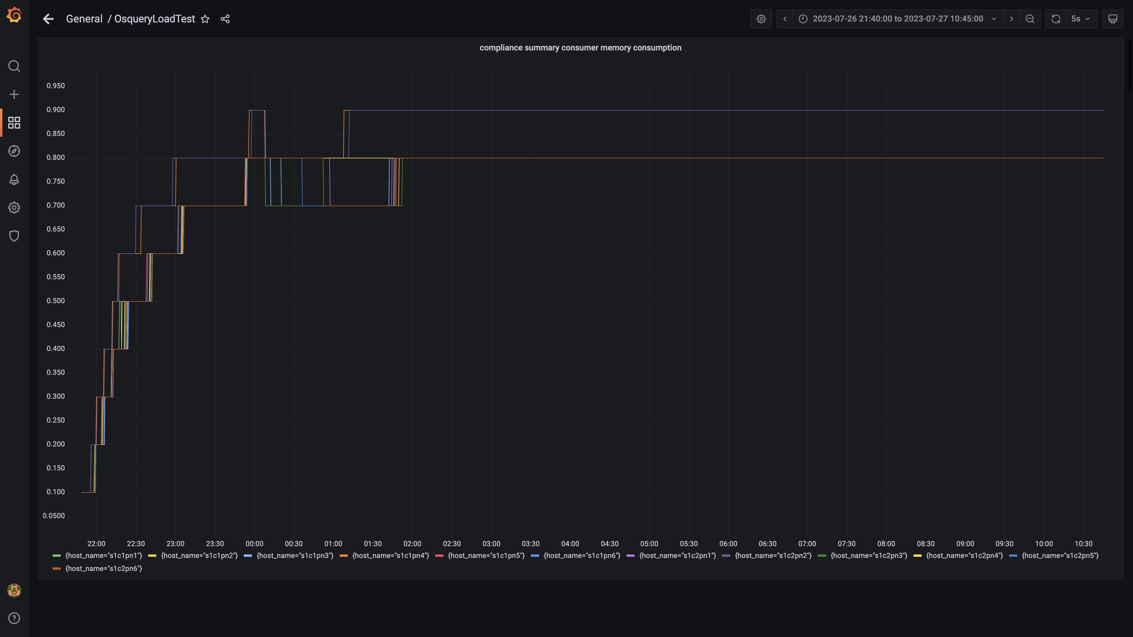

### Memory consumed by logger

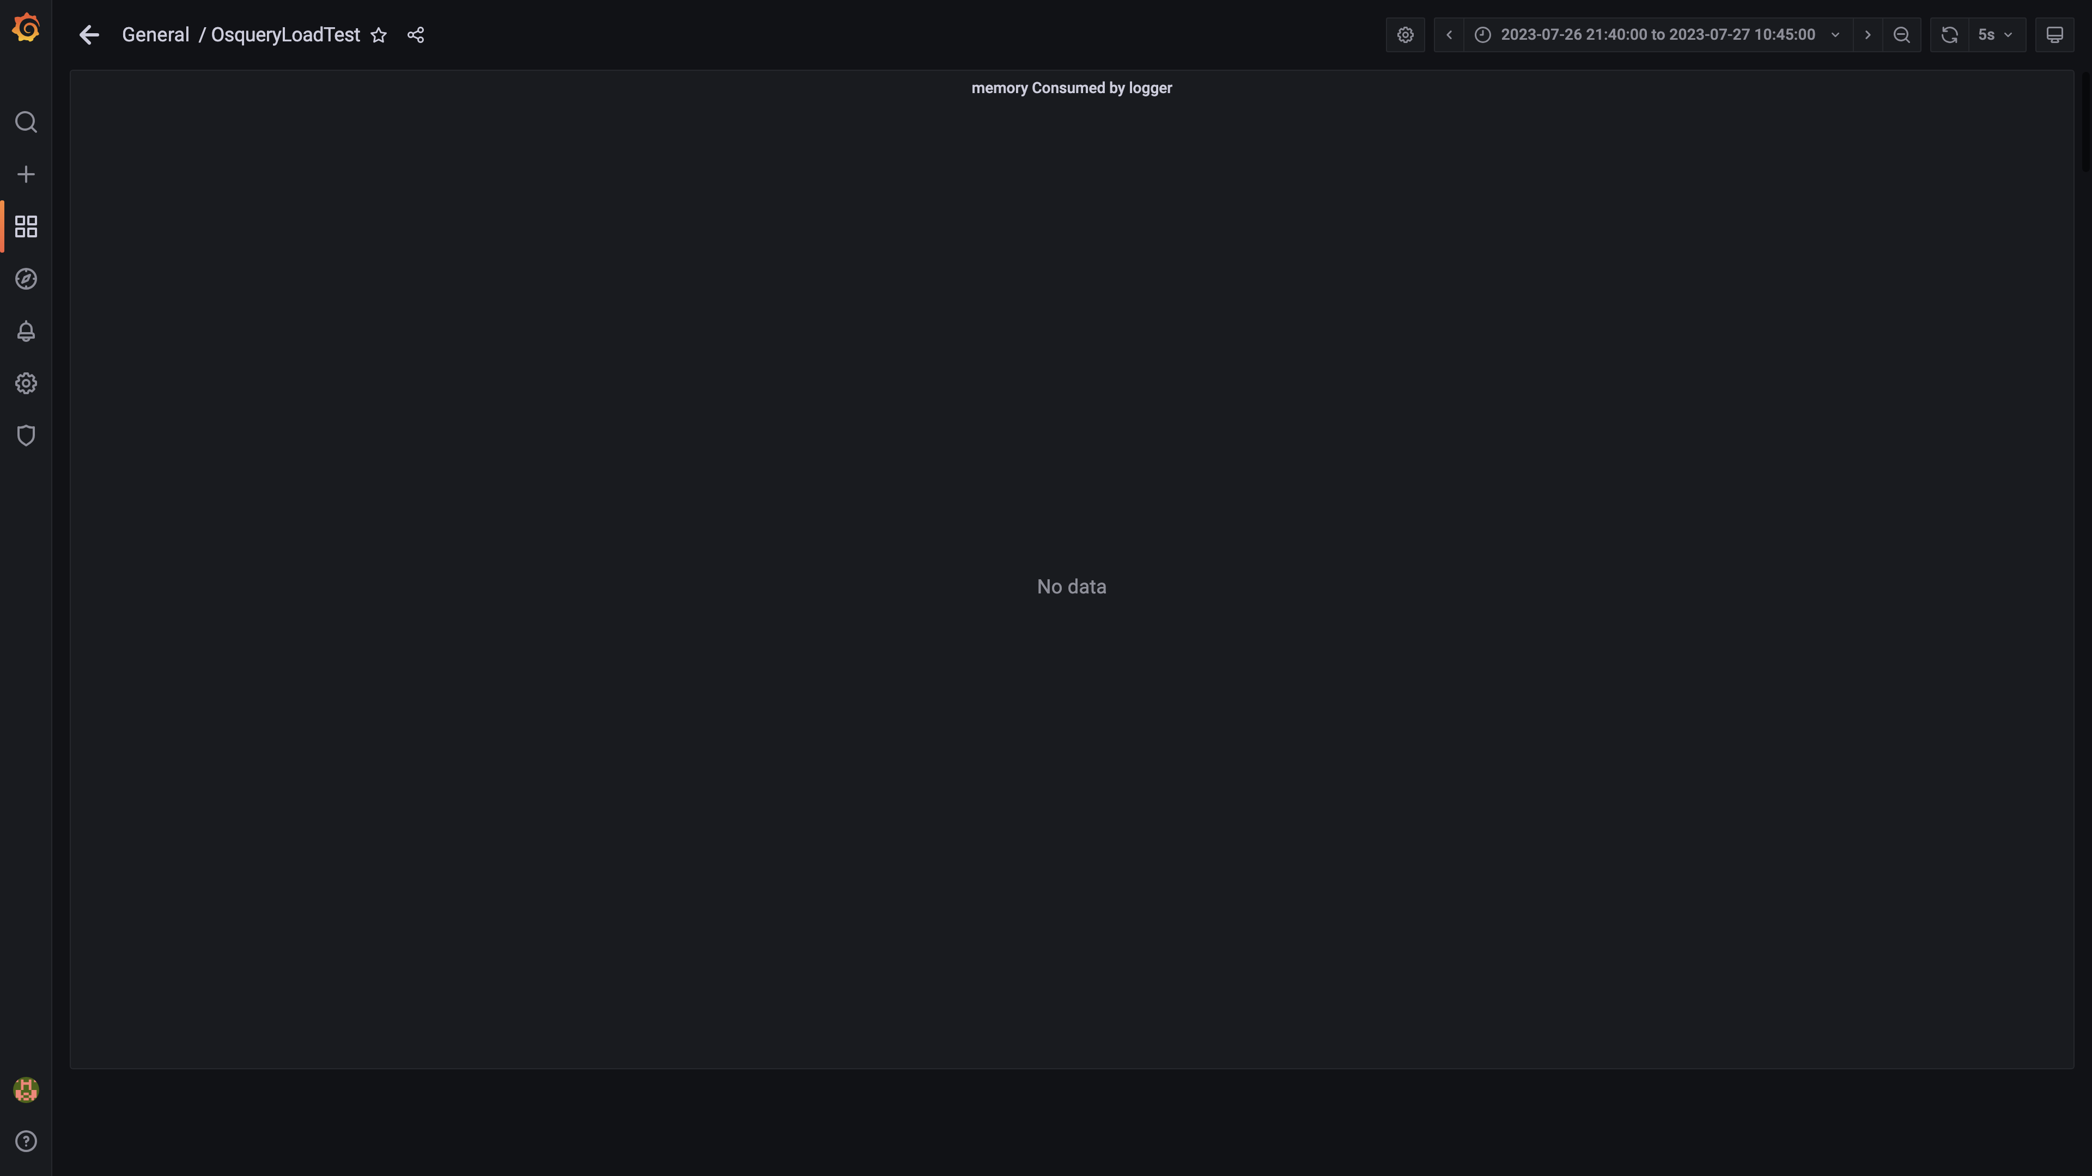

### Kafka memory used percentage

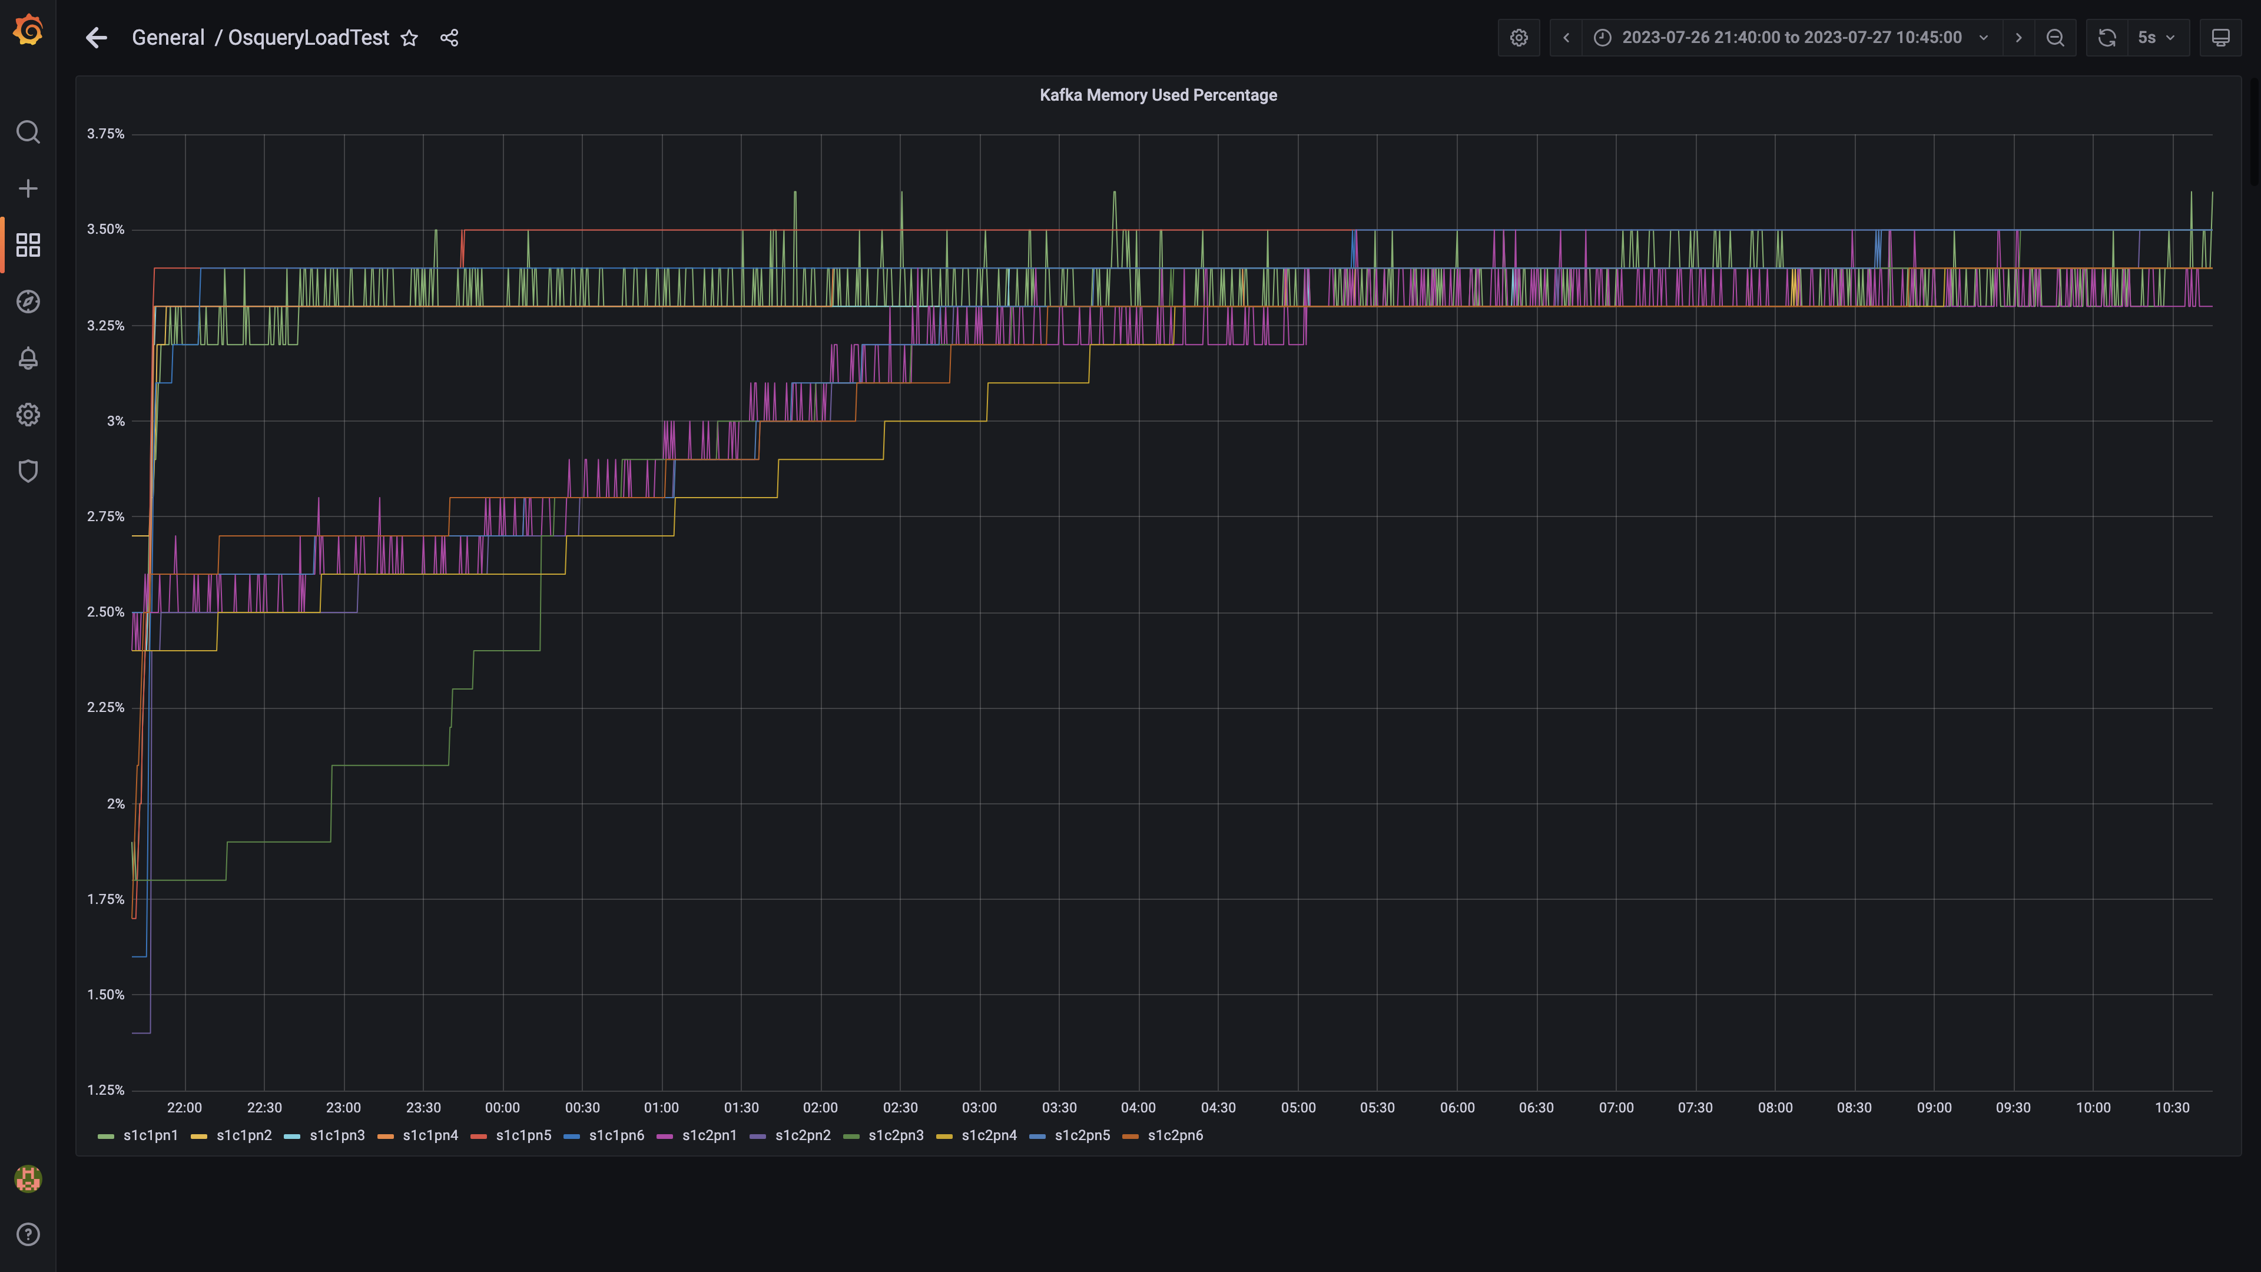

### Memory consumed by trino

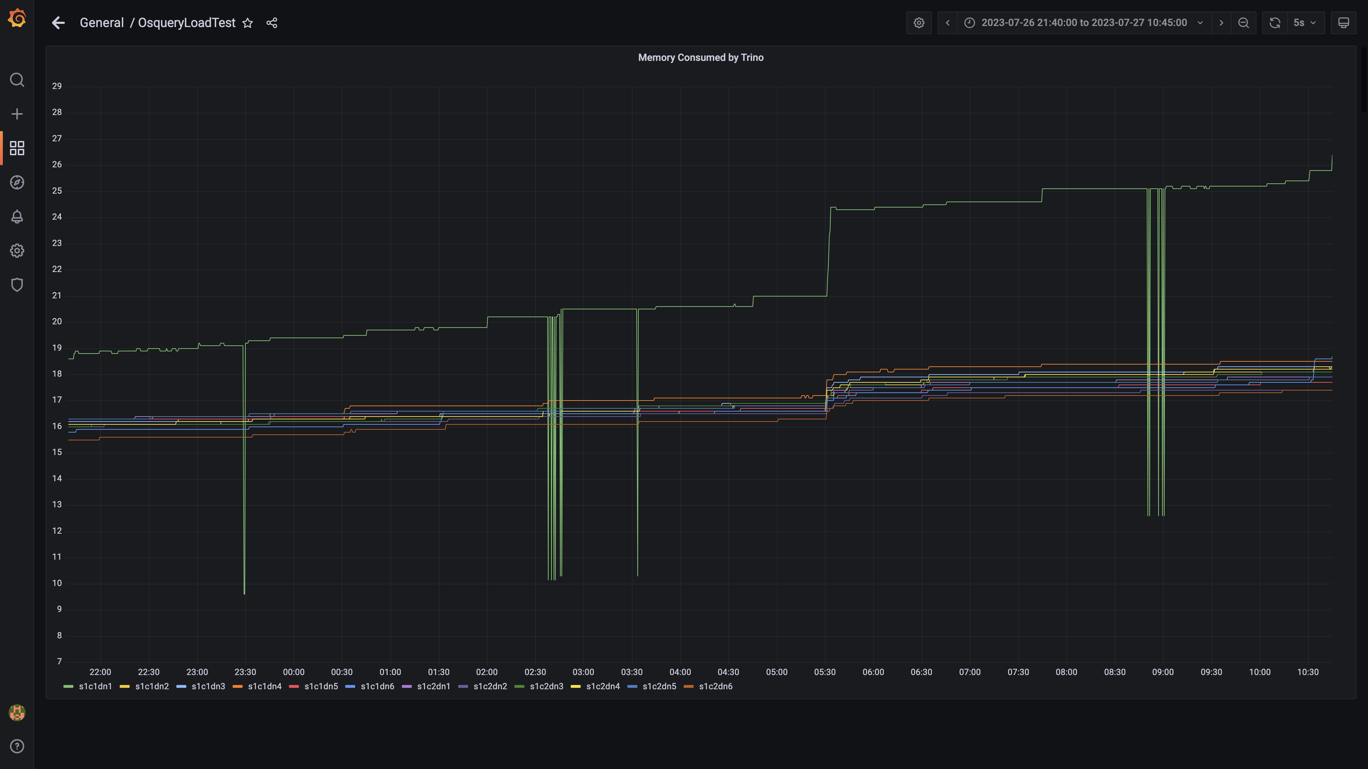

### Memory consumed by osqueryingestion

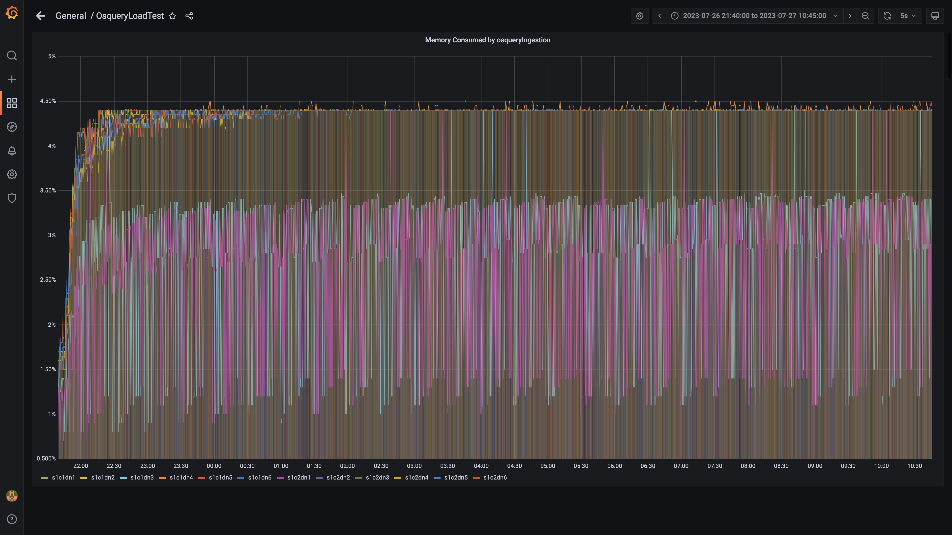

### Memory consumed by spark-worker

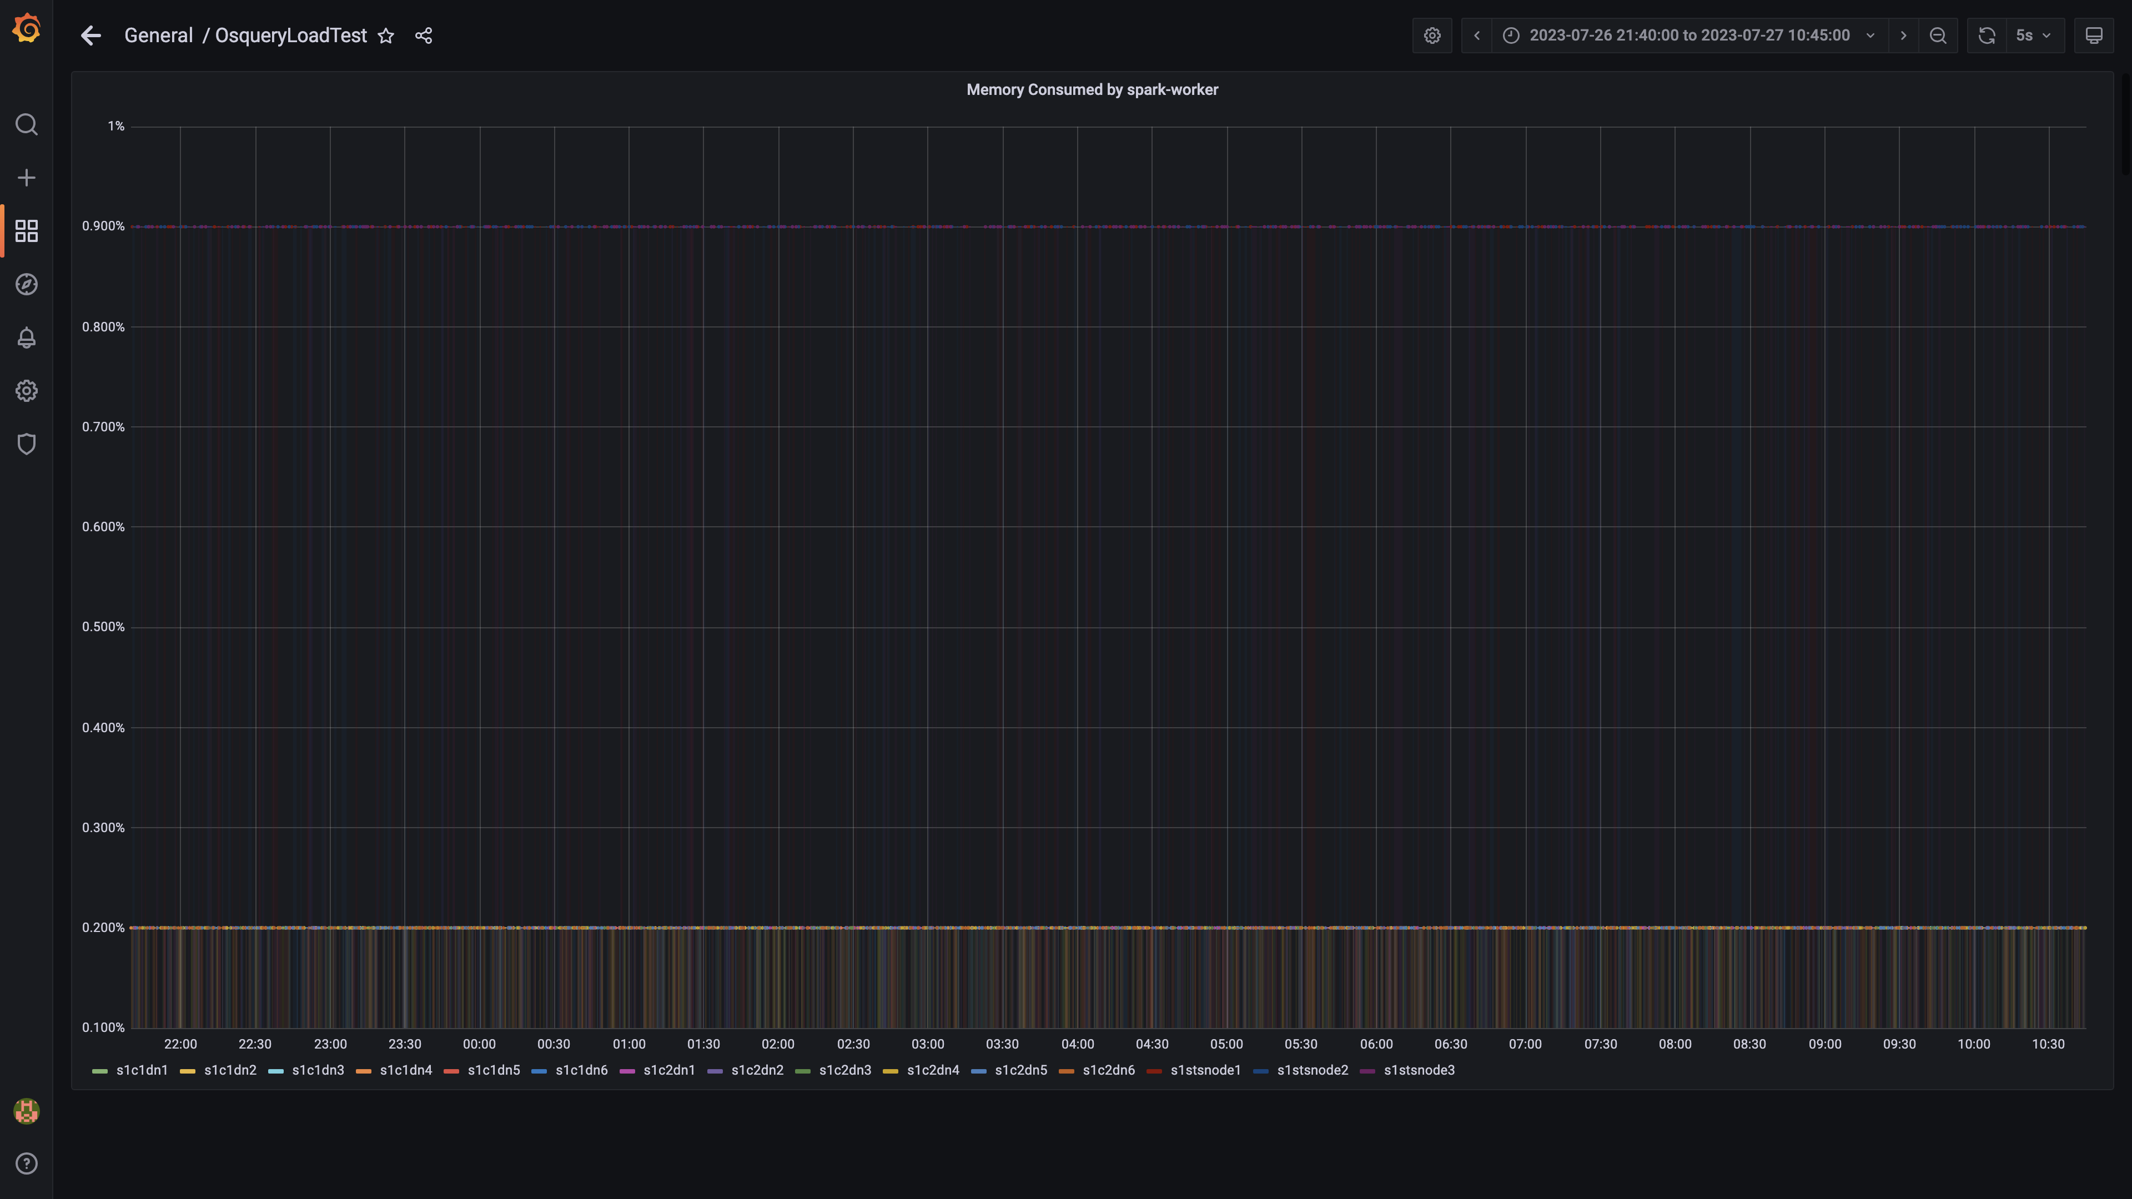

### Memory consumed by ruleengine

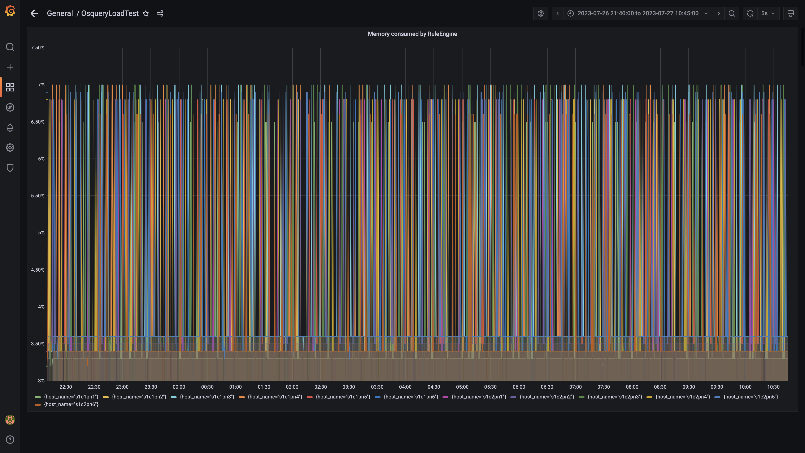

### Memory consumed by configdb

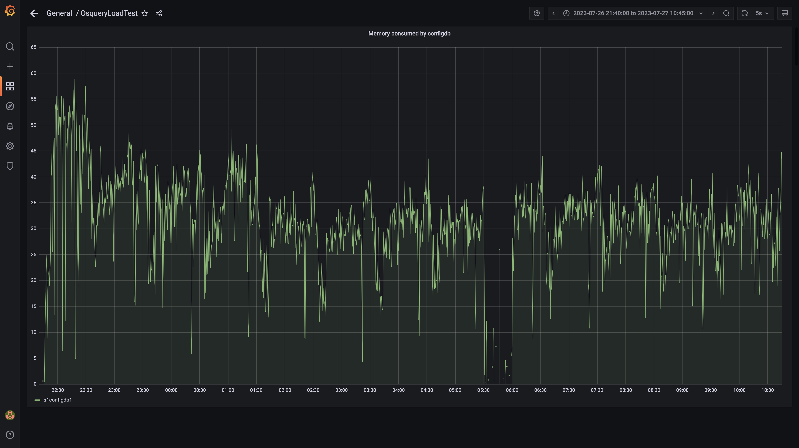

### Memory consumed by data archival

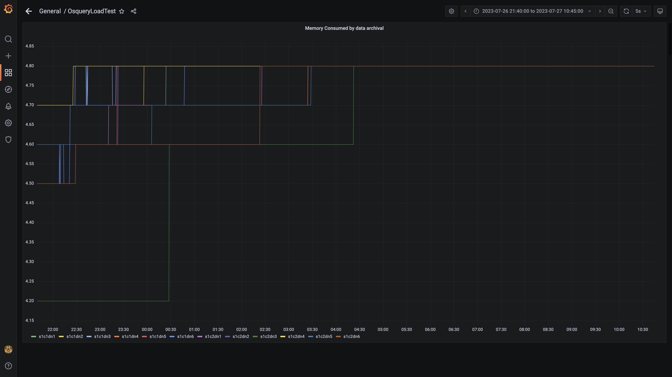

### Debezium memory usage

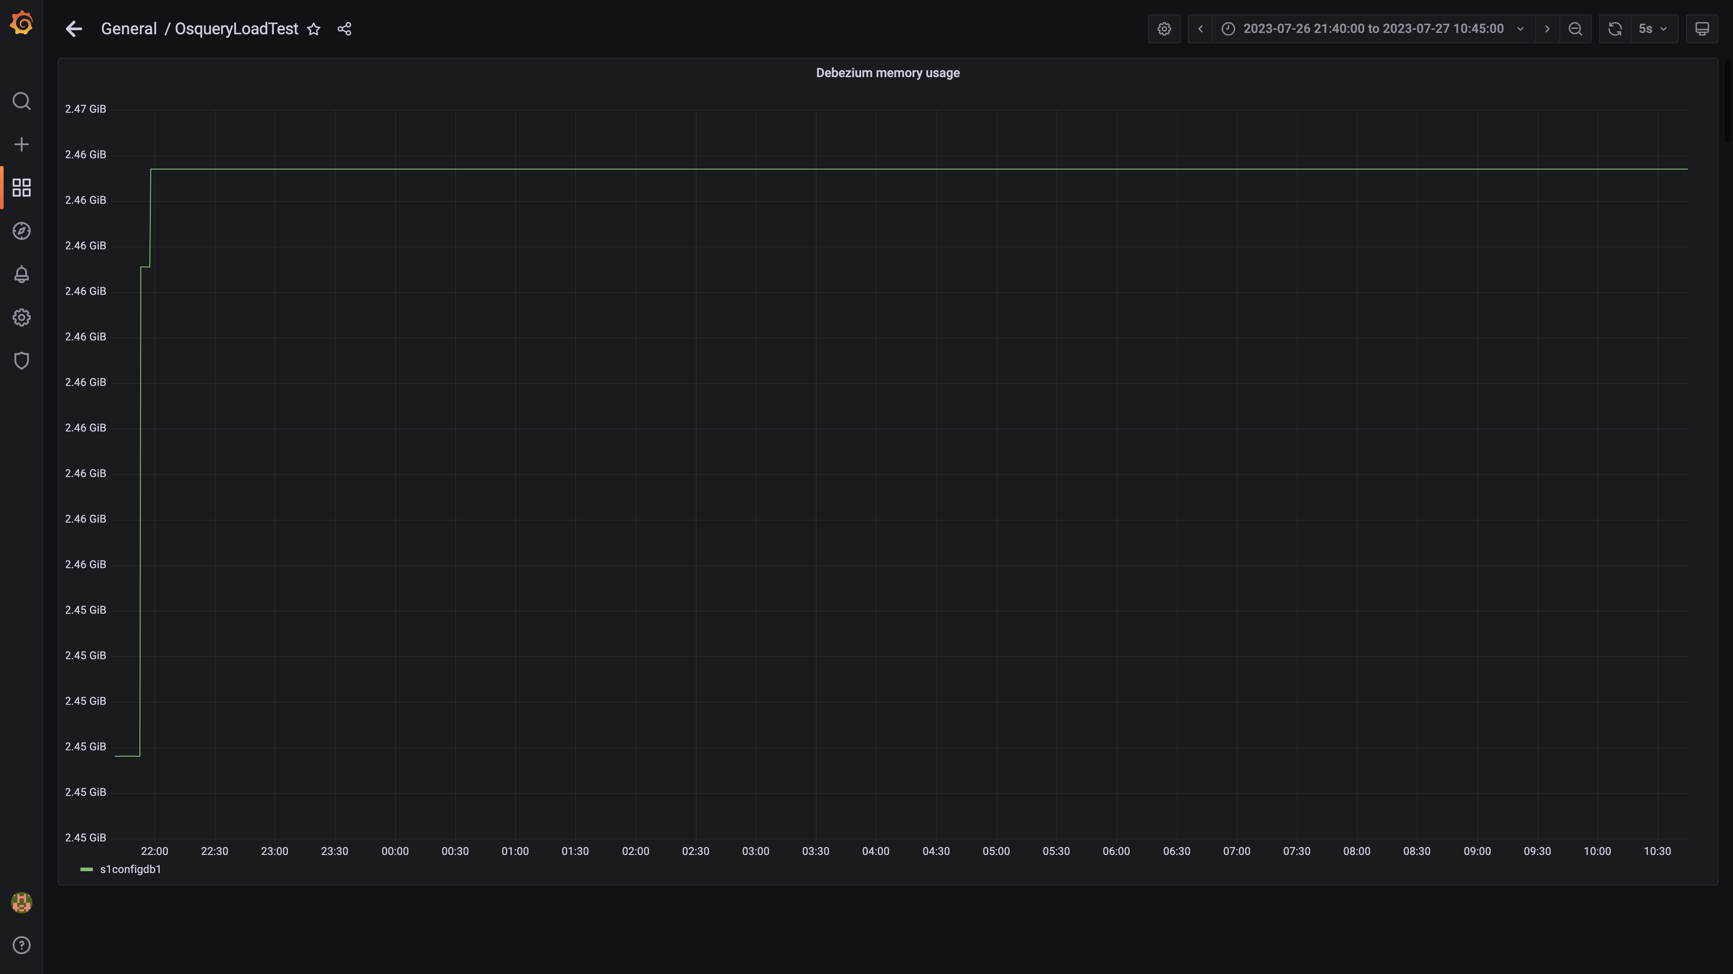

### Memory consumed by redis server

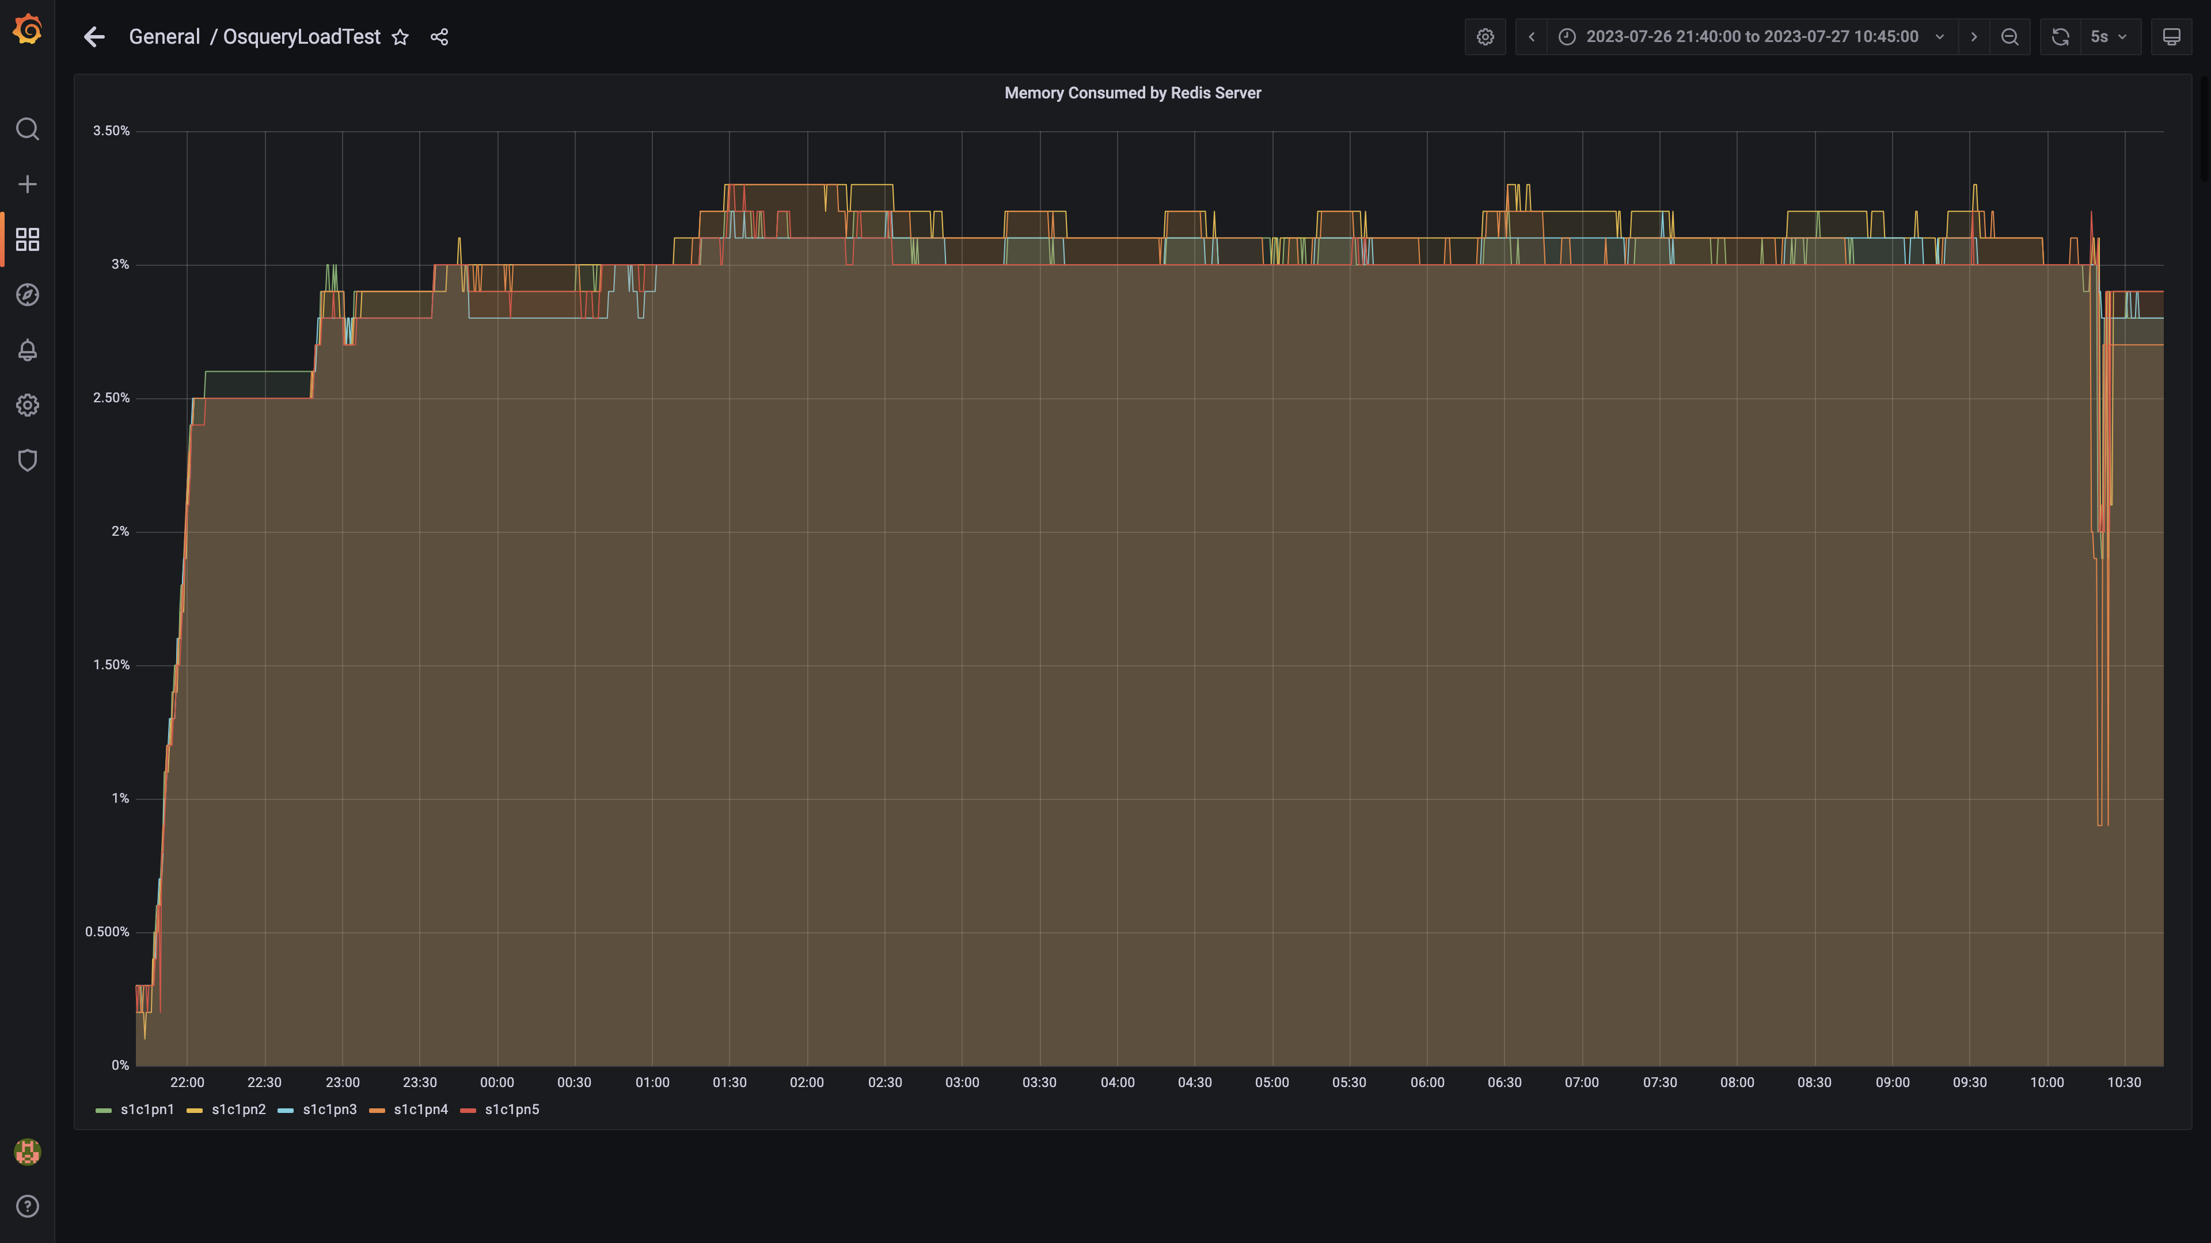

### Memory consumed by tls

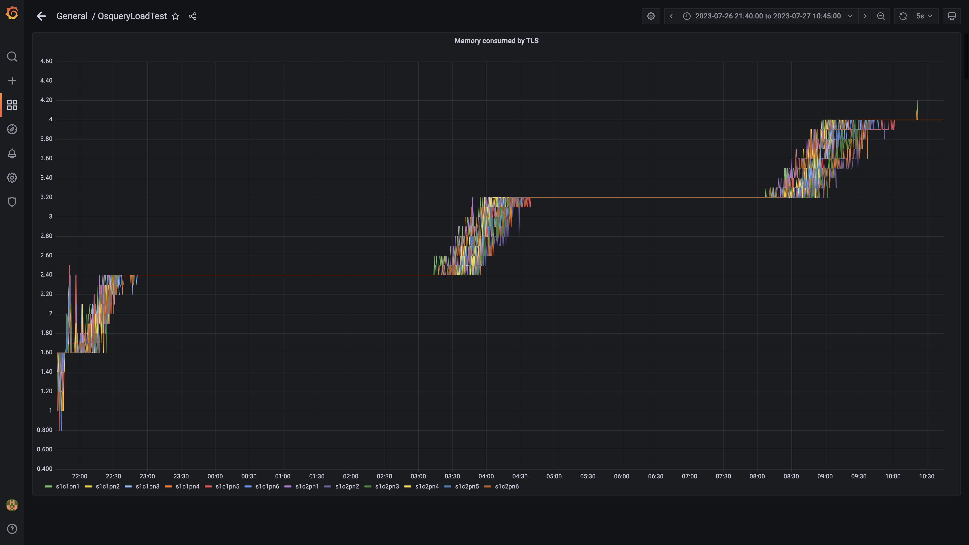

### Airflow memory usage

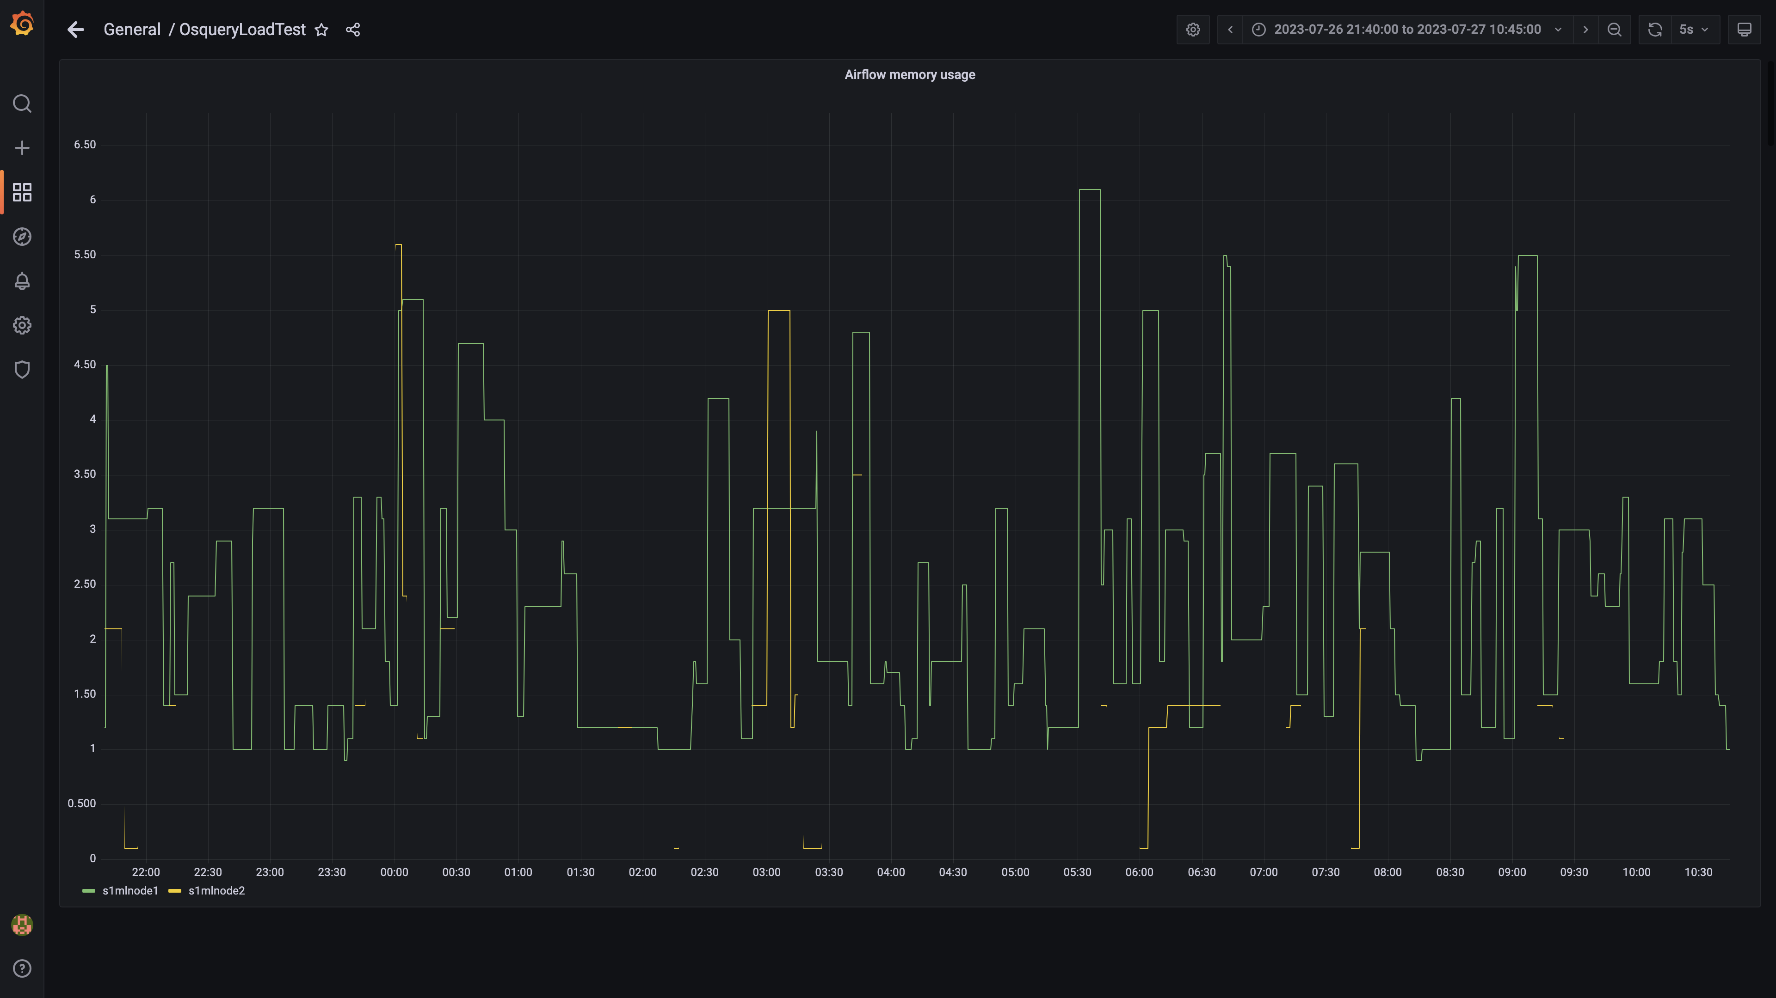

### Postgres node cpu busy percent

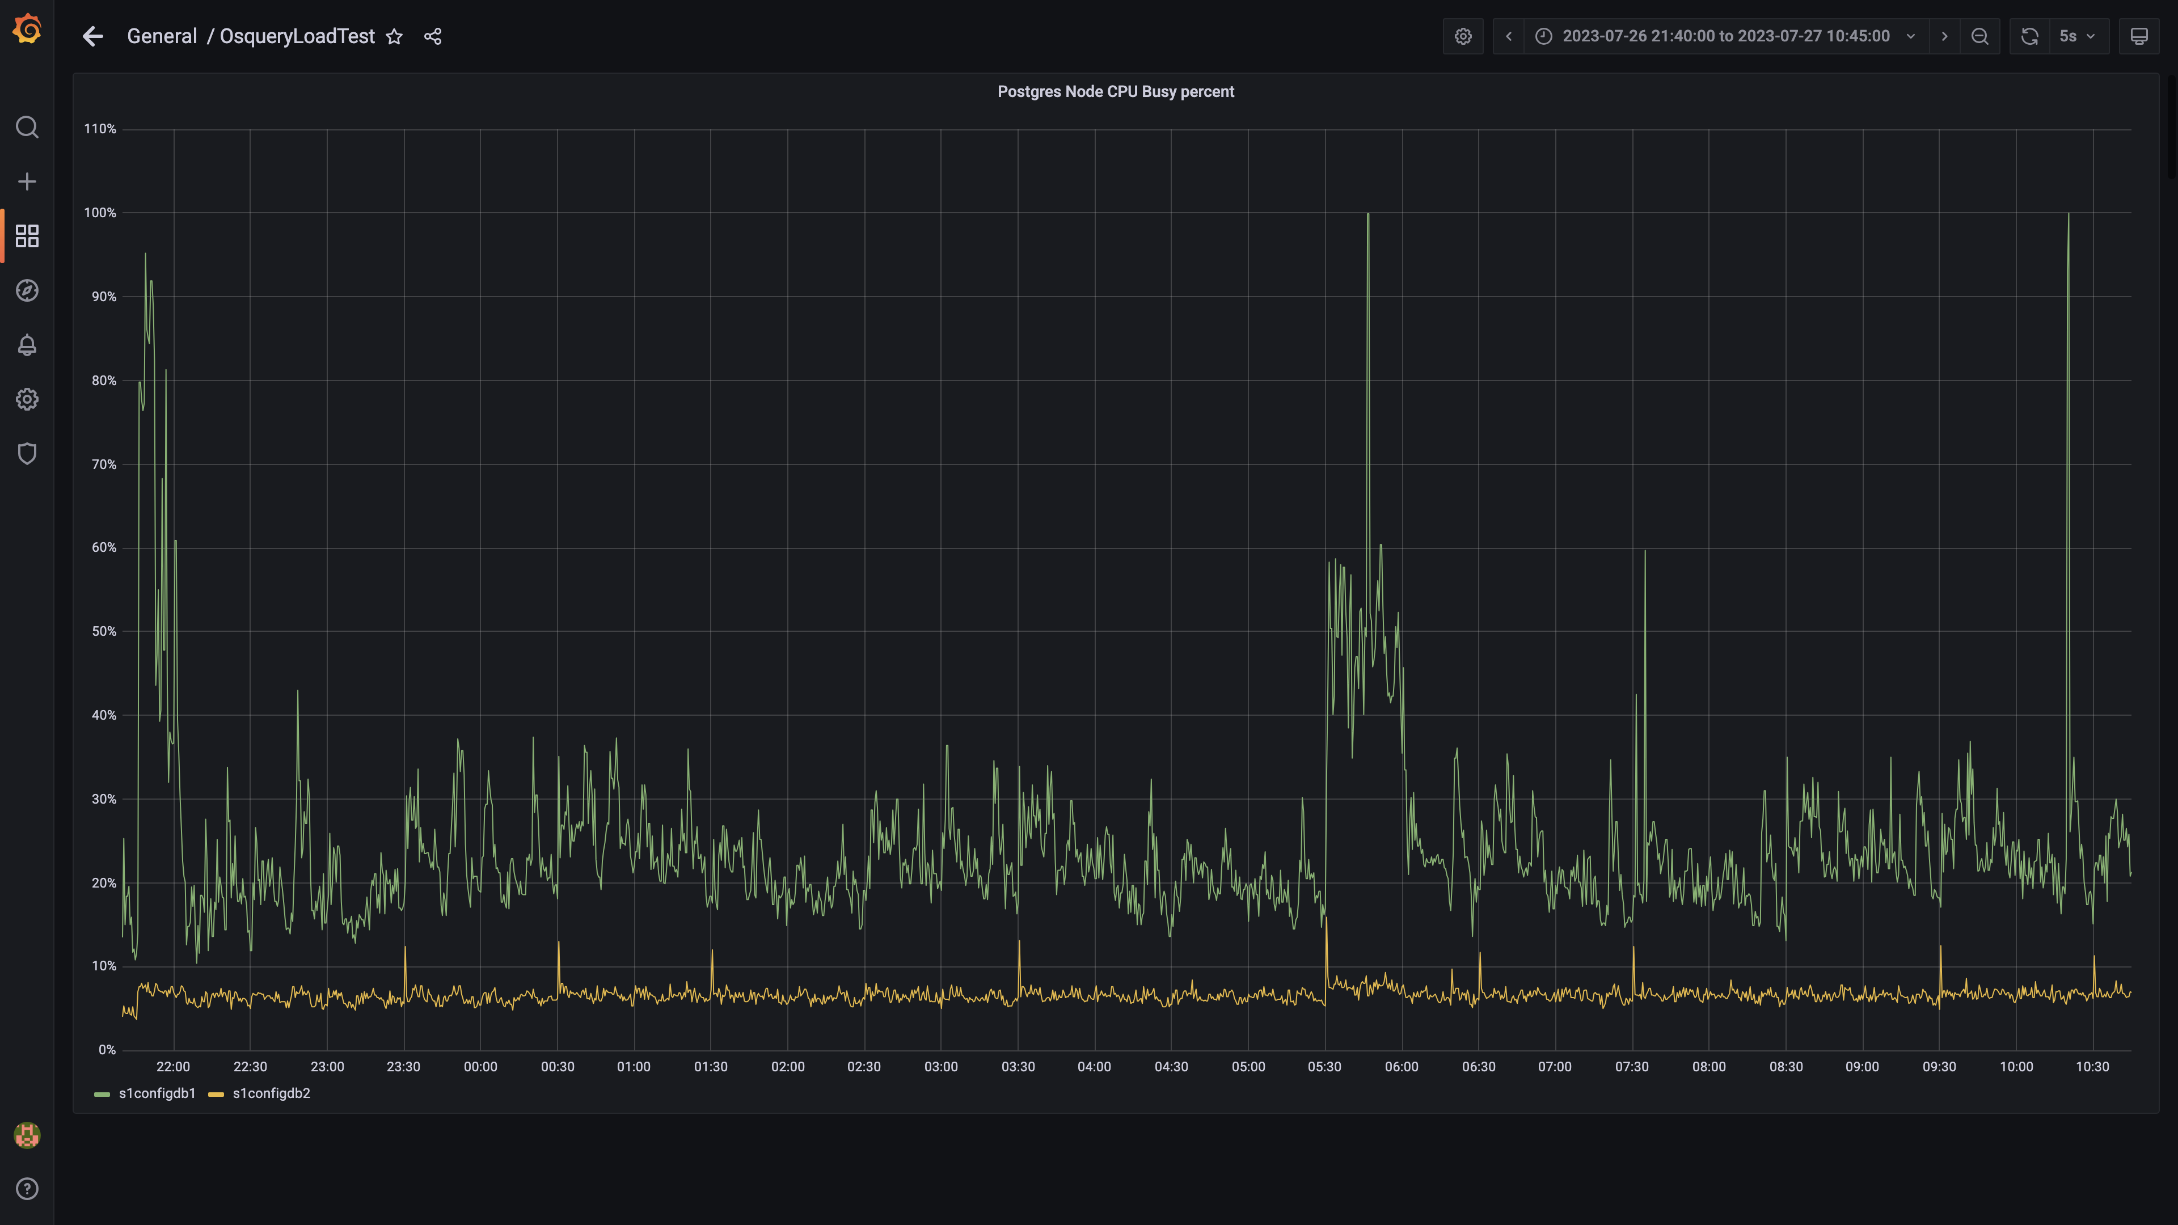

### Process node cpu busy percent

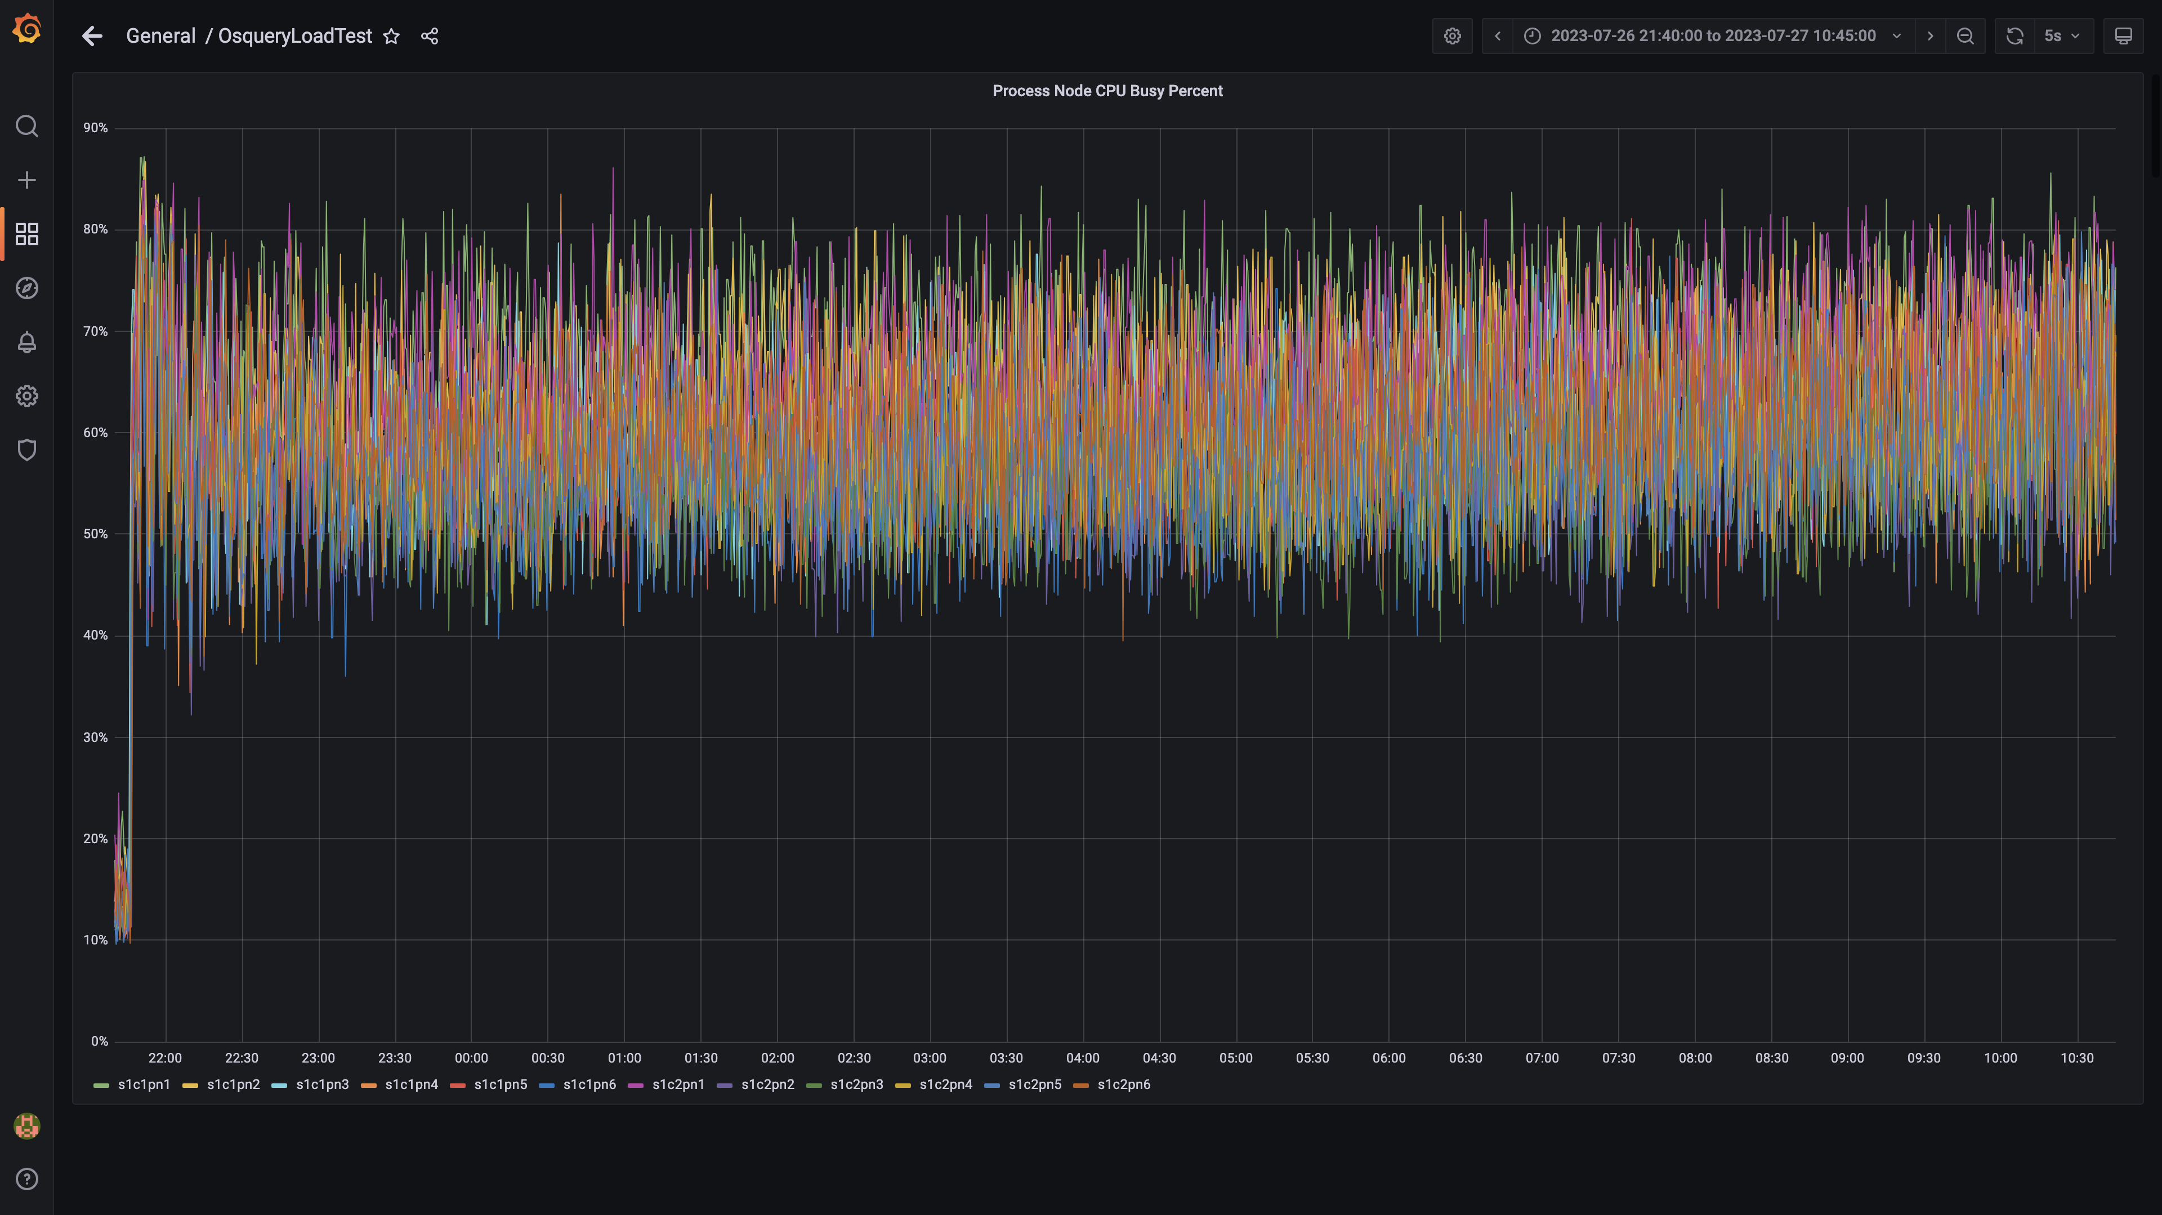

### Data node cpu busy percent

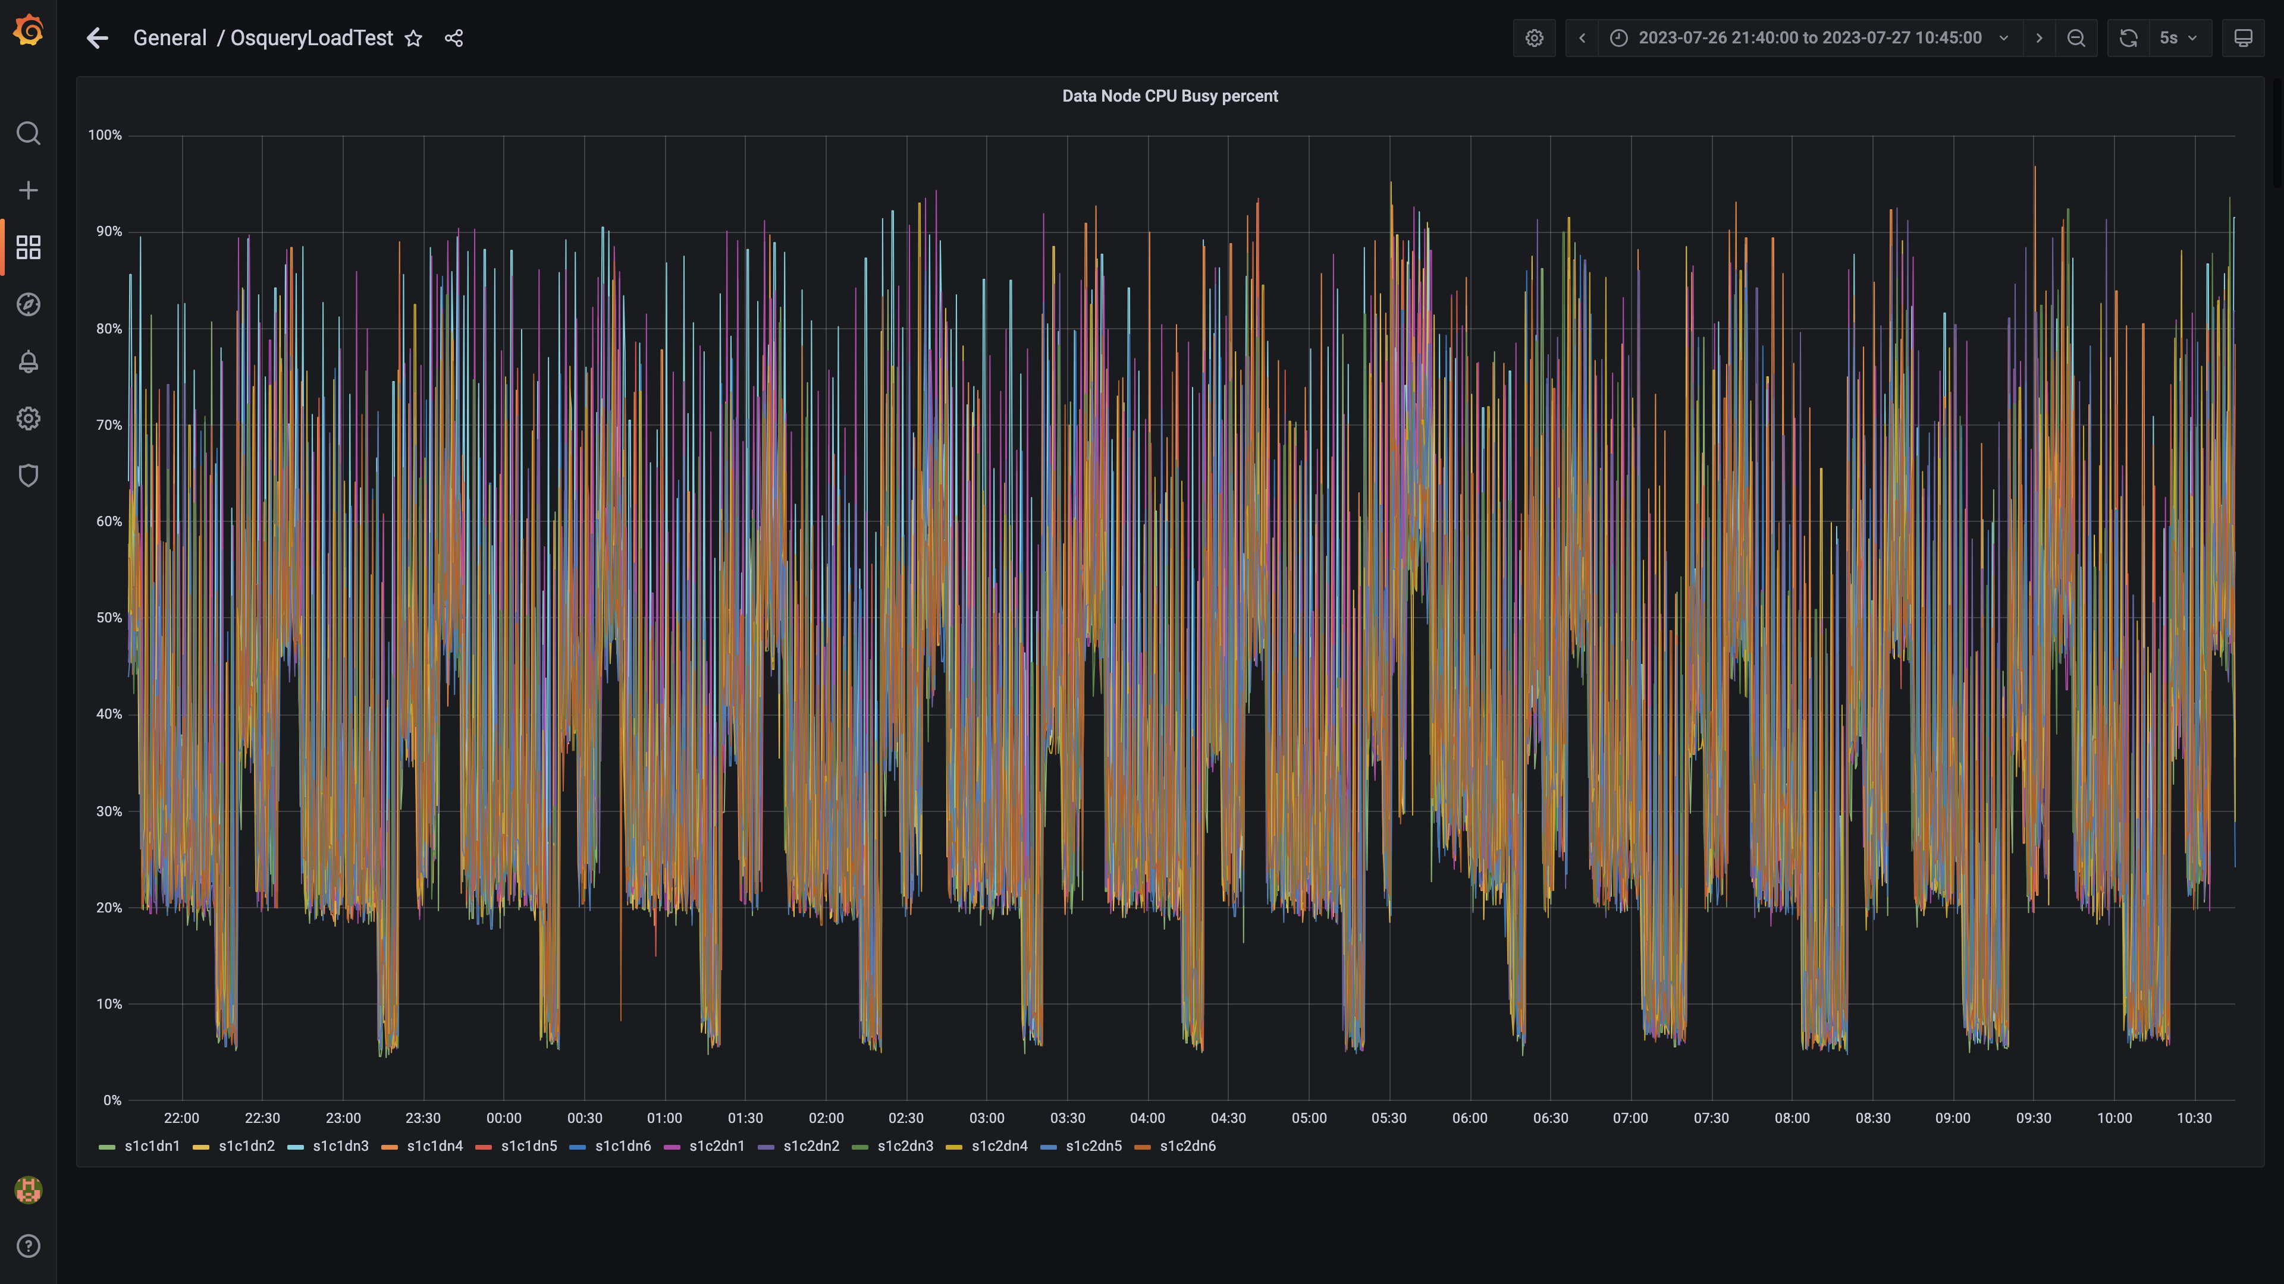

### Postgres-configdb cpu used percentage

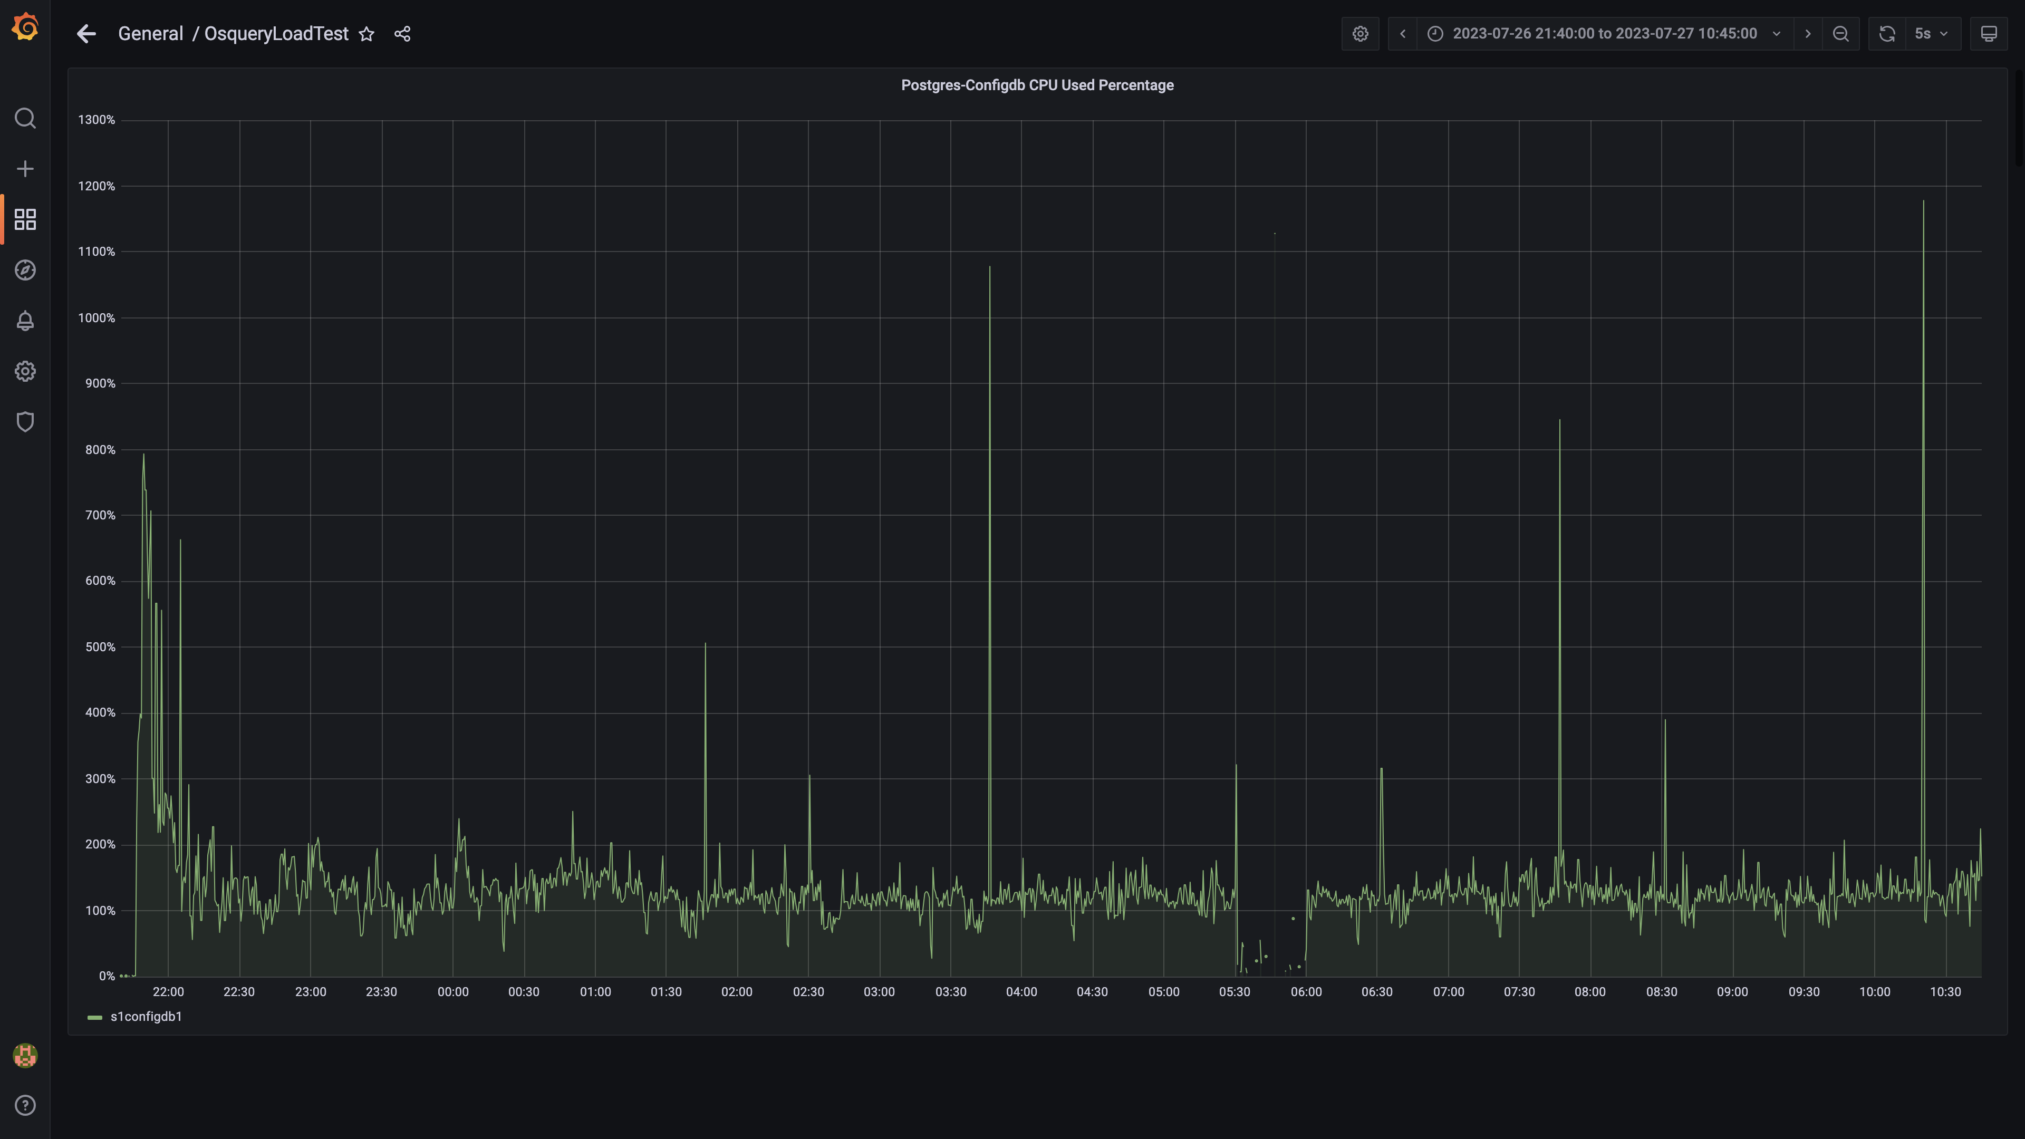

### Pgbouncer cpu used percentage

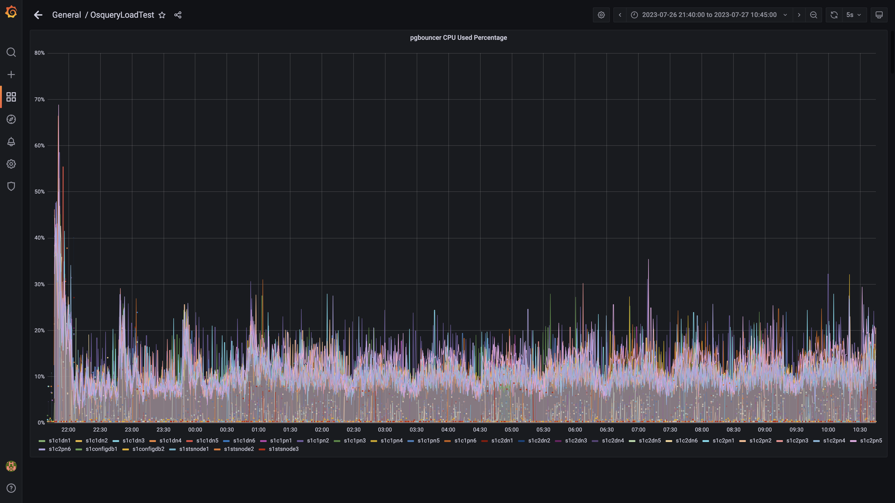

### Cpu consumed by eventsdbingestion

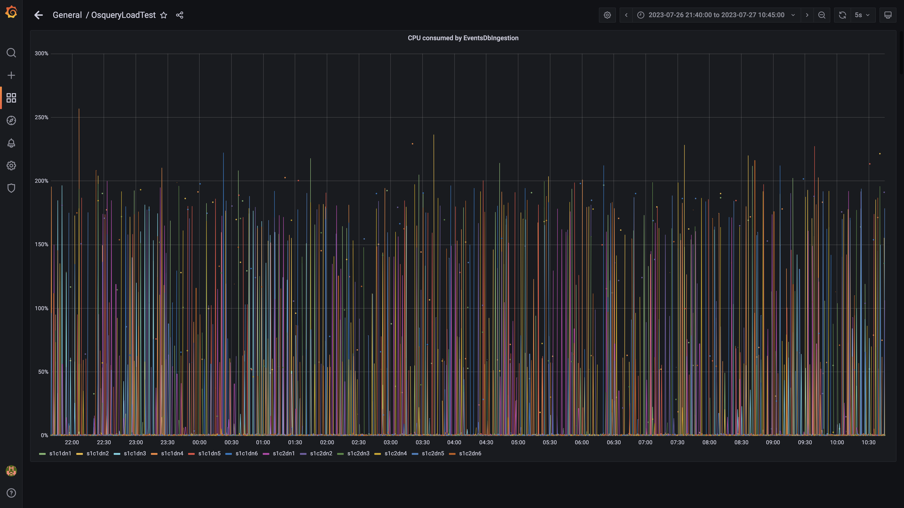

### Cpu consumed by pushgateway

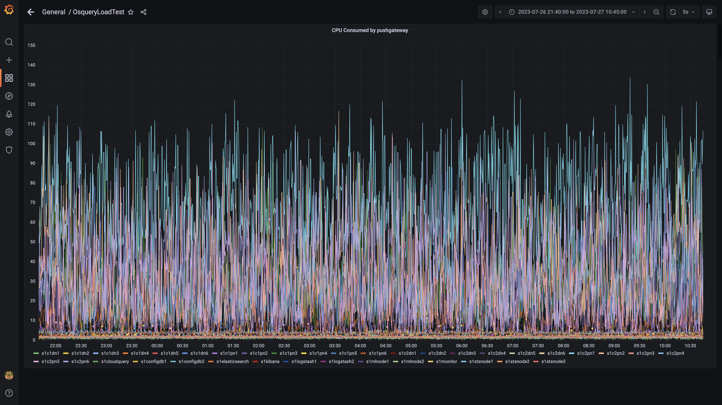

### Cpu consumed by ruleengine

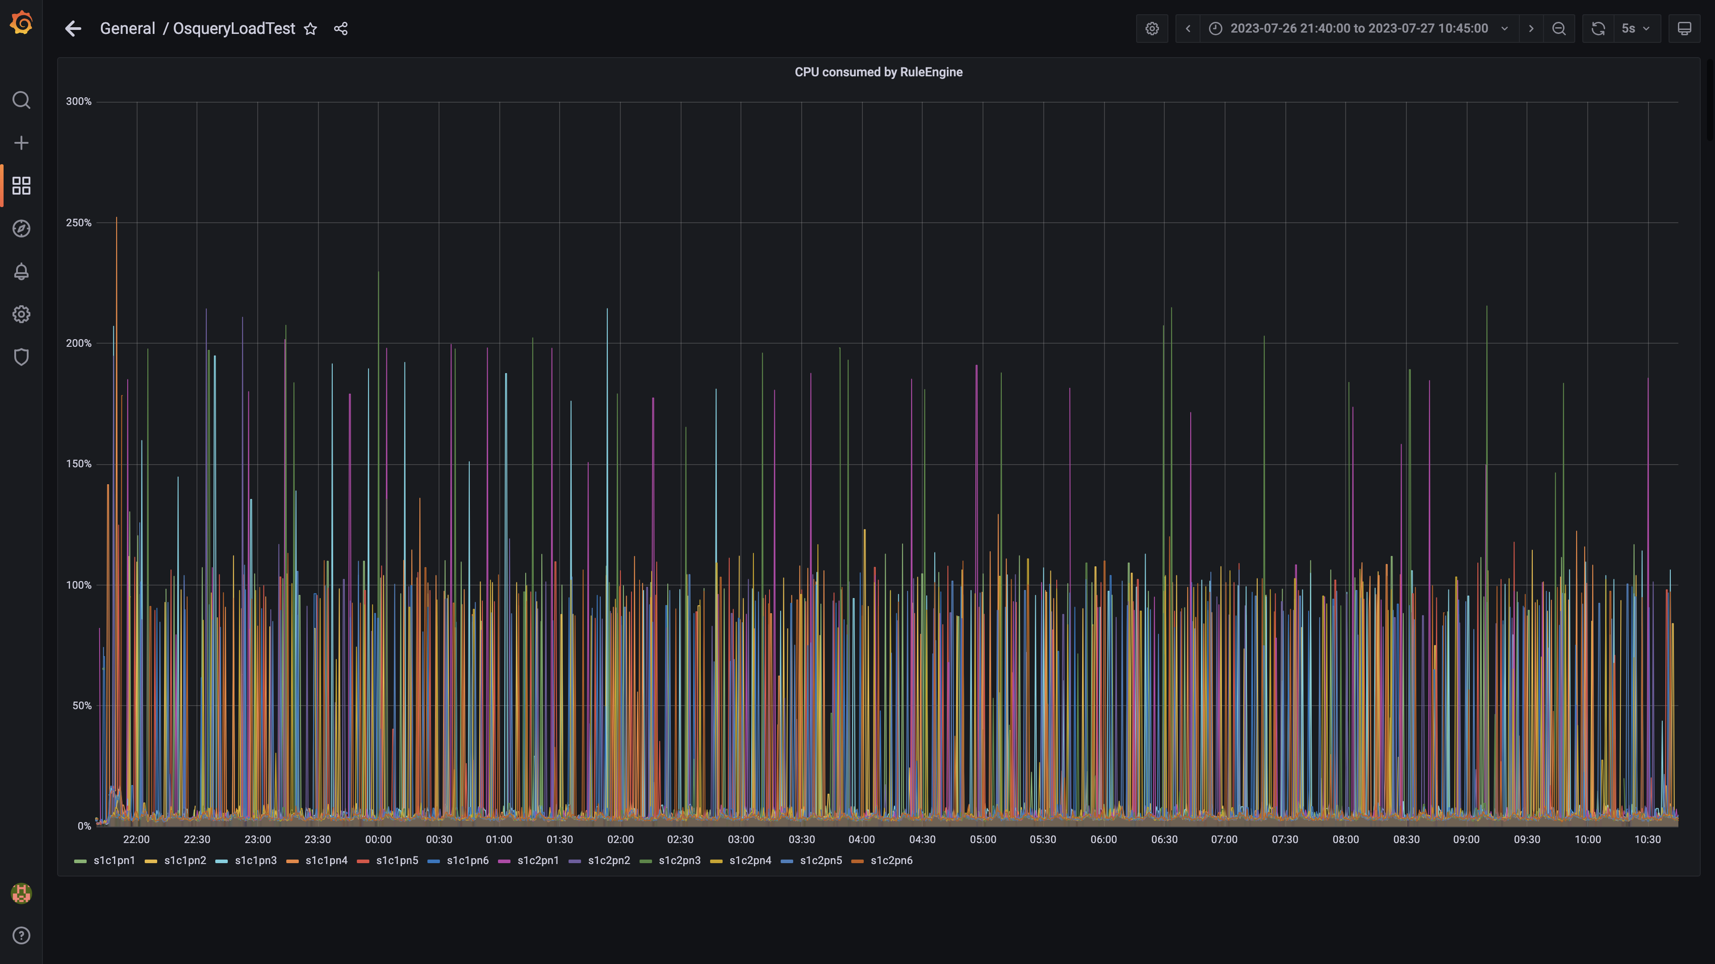

### Kafka cpu used percentage

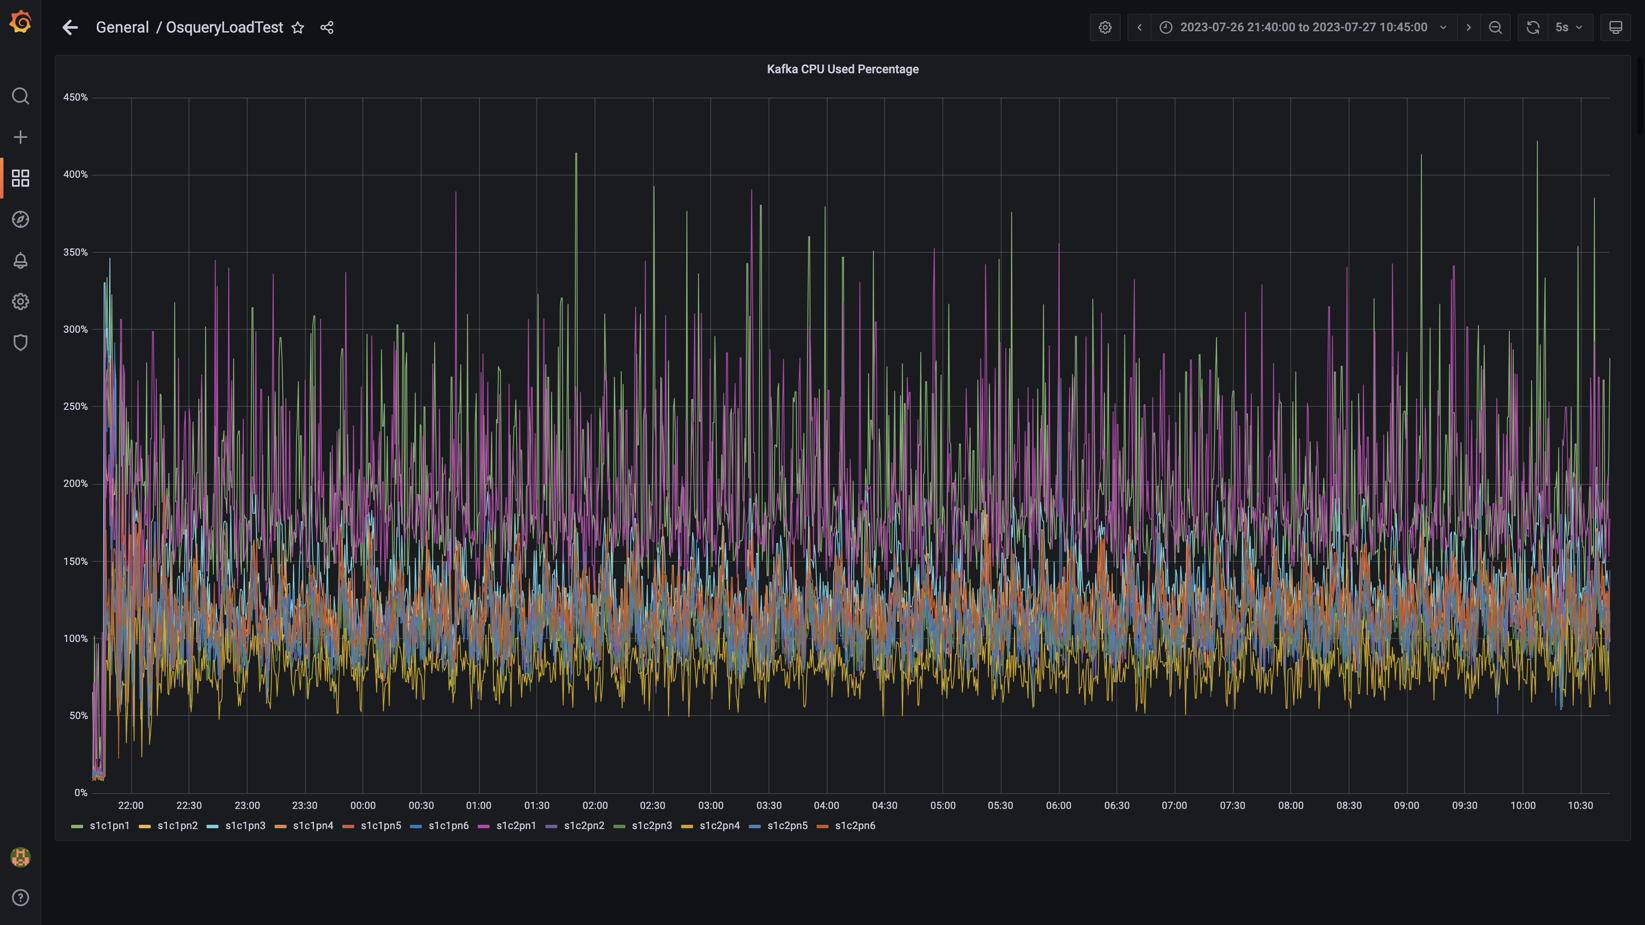

### Cpu used by data-archival

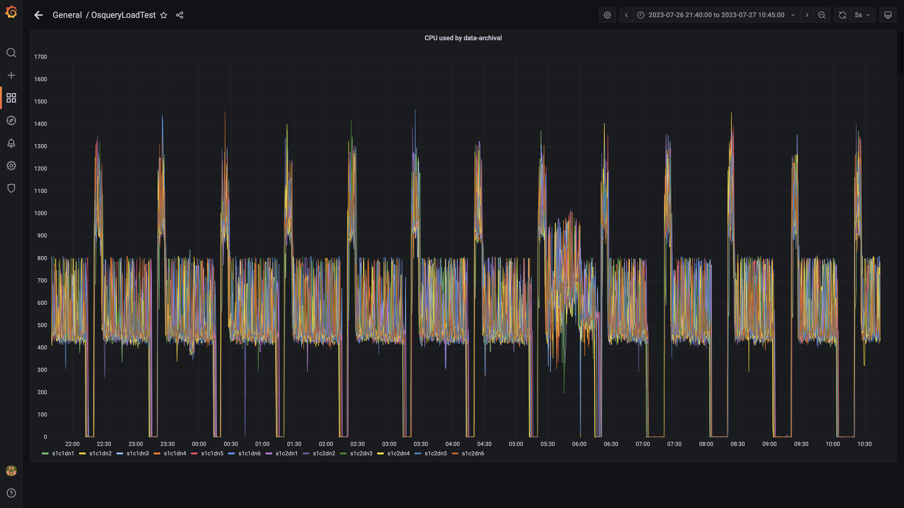

### Cpu consumed by osqueryingestion

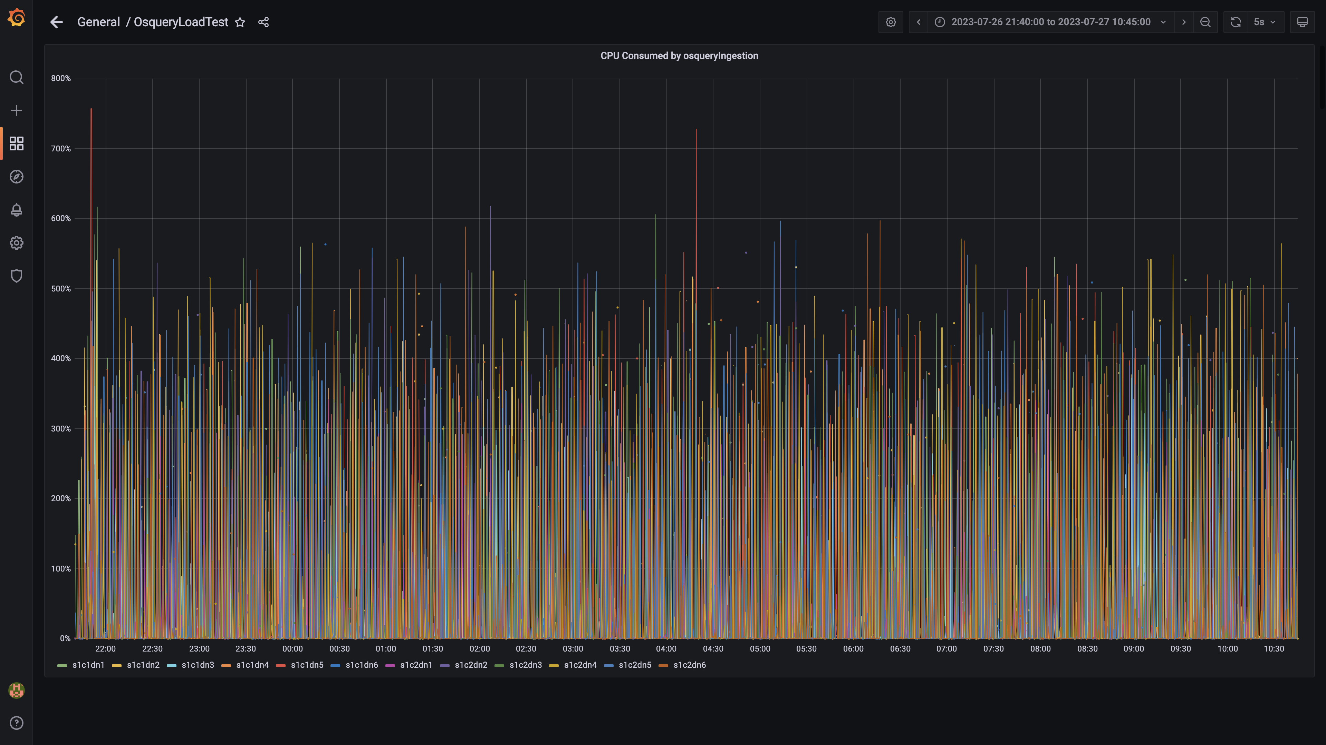

### Cpu consumed by redis server

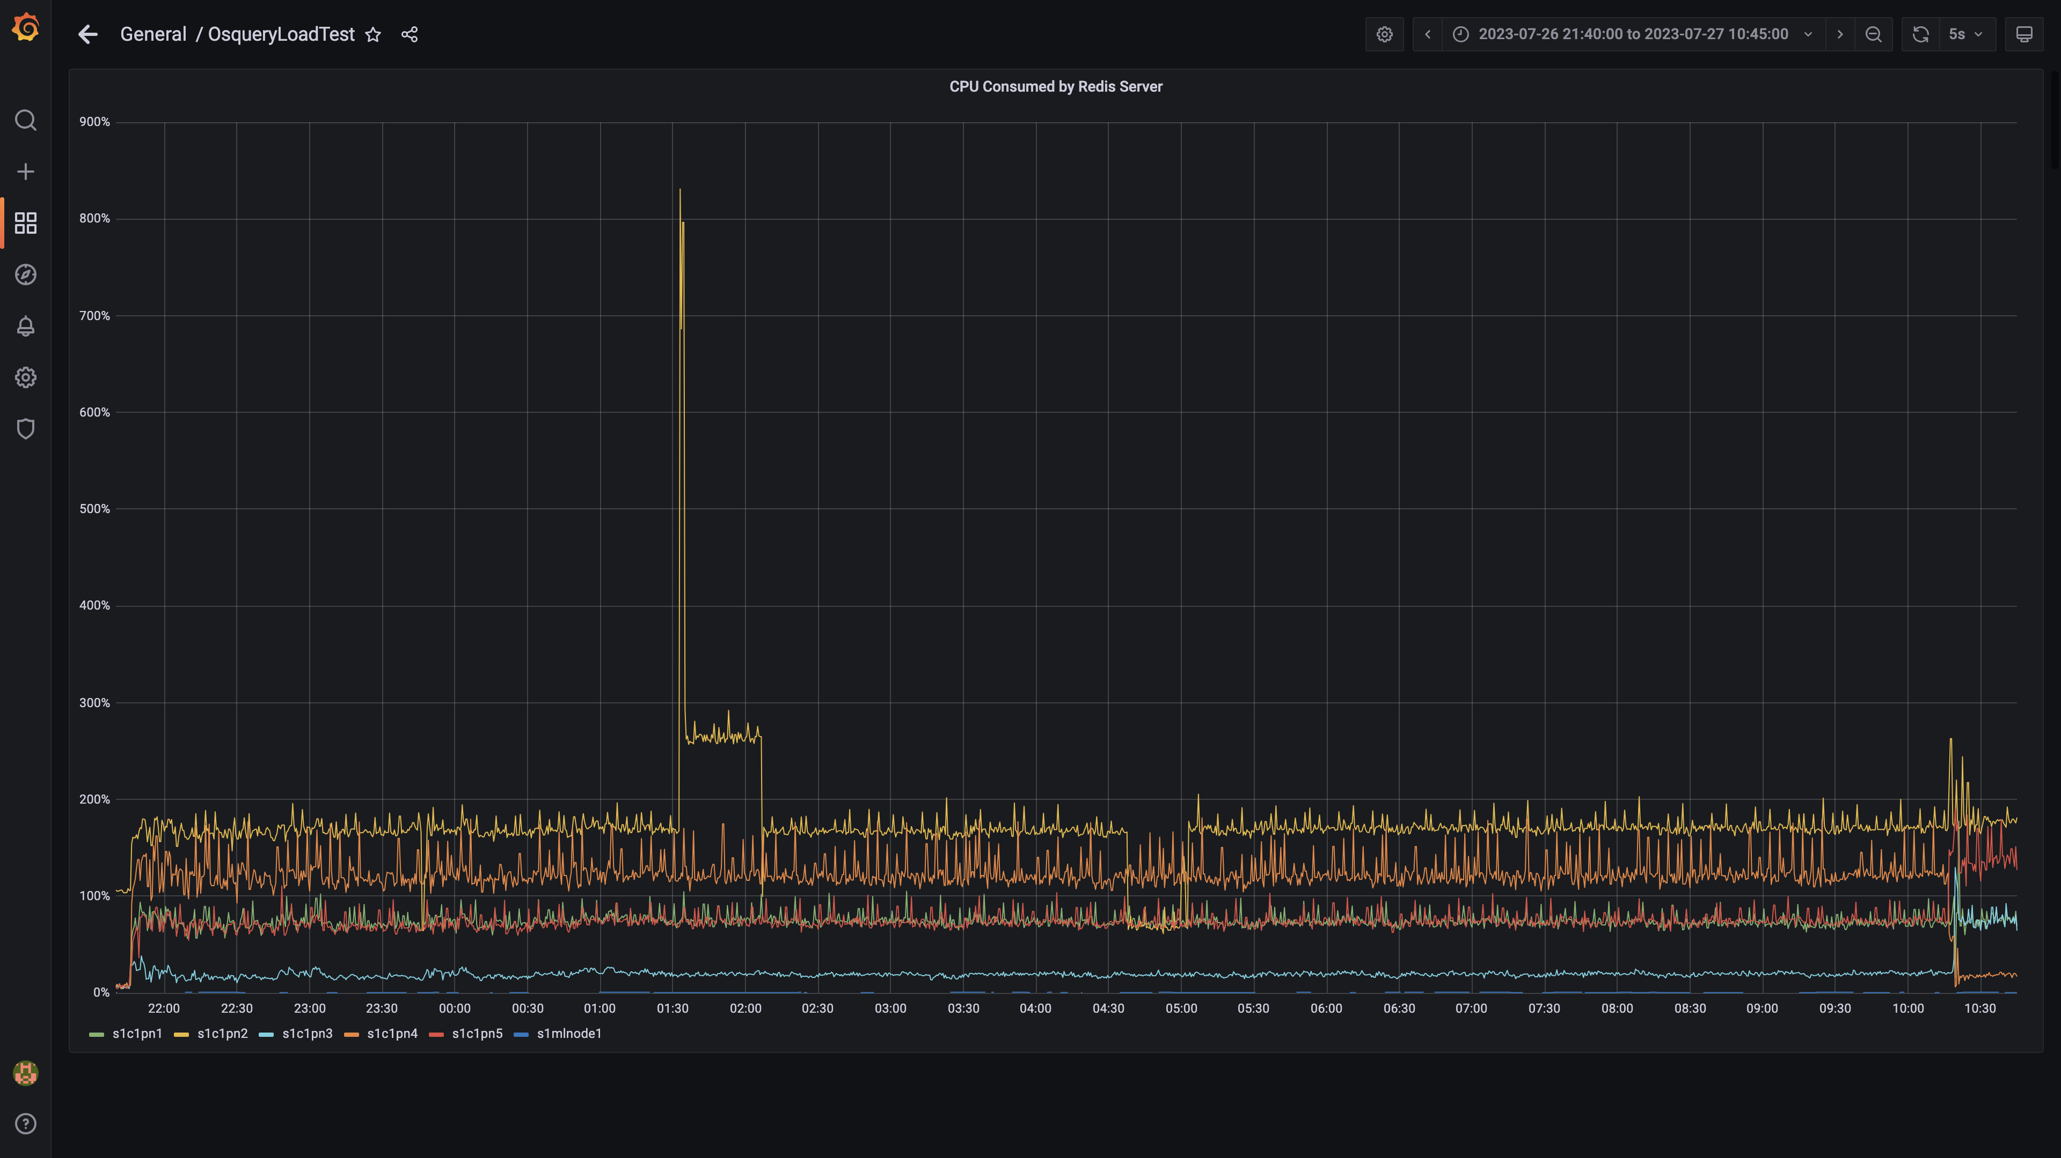

### Cpu consumed by orc-compaction

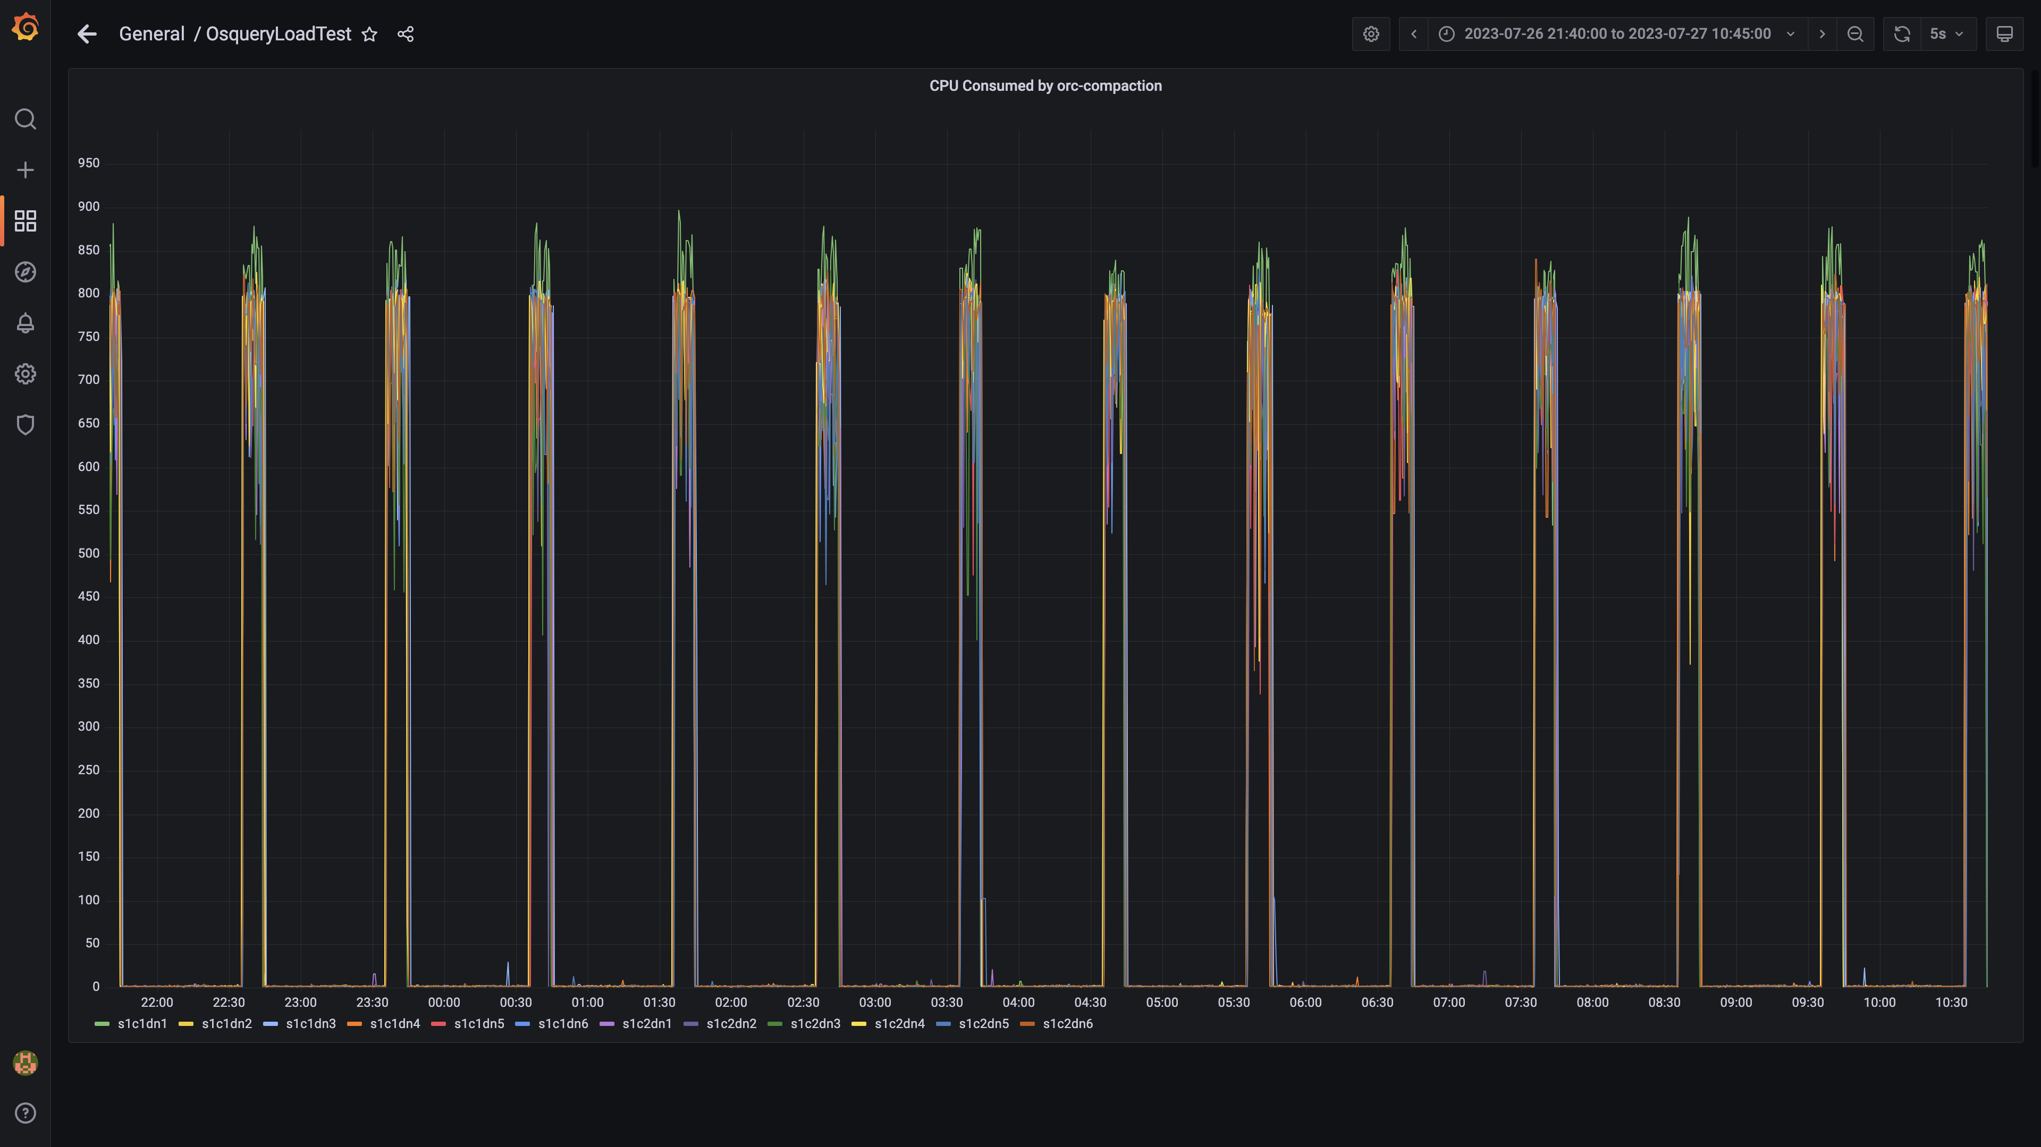

### Cpu consumed by spark-worker

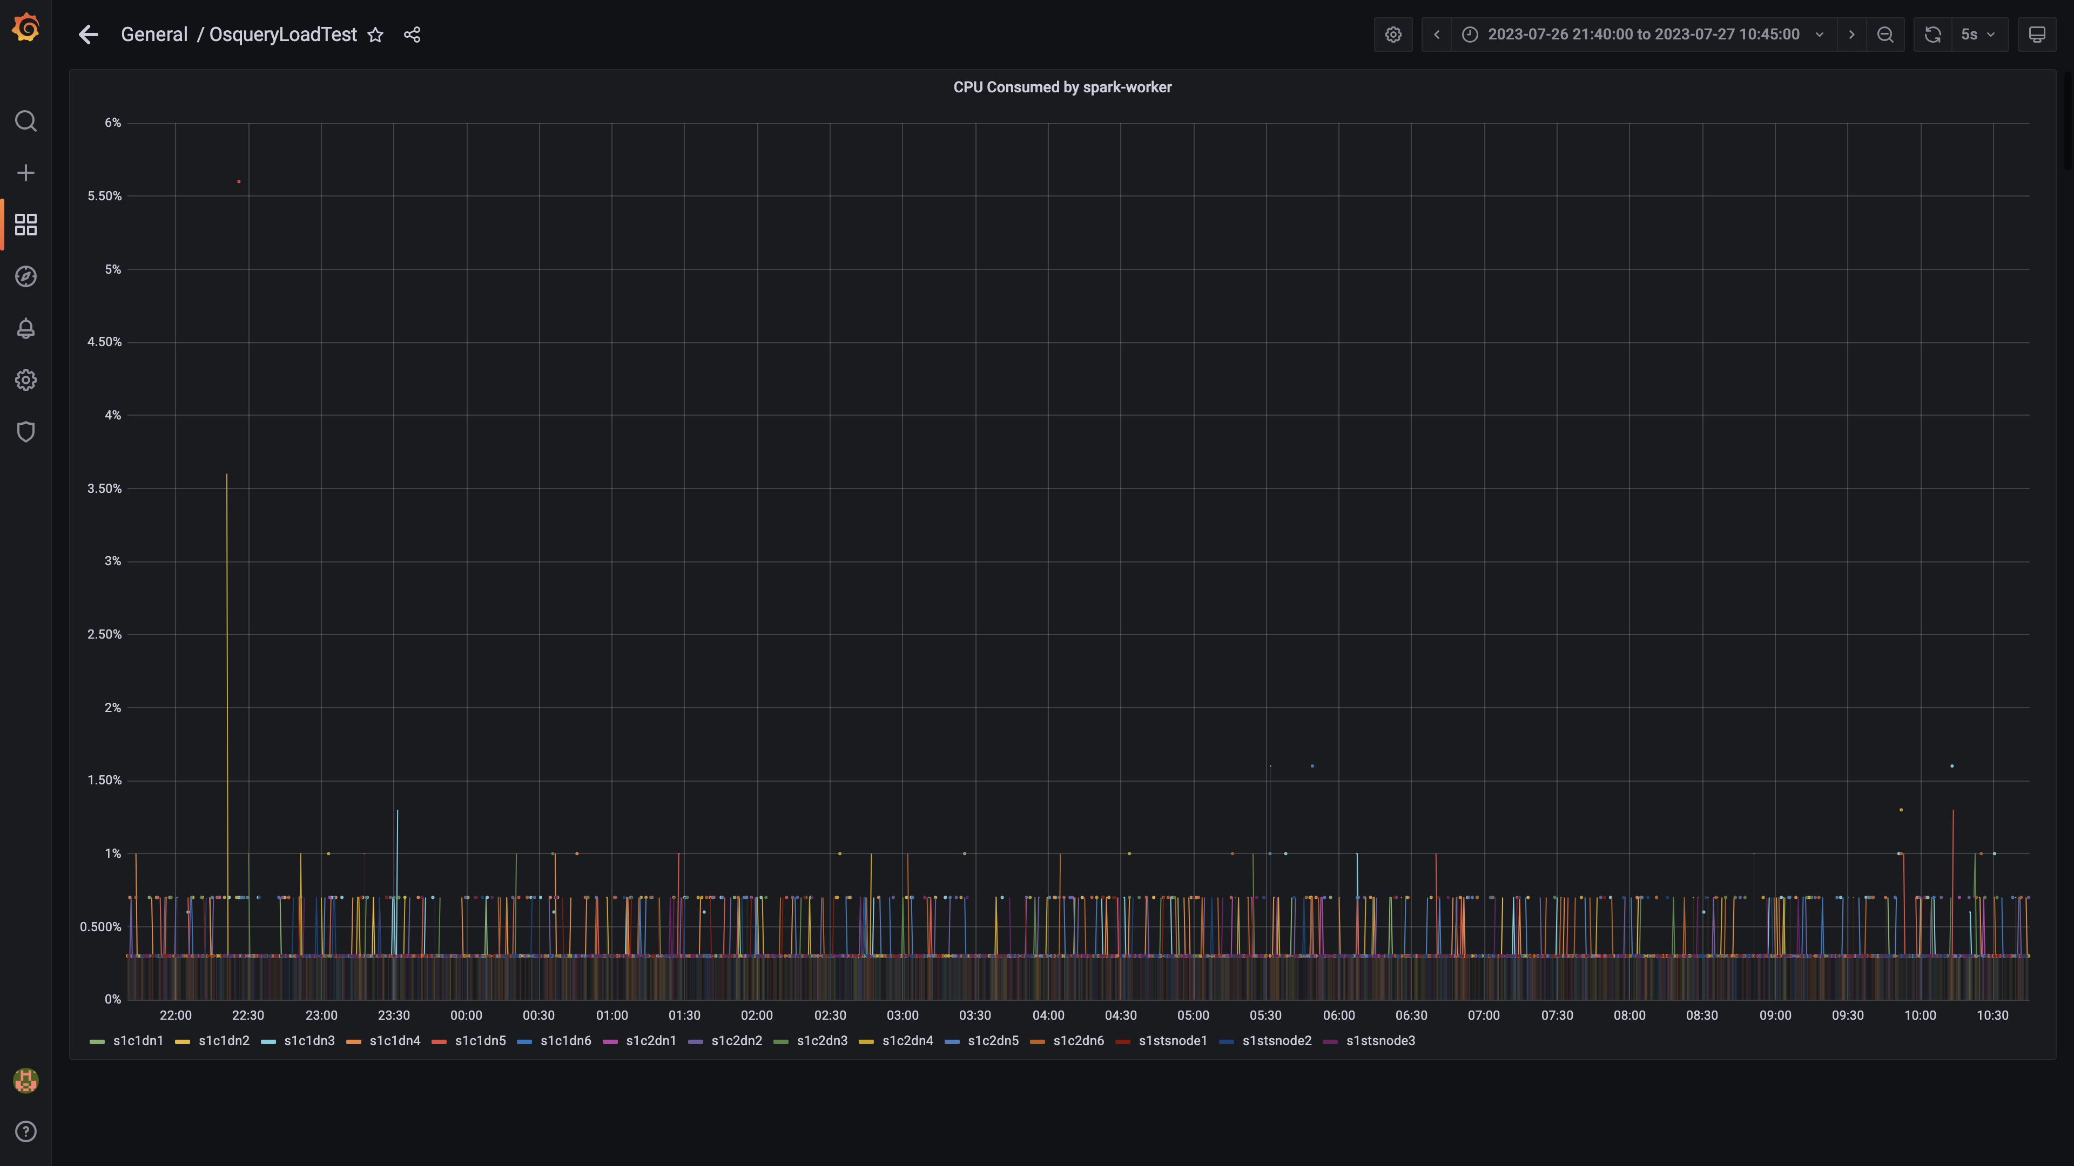

### Cpu consumed by logger

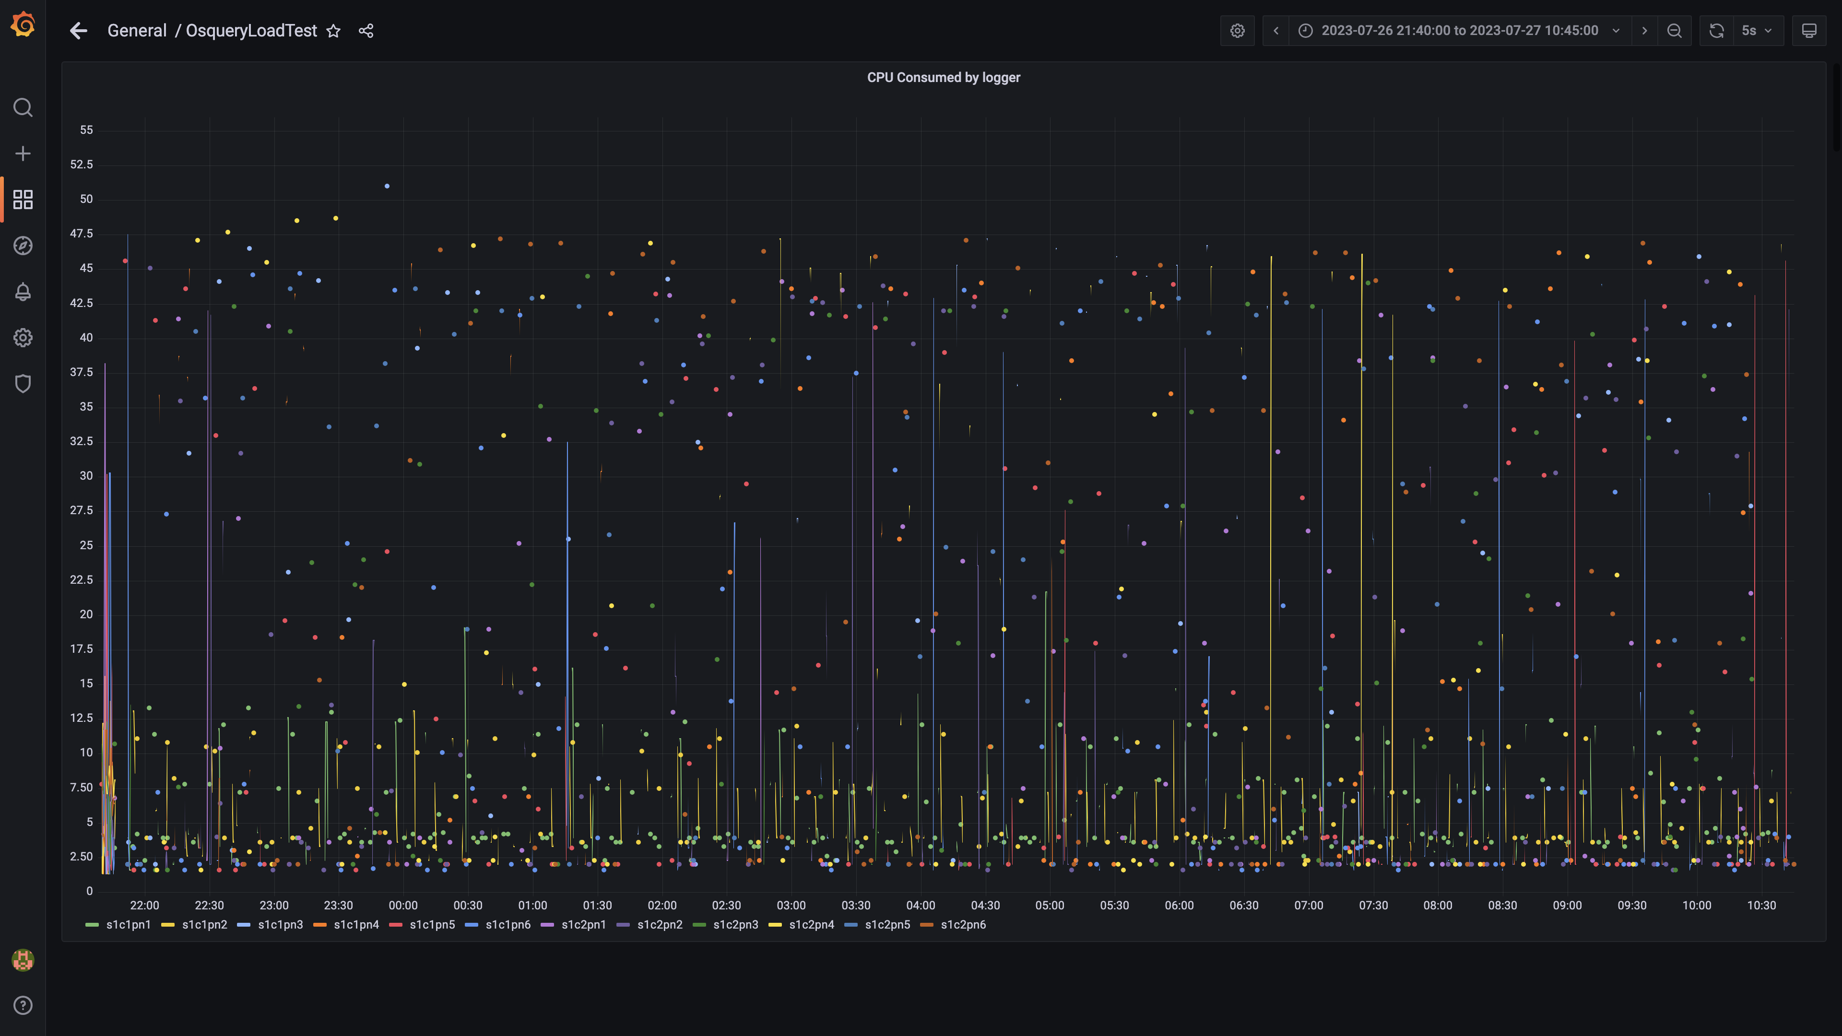

### Compliance summary consumer cpu consumption

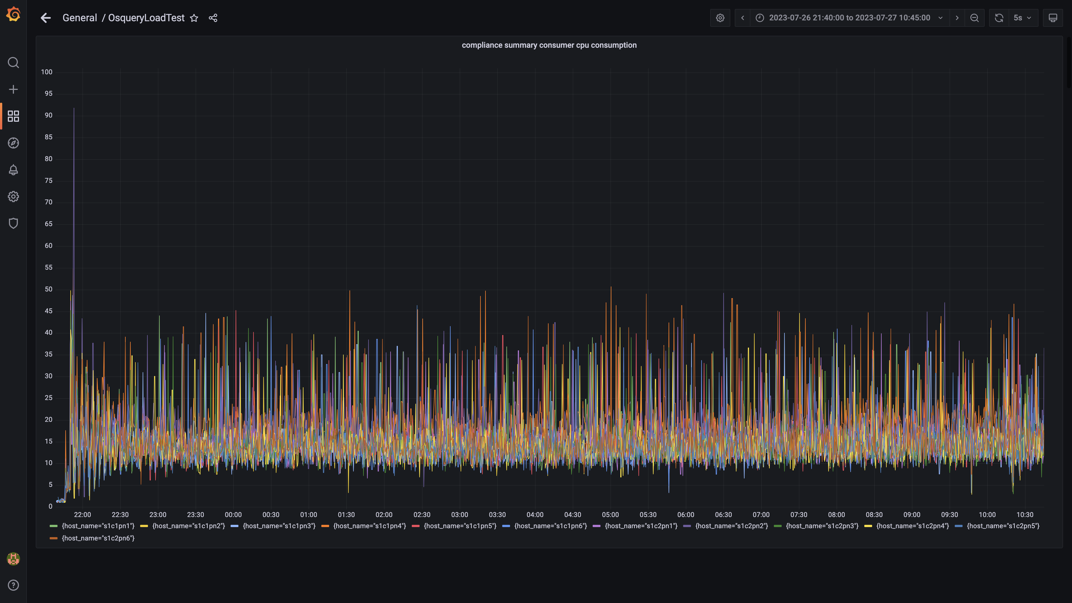

### Cpu consumed by trino

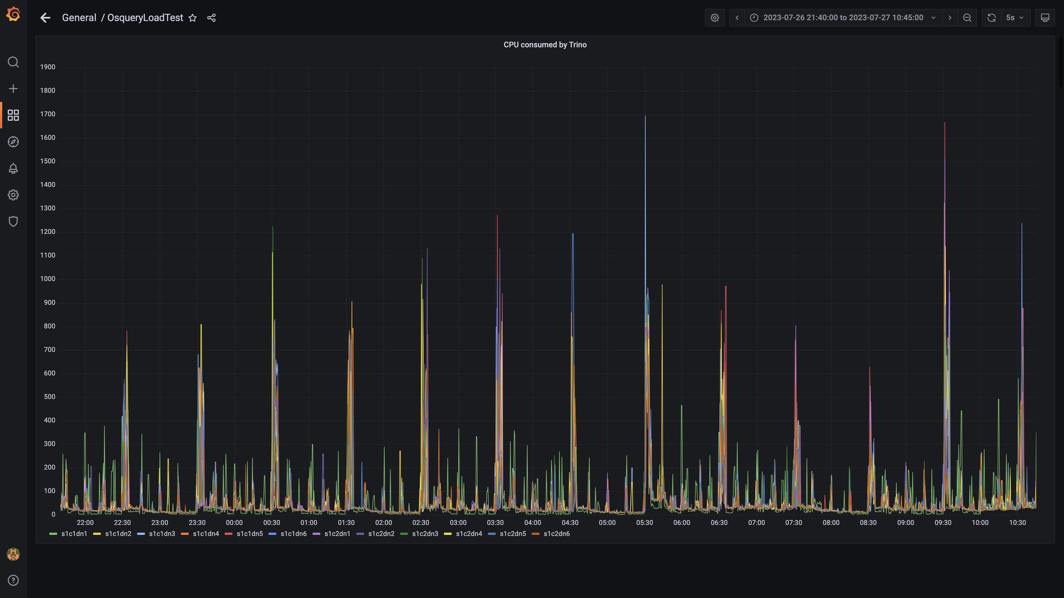

### Debezium cpu usage

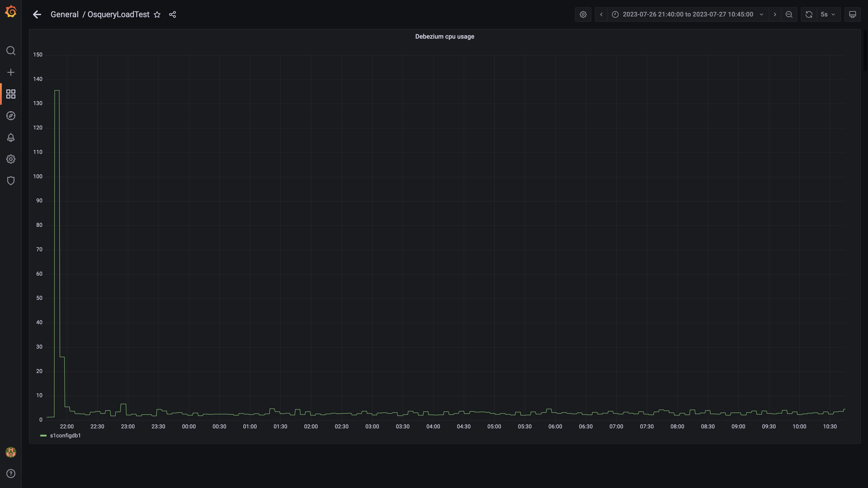

### Cpu consumed by spark-master

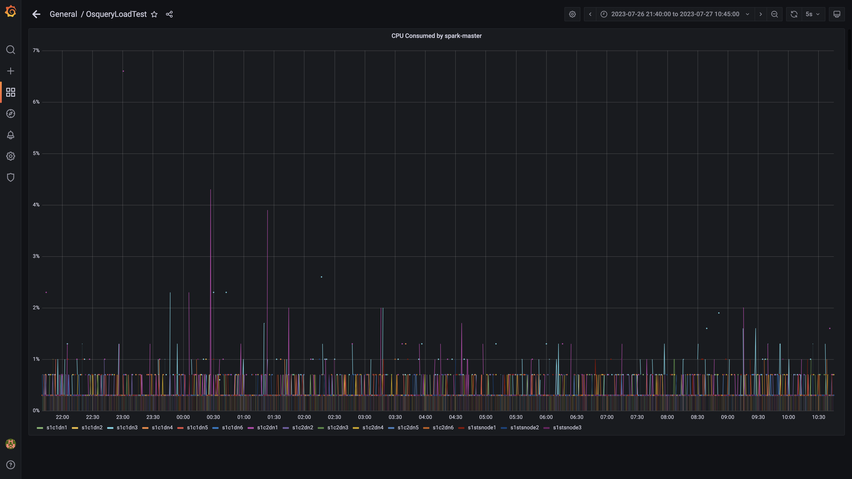

### Cpu consumed by tls

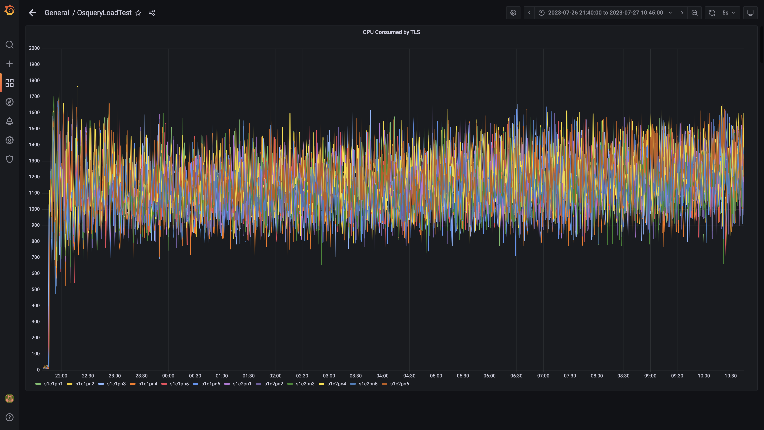

### Airflow cpu usage

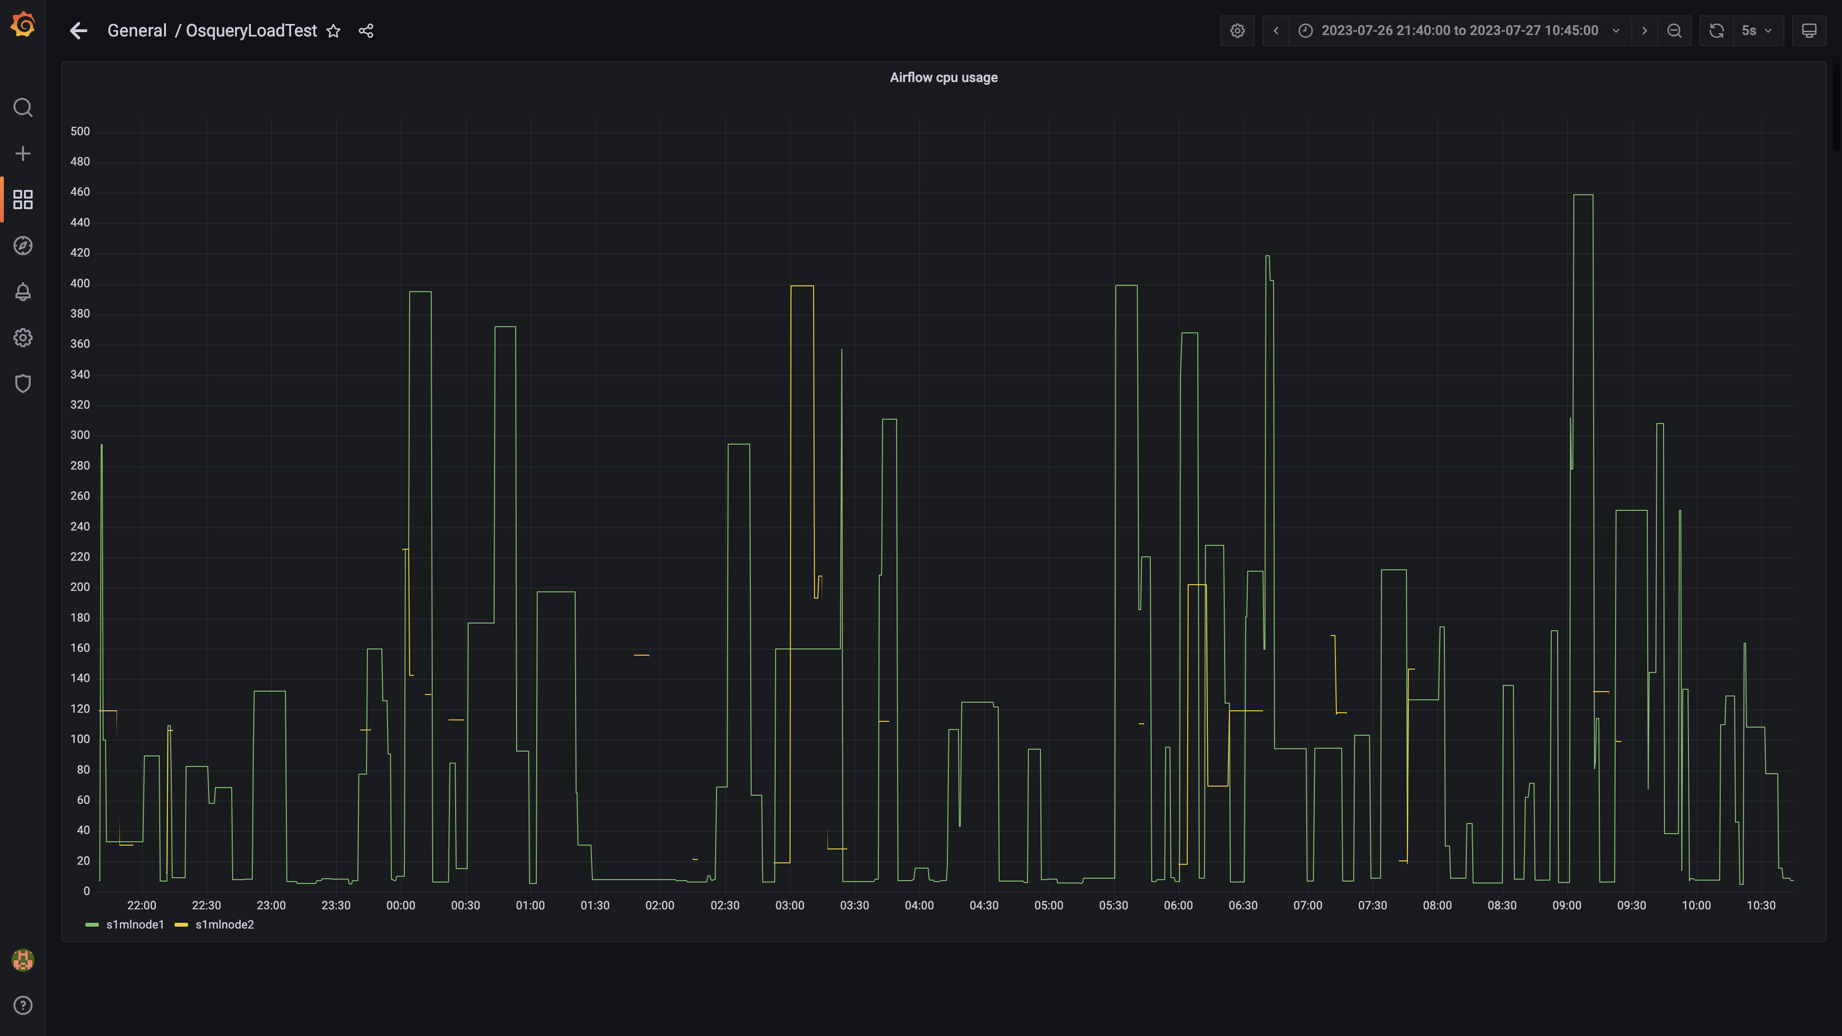

### Spark inject and drain rate agent osquery

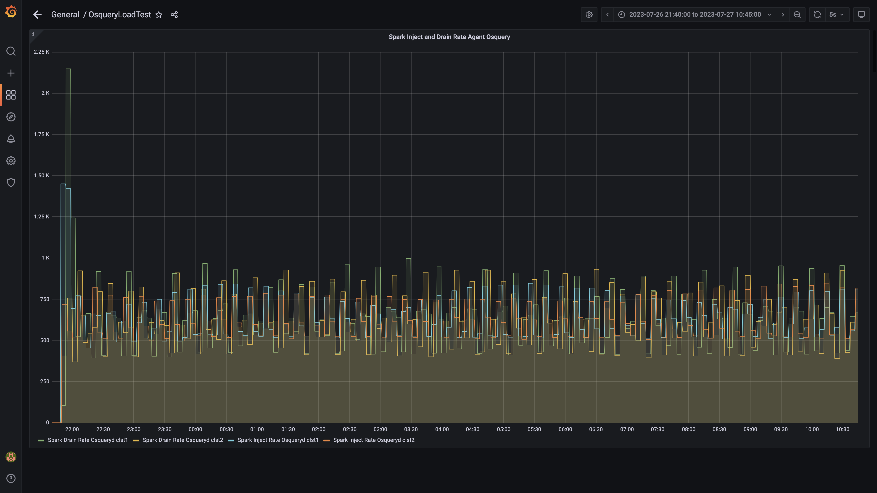

### Spark lag for agent osquery

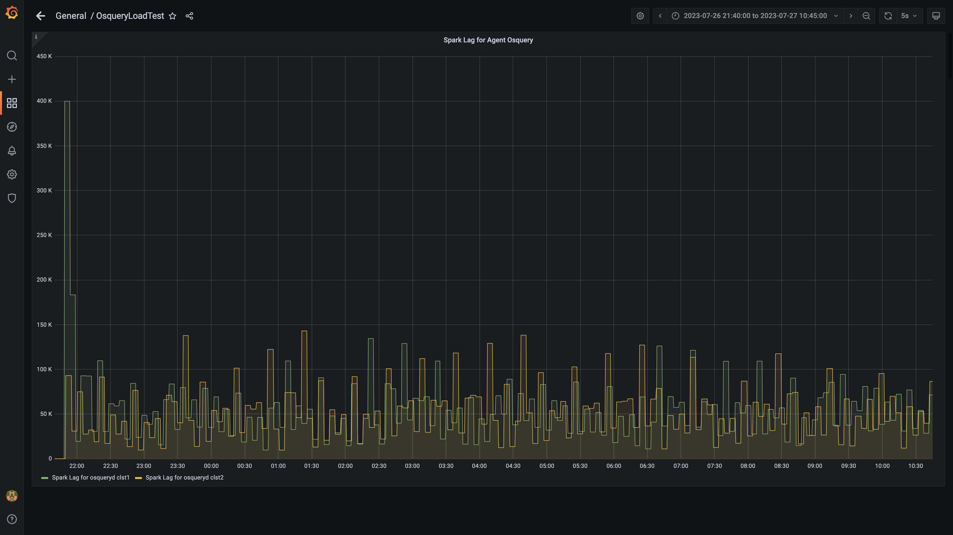

### Spark inject and drain rate events

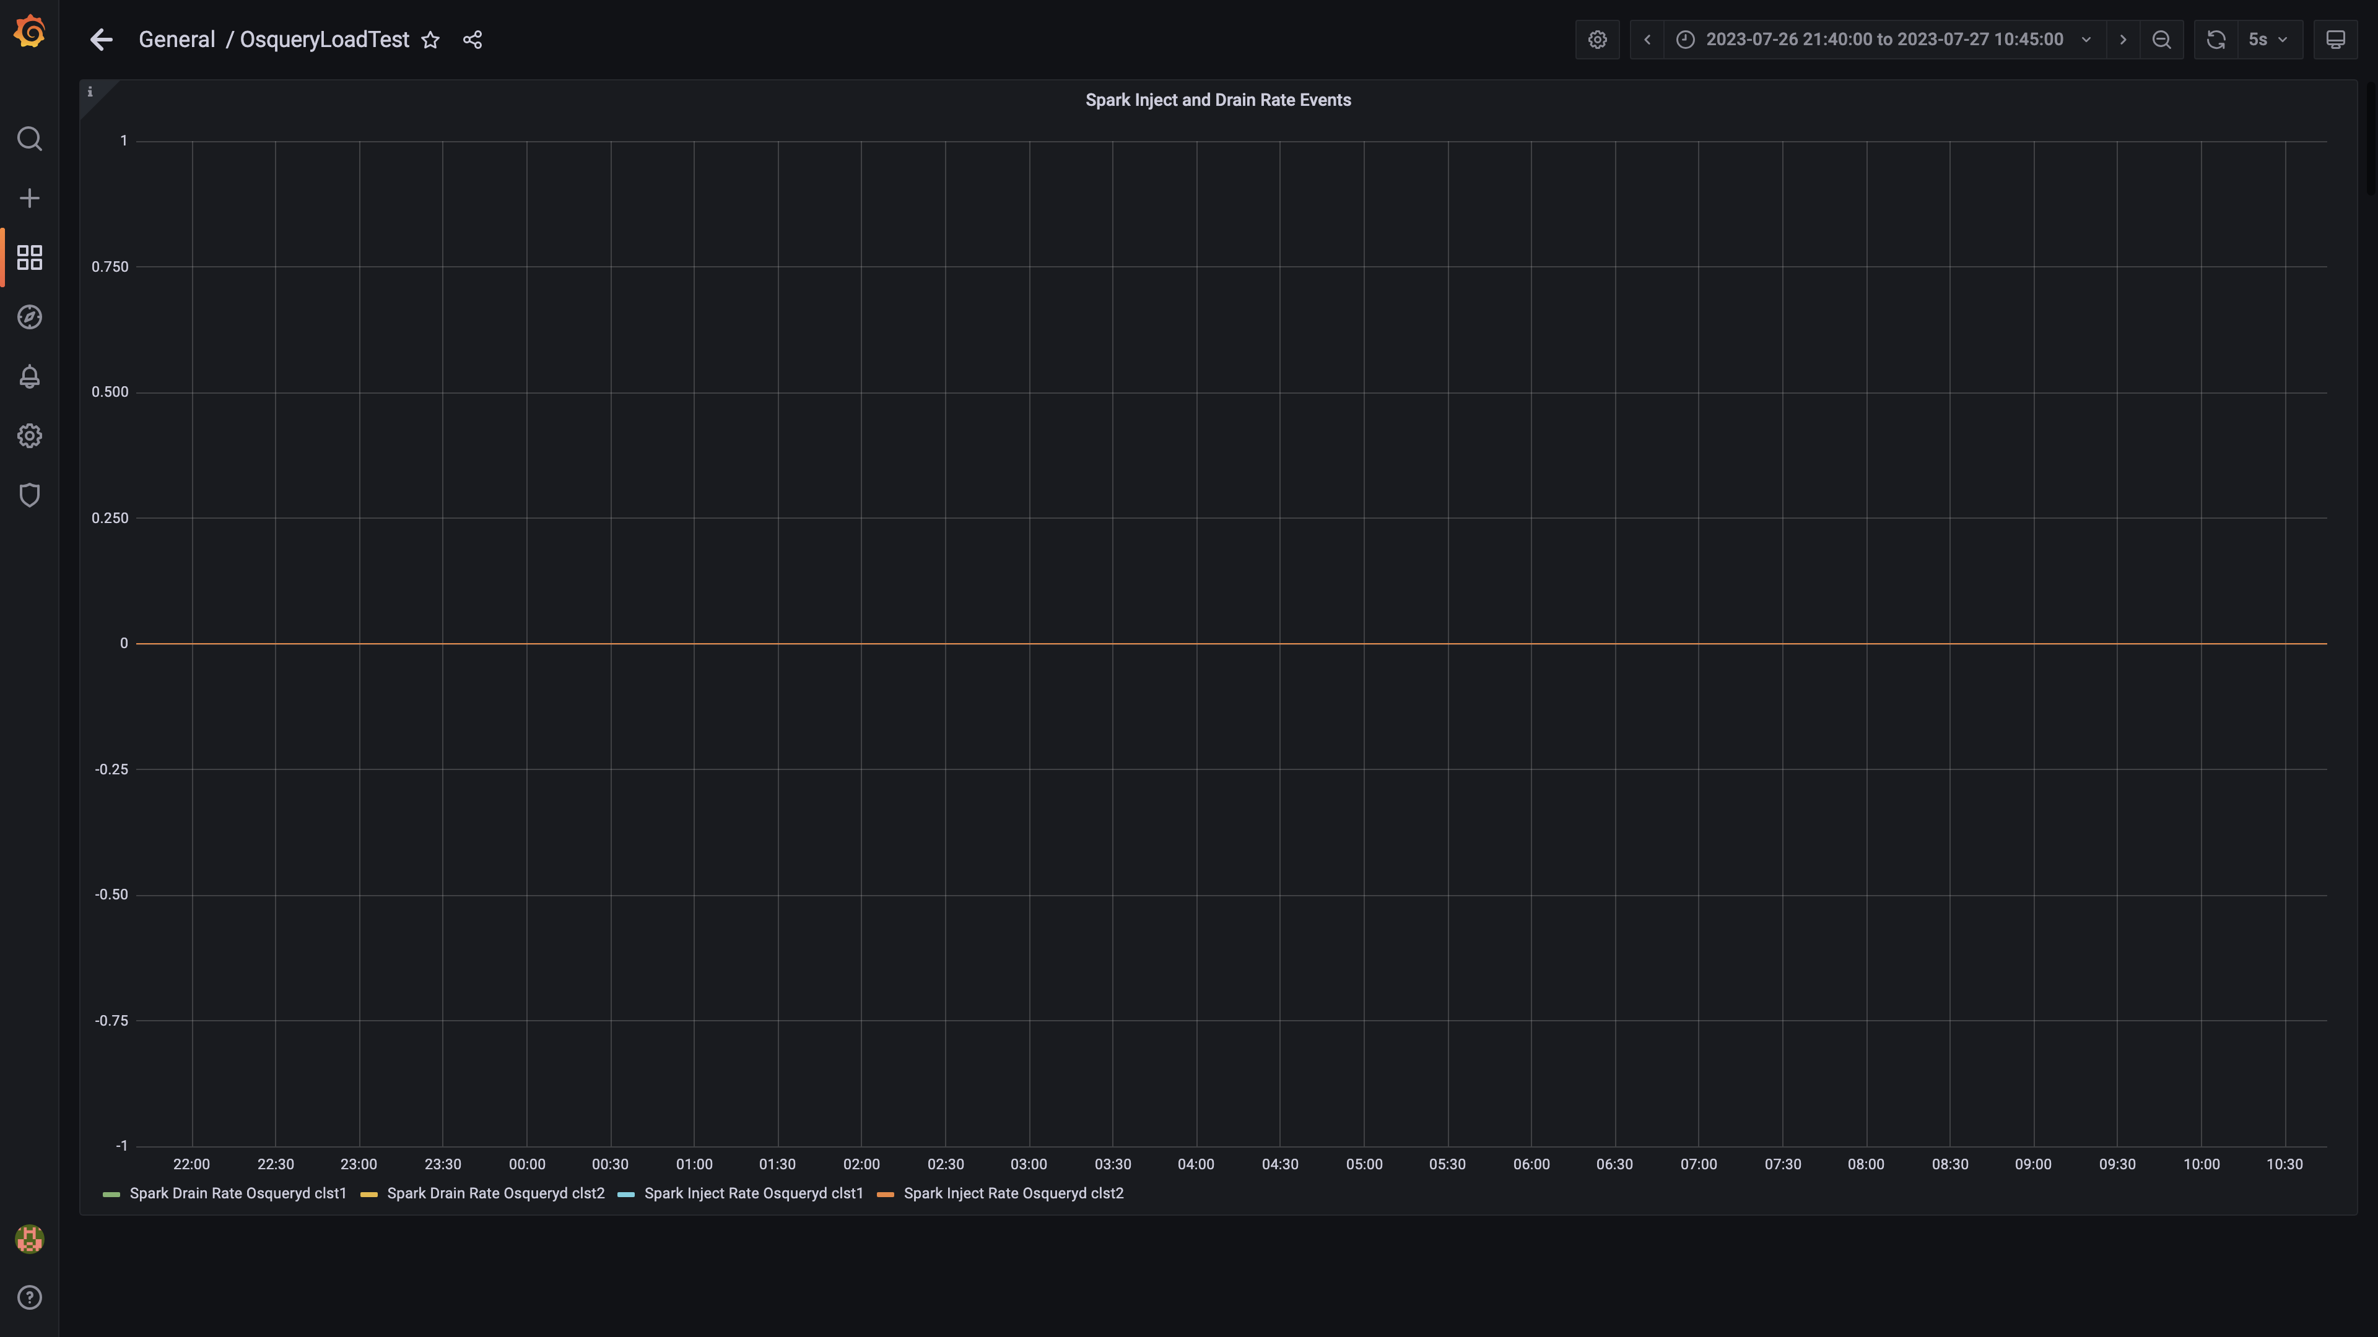

### Spark lag for events

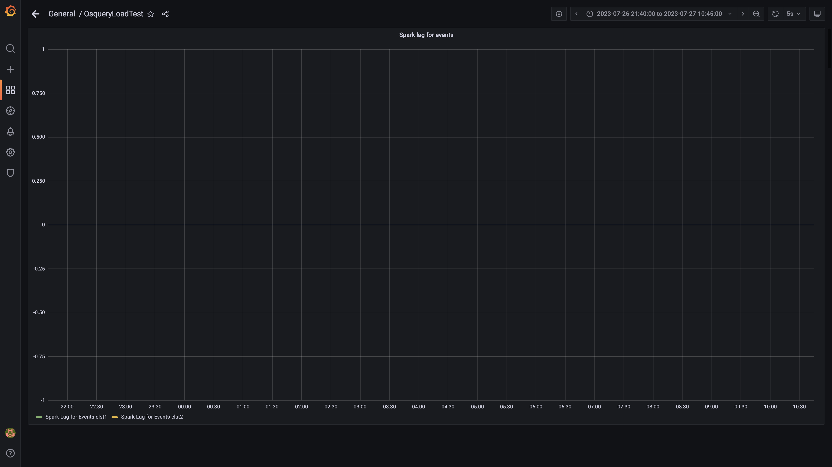

### Inject and drain rate db-alerts group

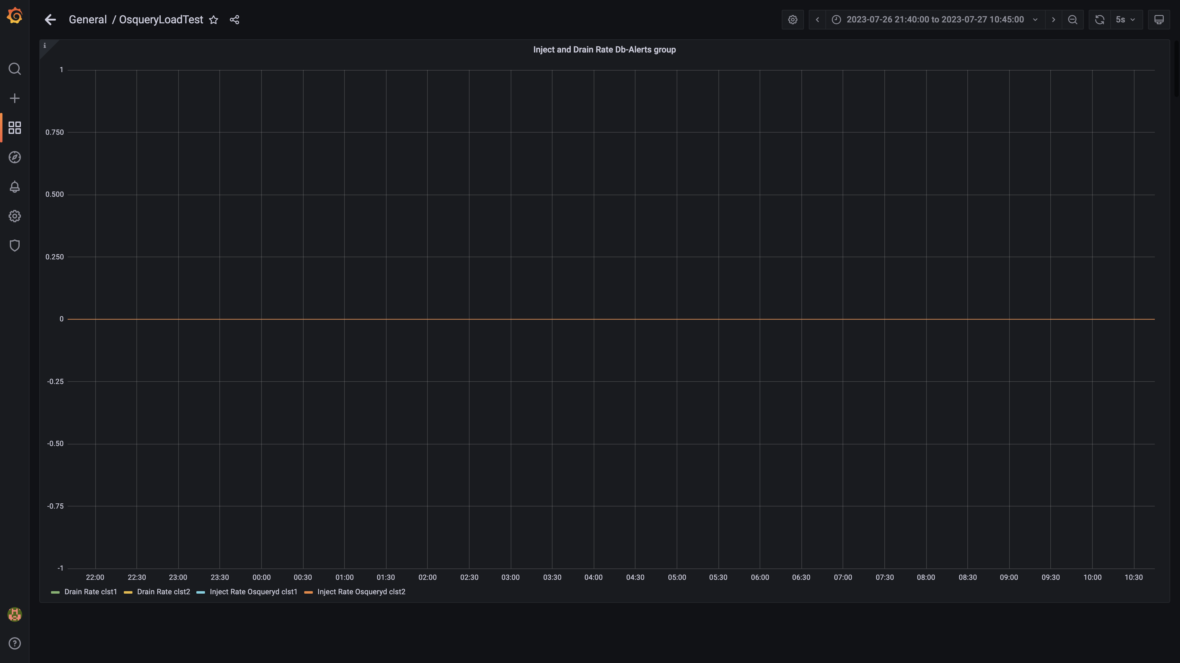

### Kafka lag for db-alerts group

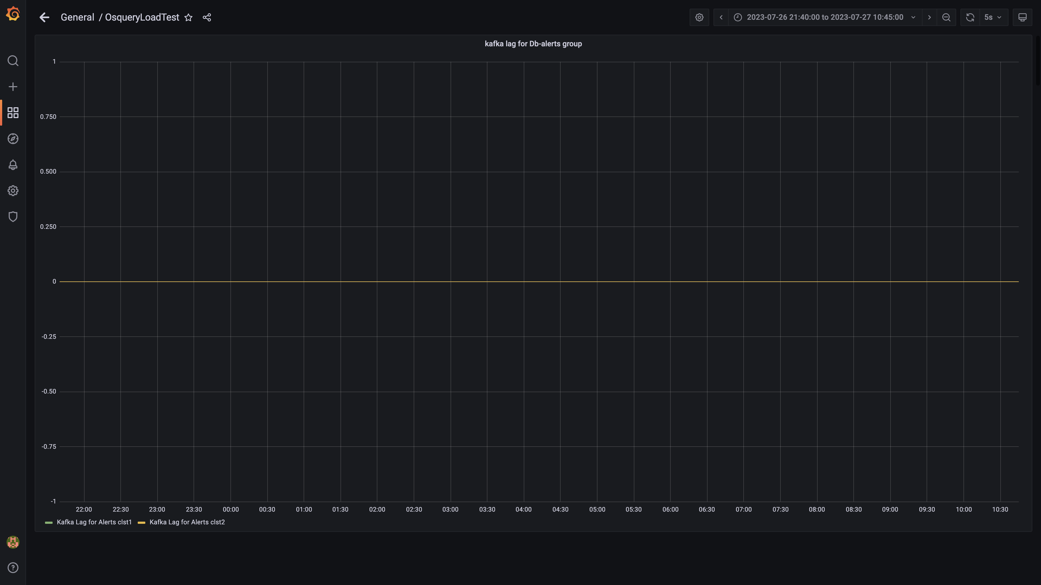

### Inject drain rates for ruleengine group

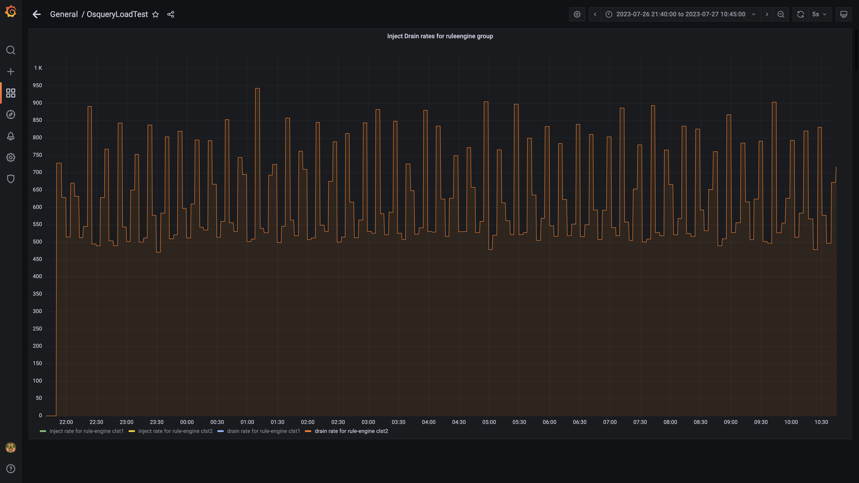

### Kafka lag for ruleengine group

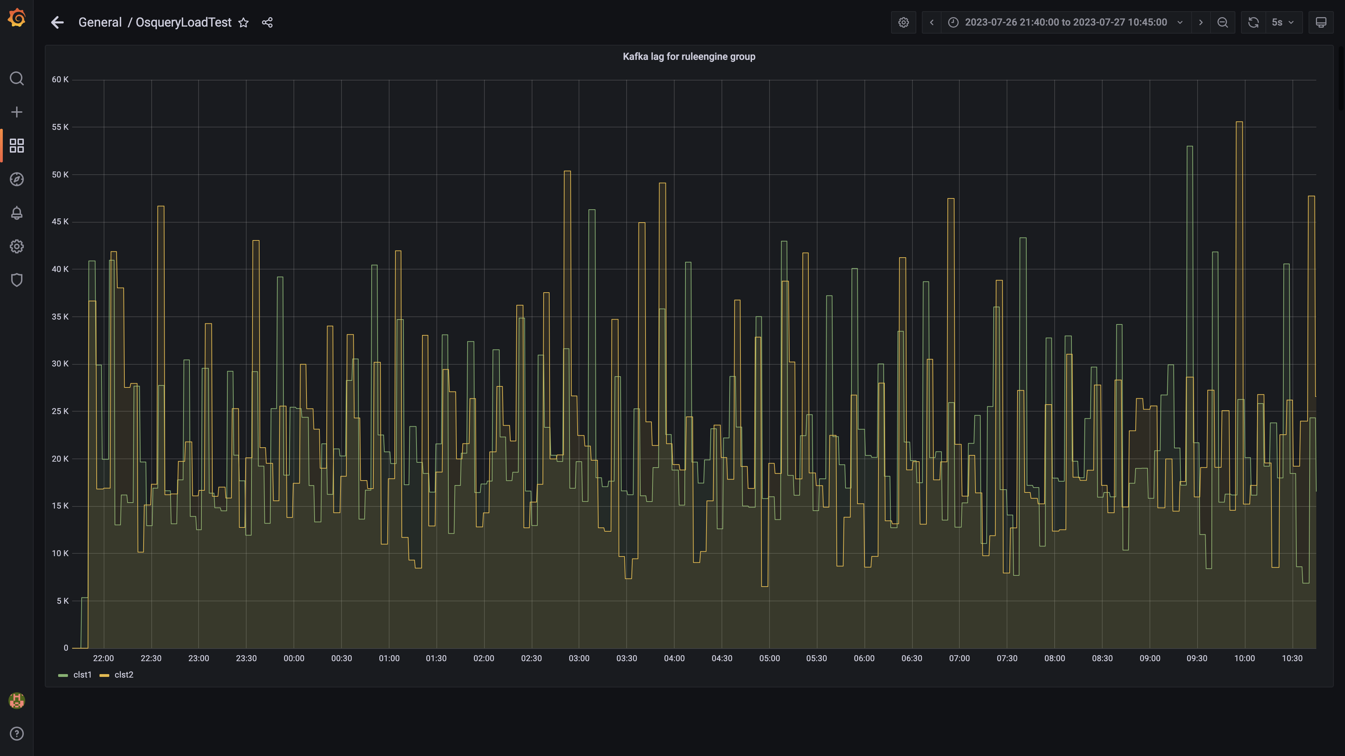

### Kafka inject and drain rates for debezium group

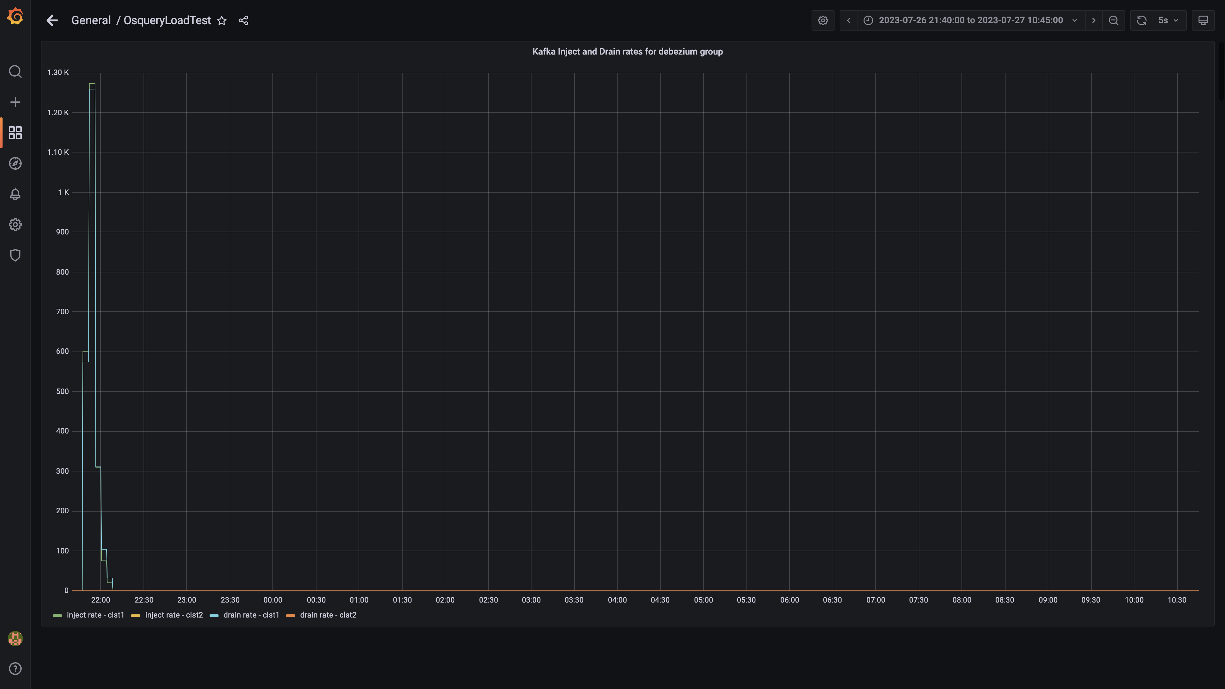

### Aggregate lag

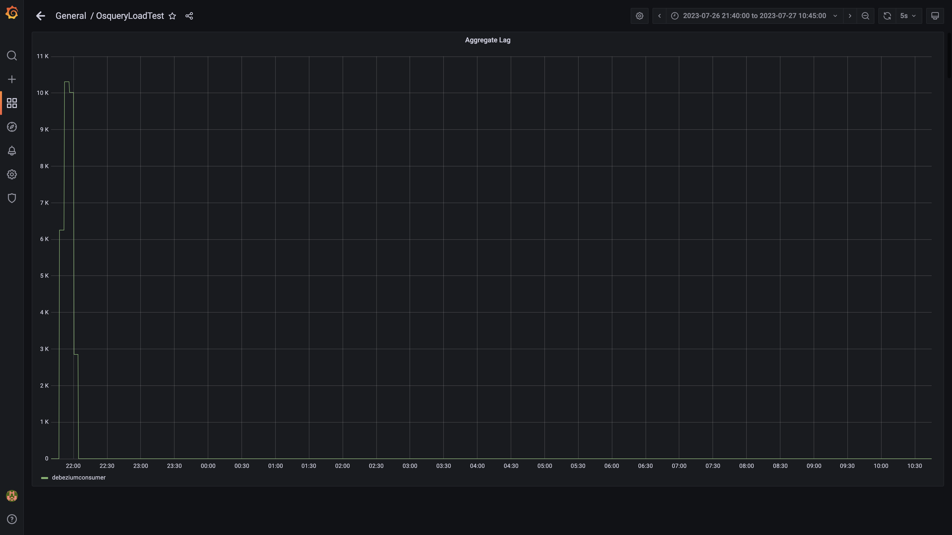

### Debezium replication lag

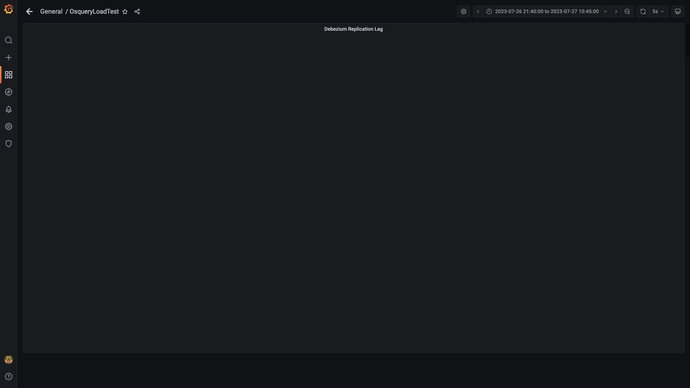

### Active client connections

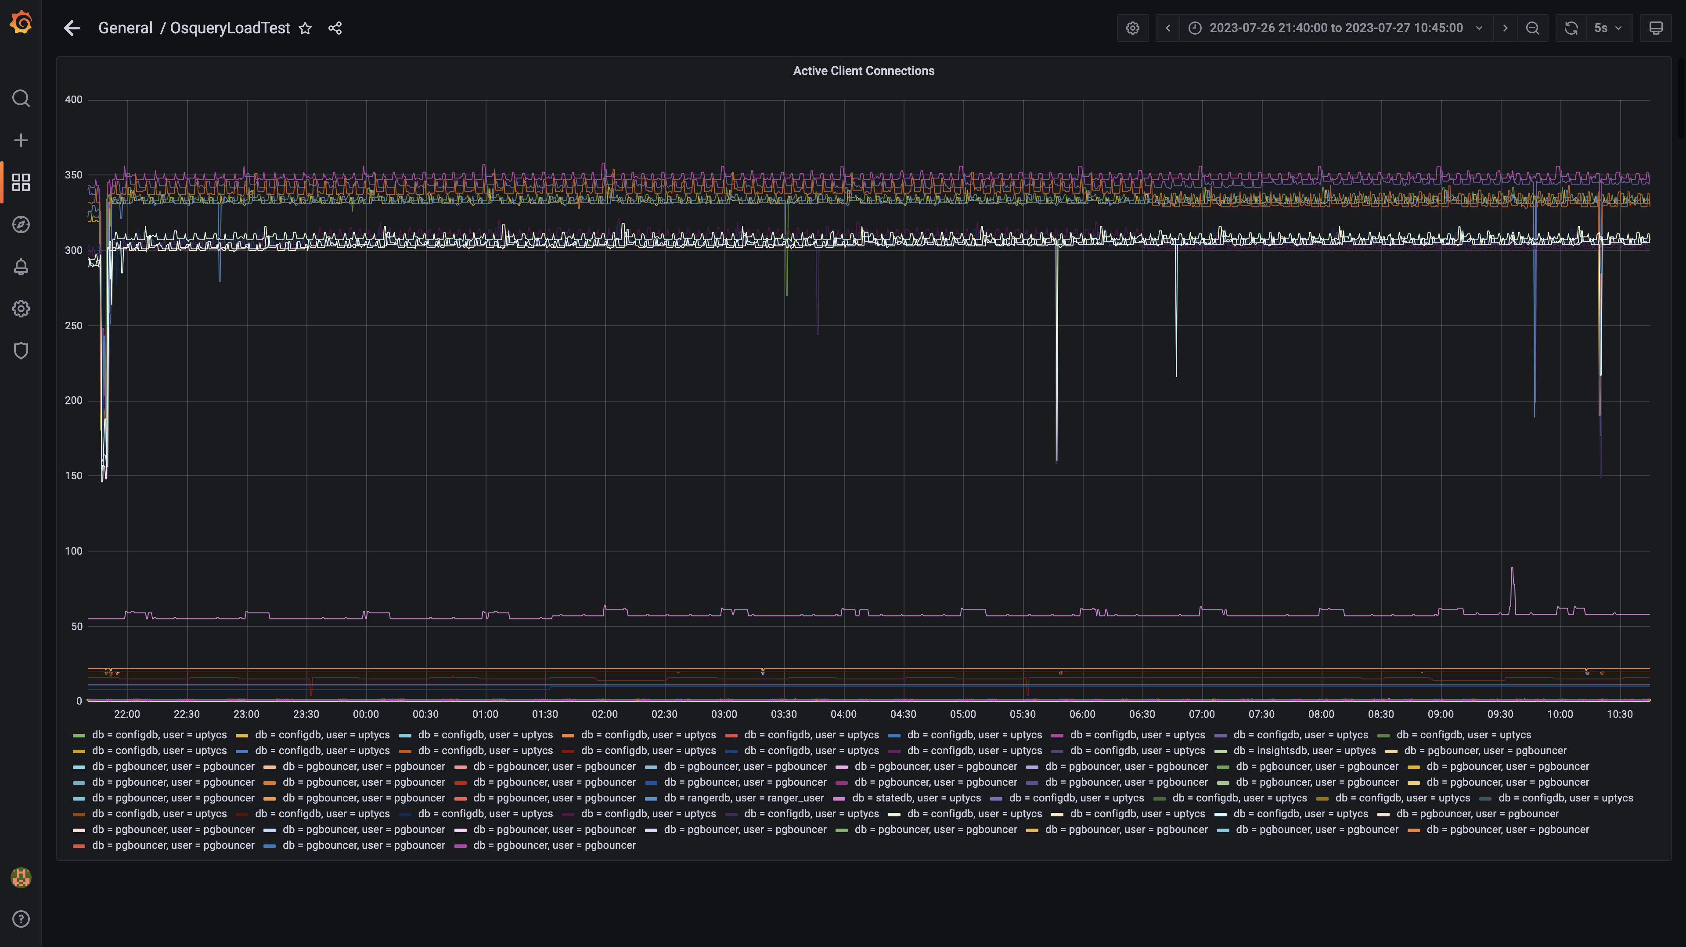

### Panel 130 not loaded in given time

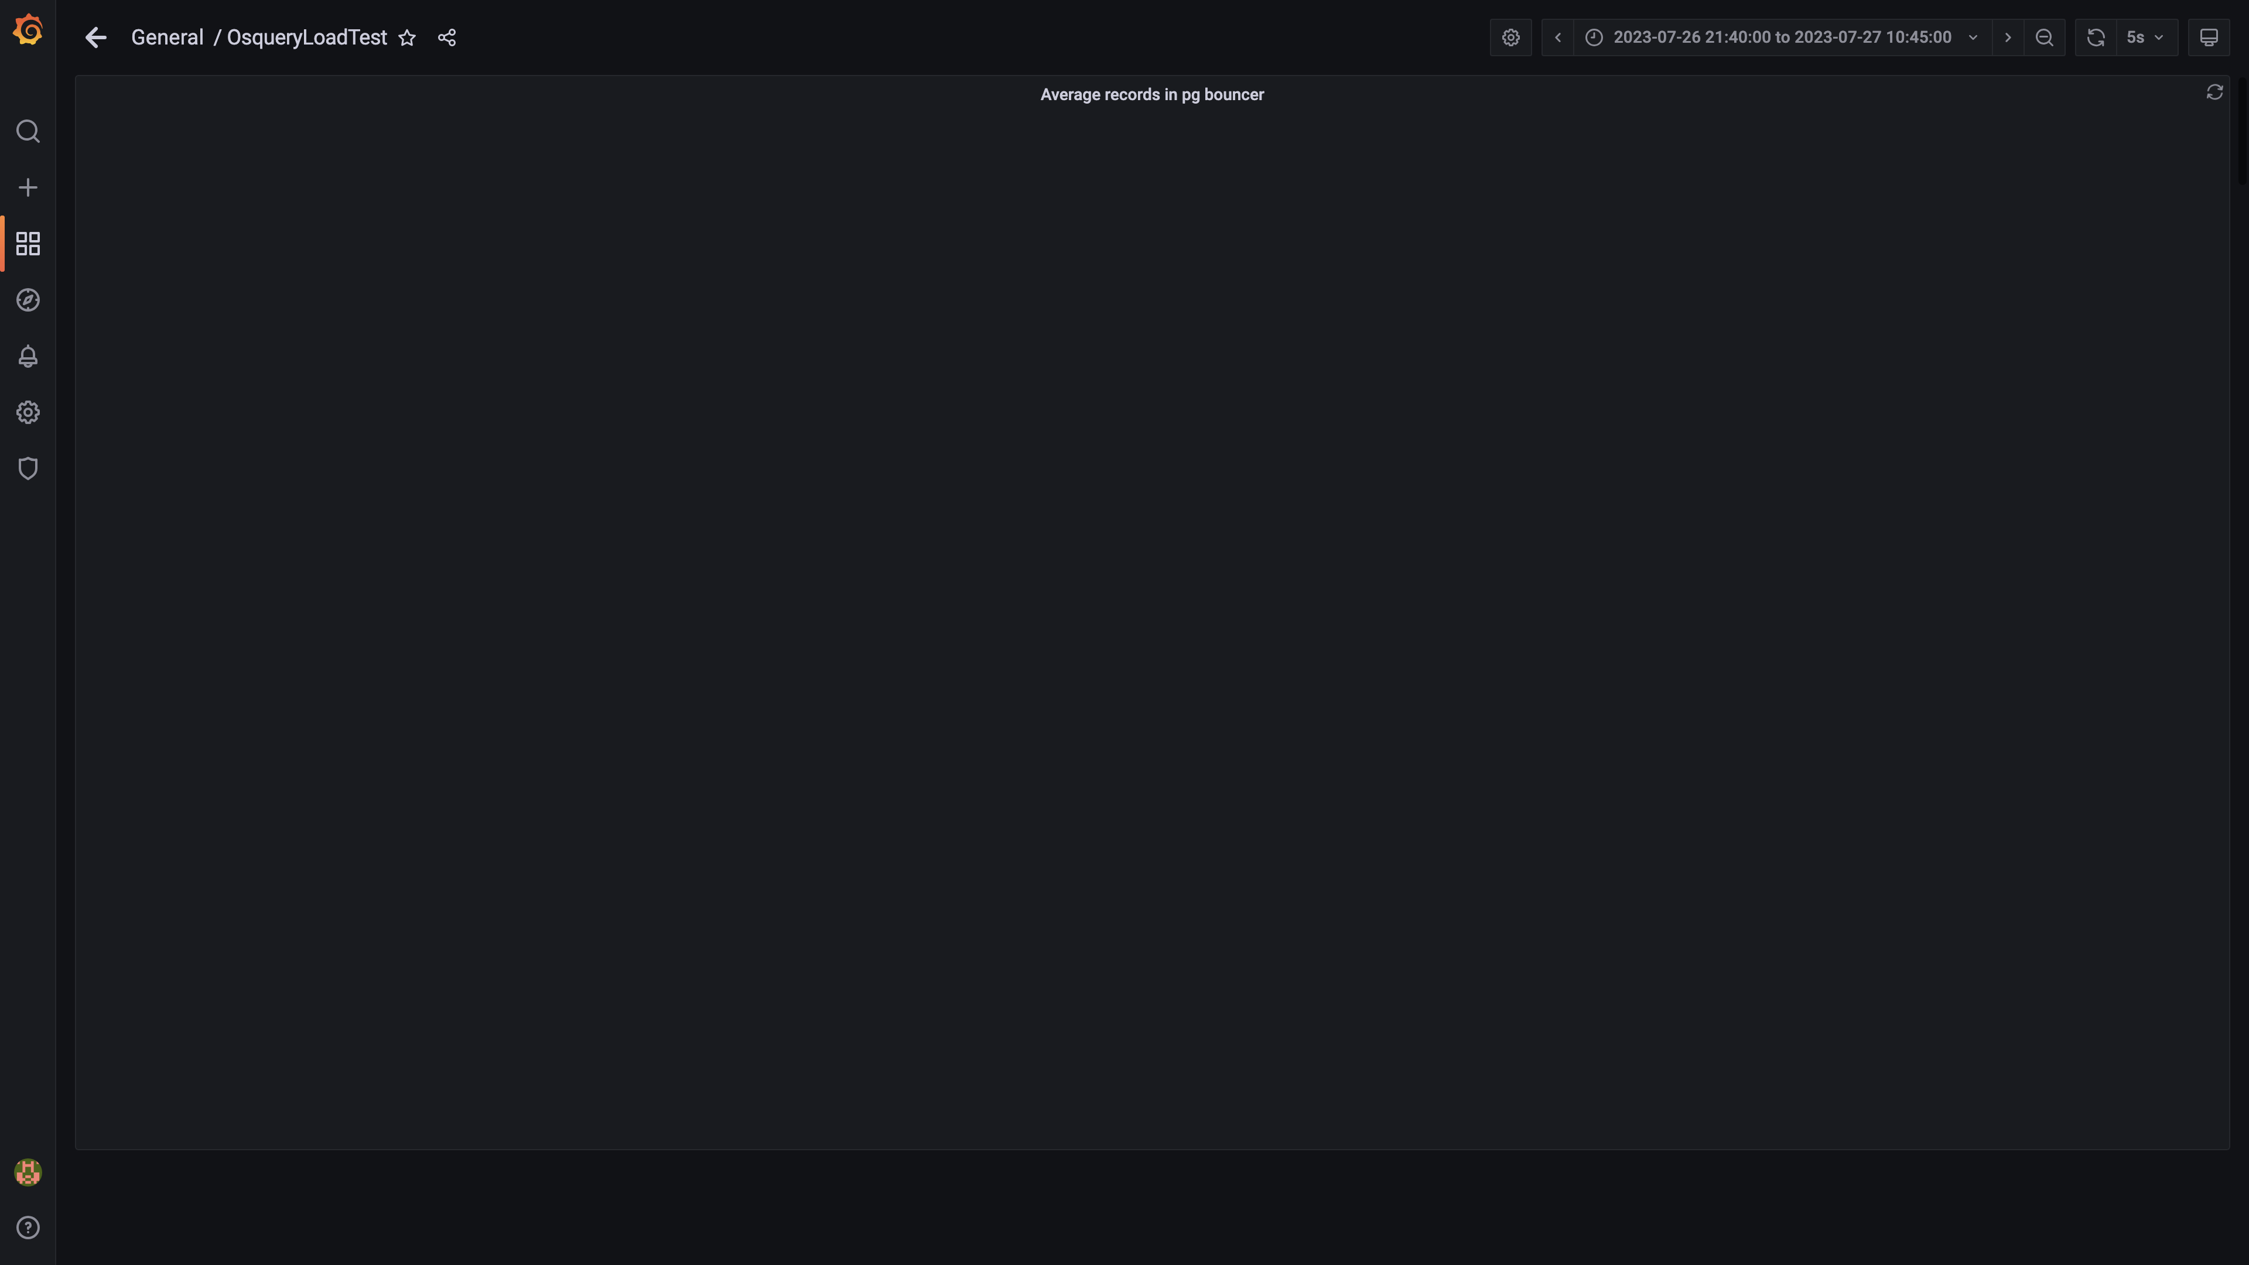

### Panel 128 not loaded in given time

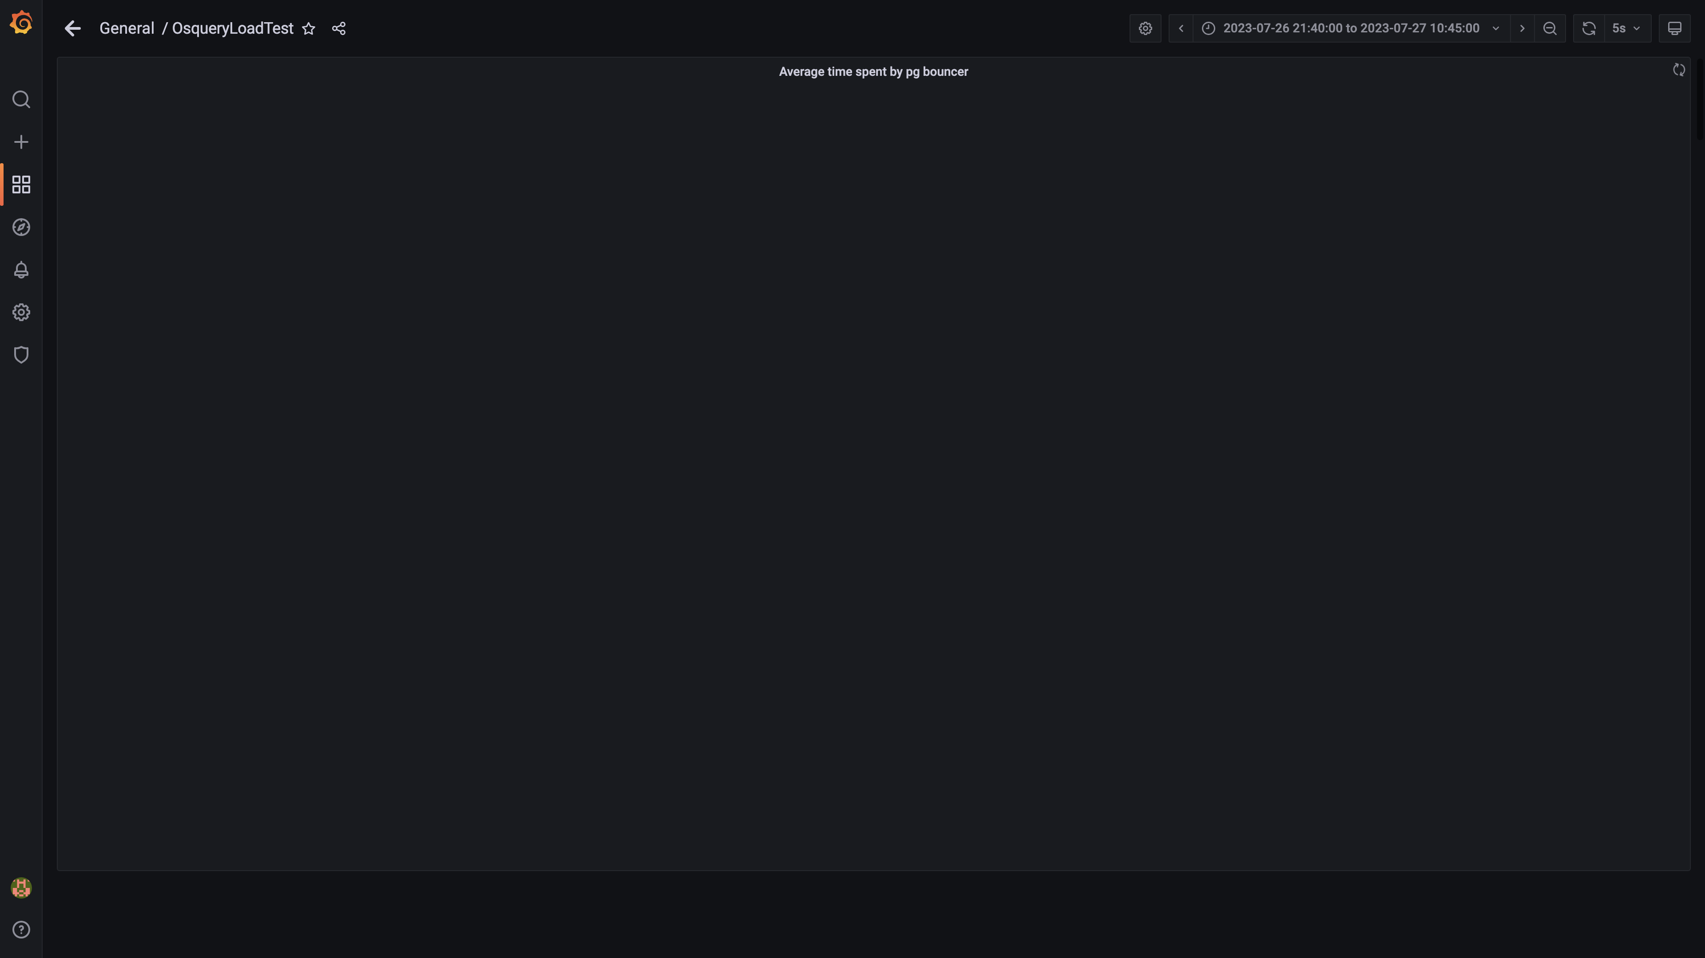

### Redis client connections for tls

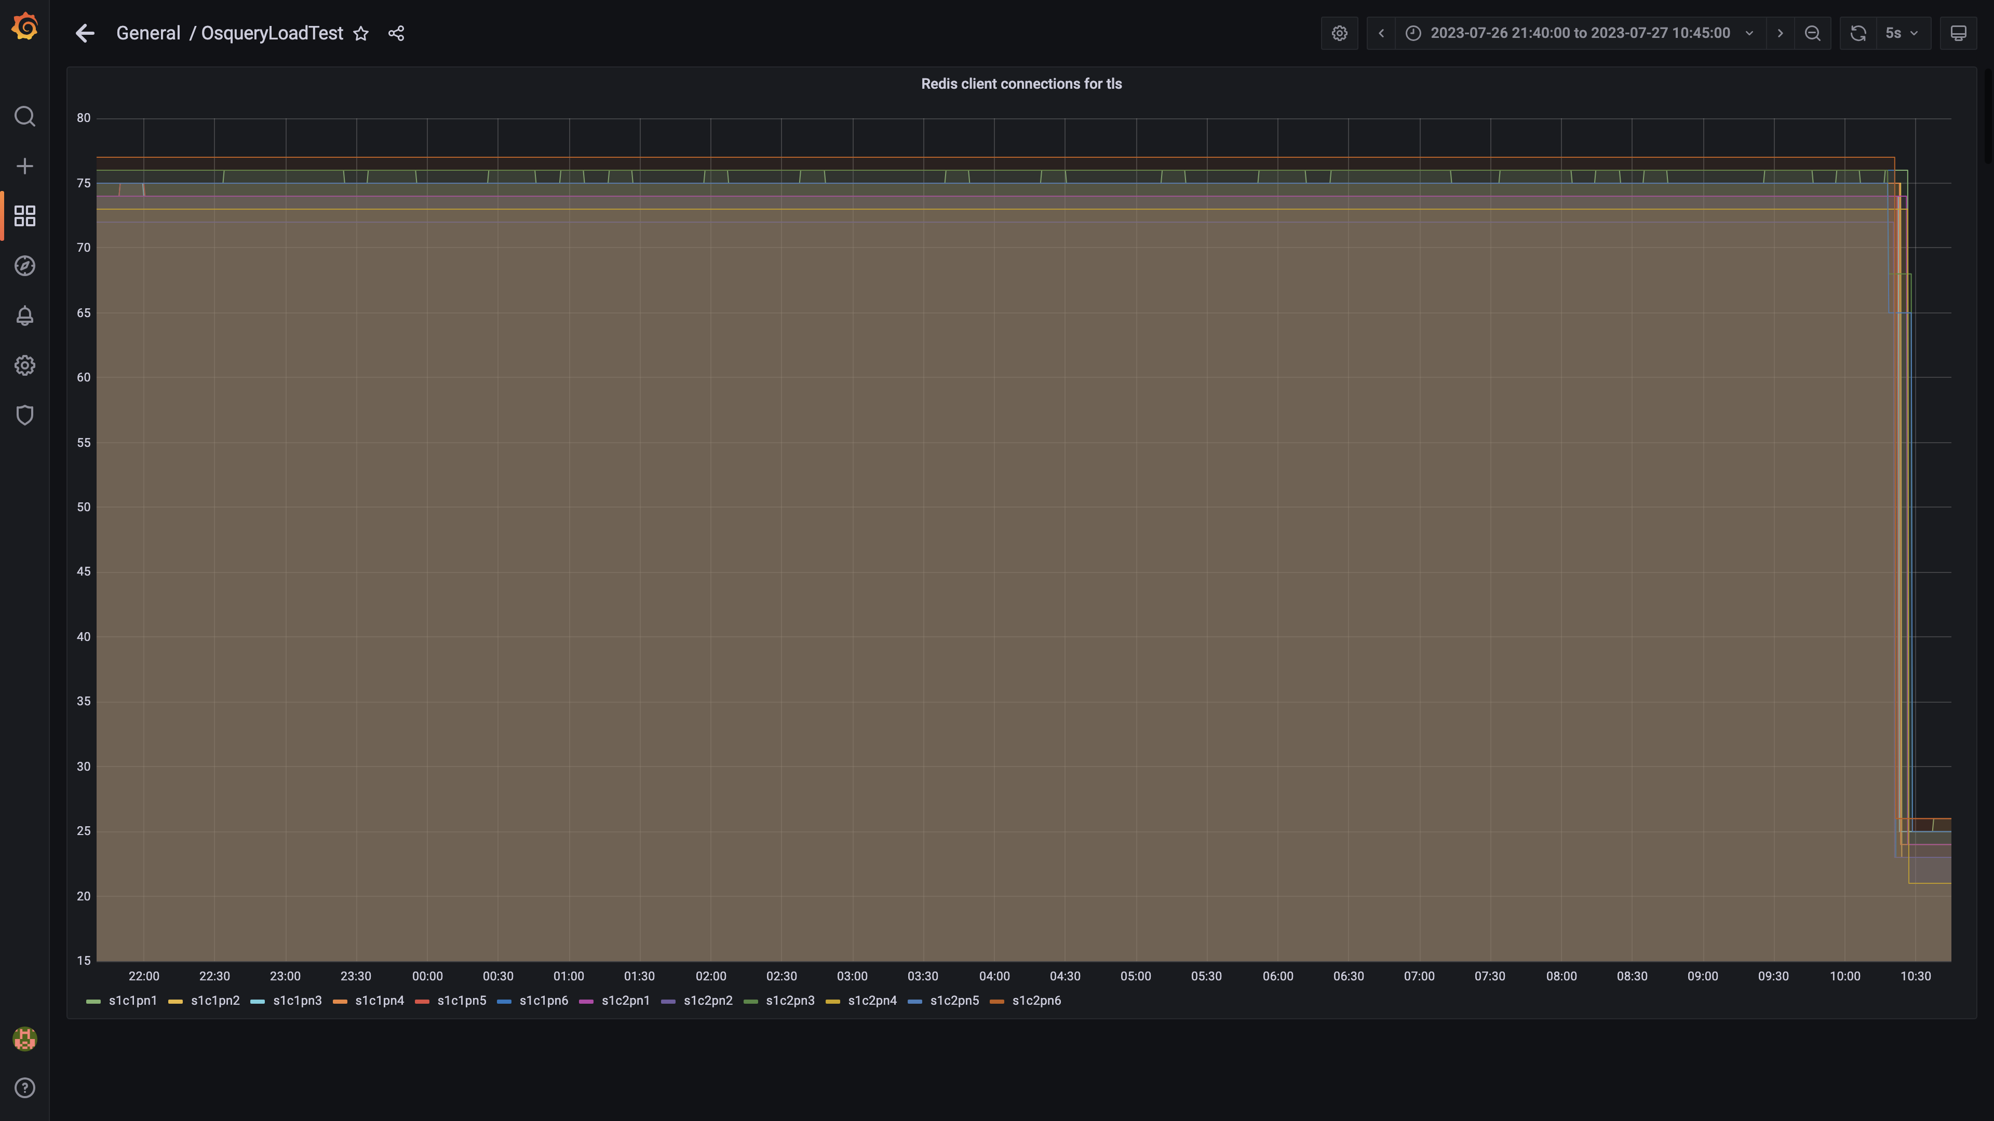

### Configdb pg wal folder size

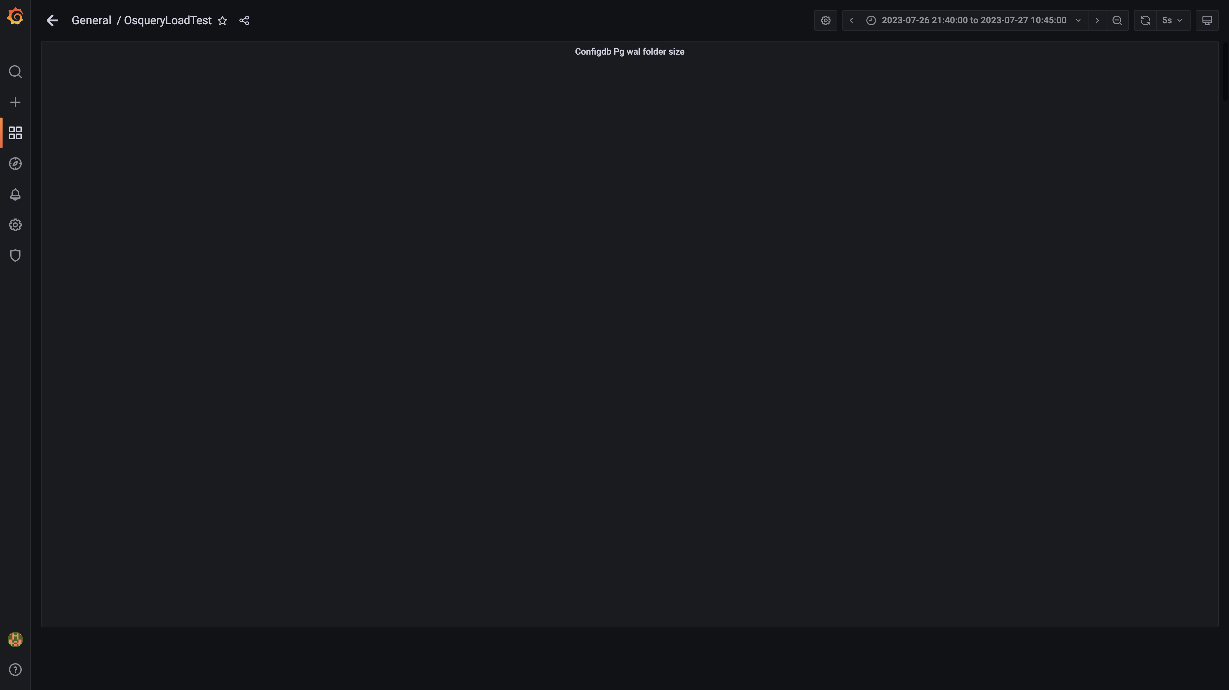

### Configdb number of wal files

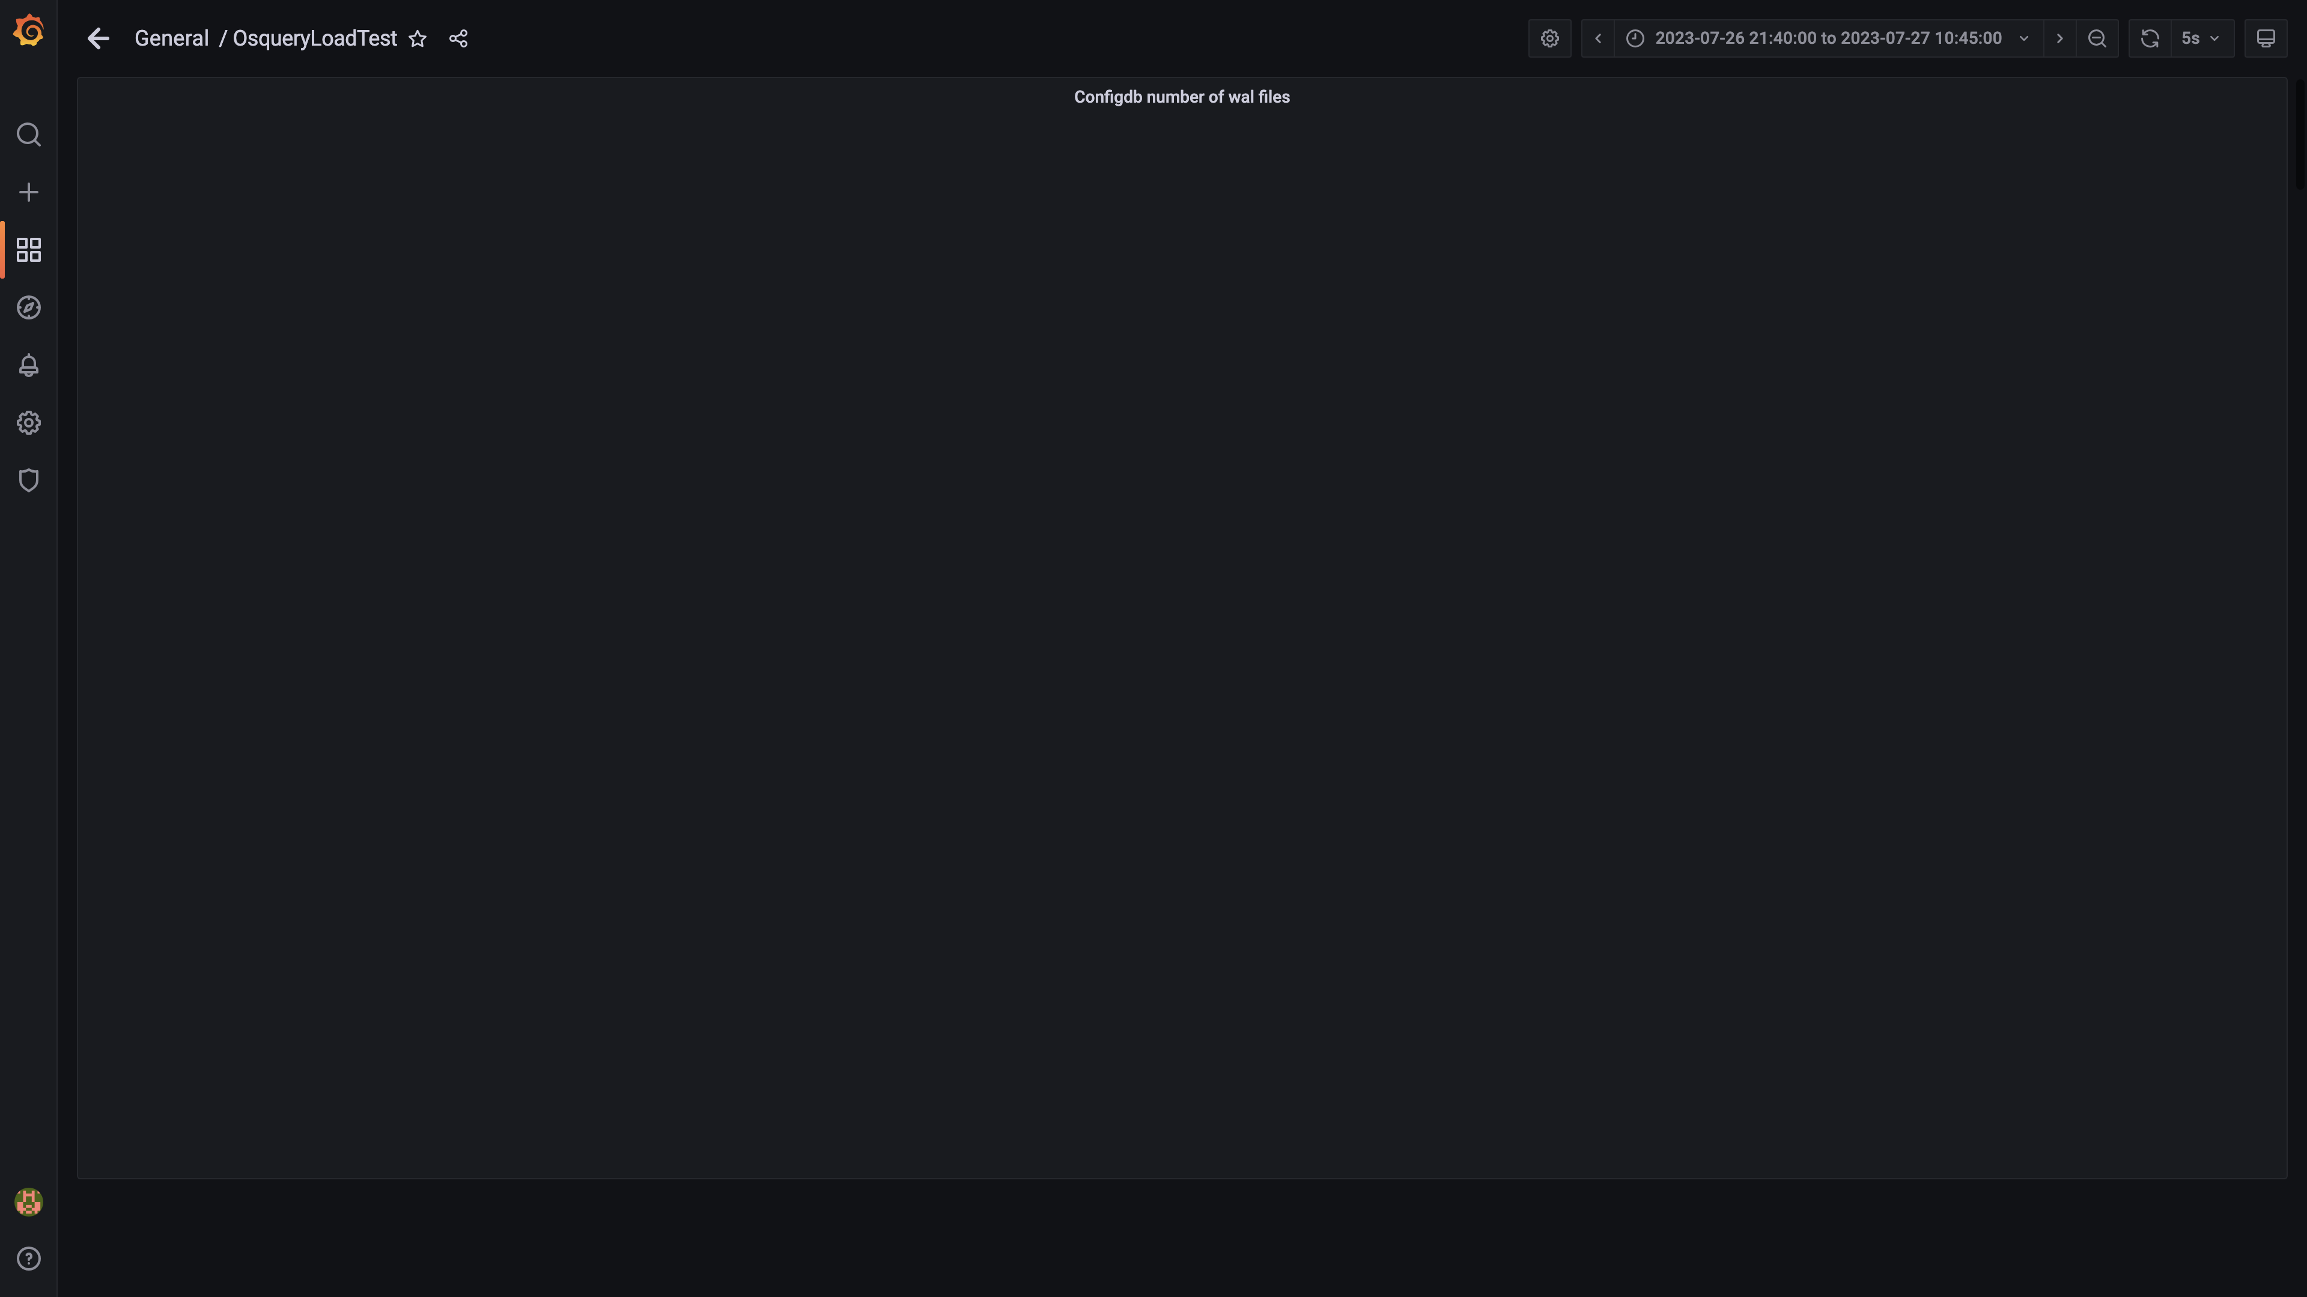

### Top 10 redis client connections by app

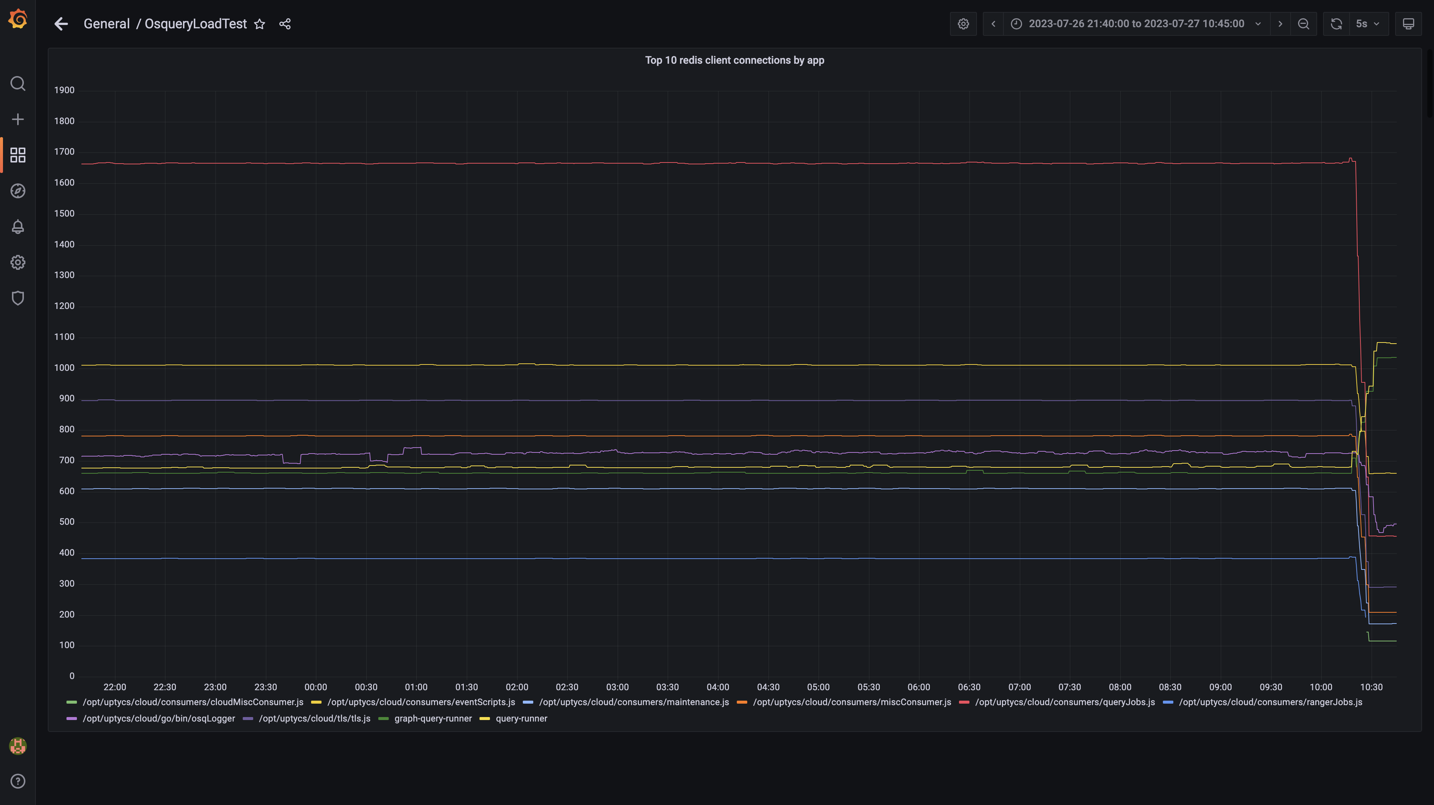

### Configdb folder size

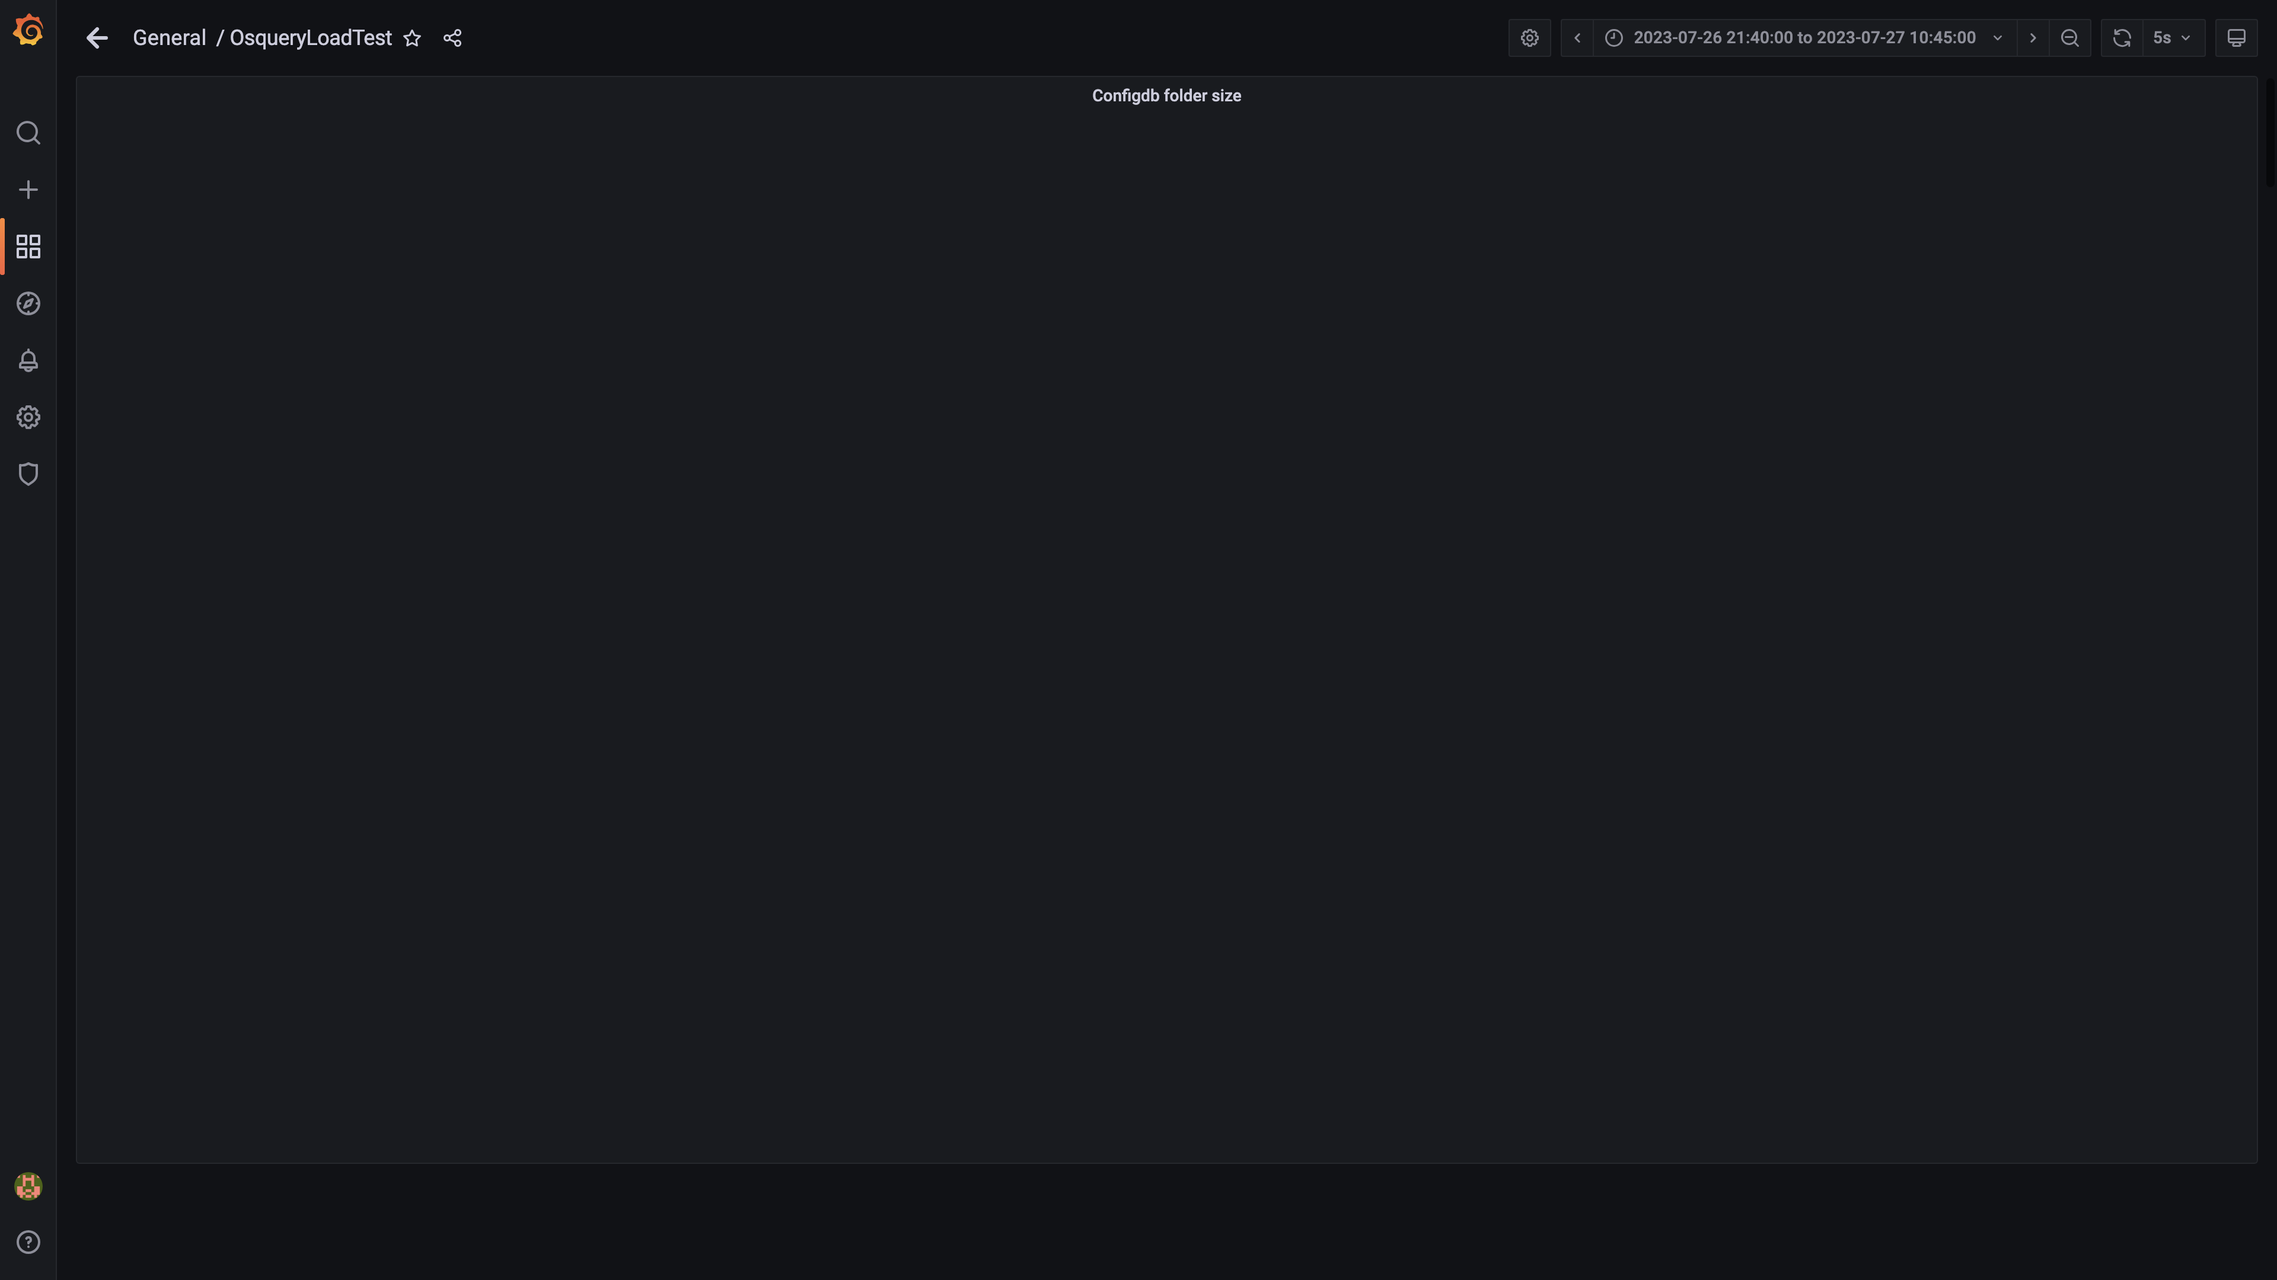

### Cpu and memory usages

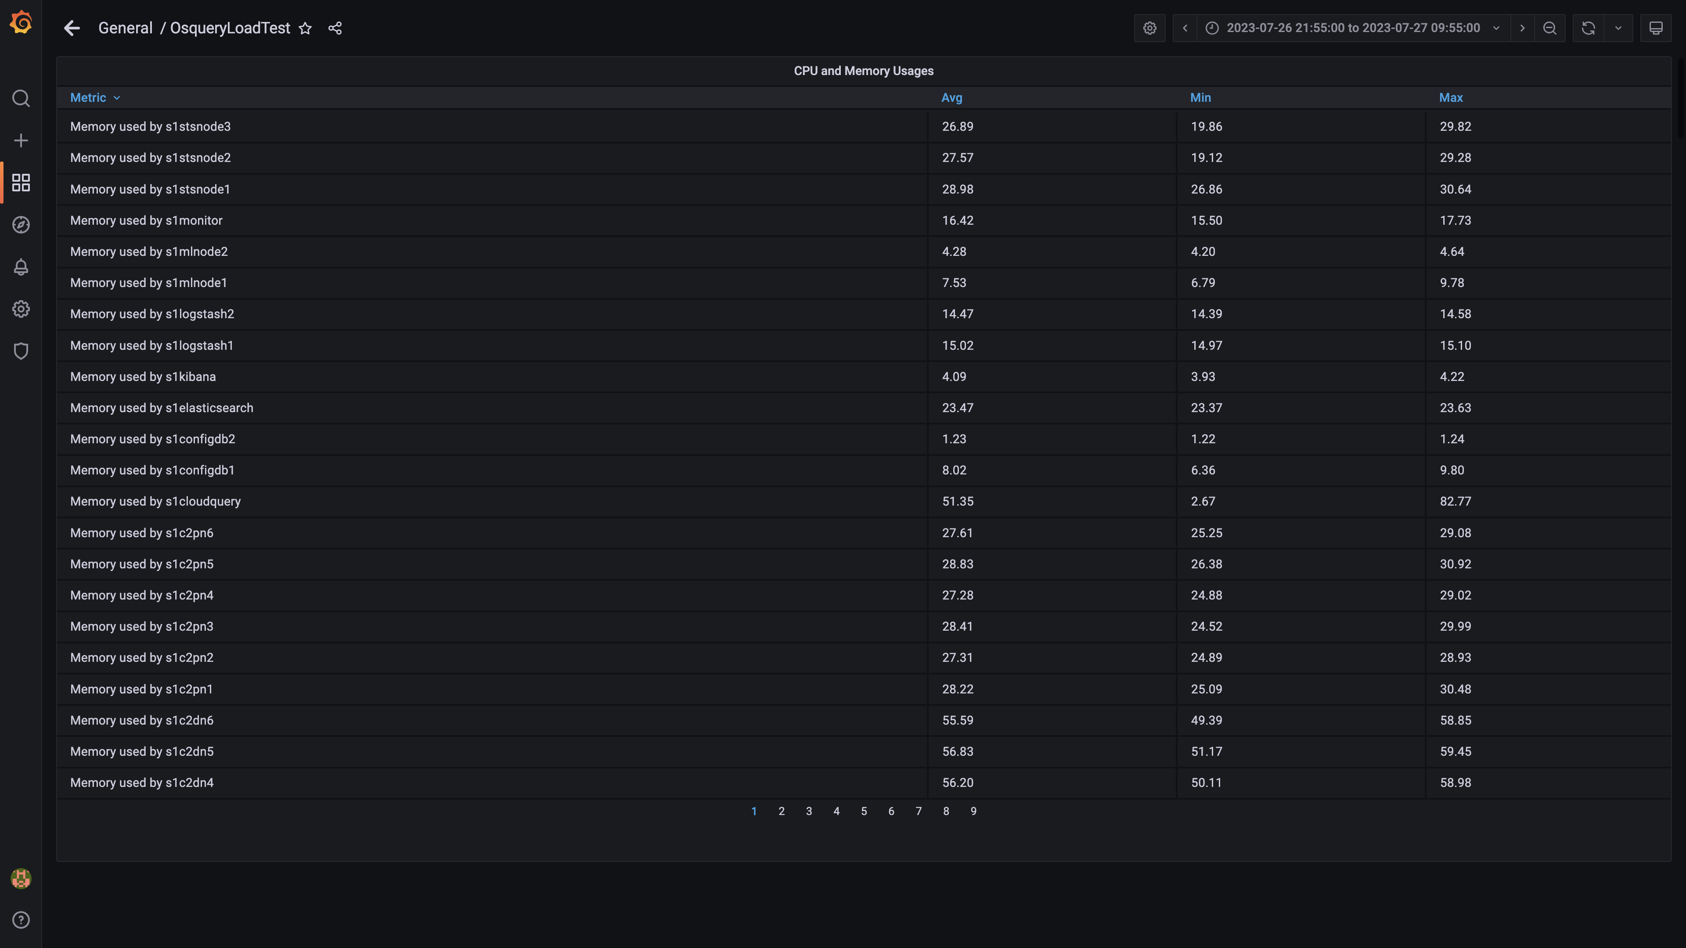

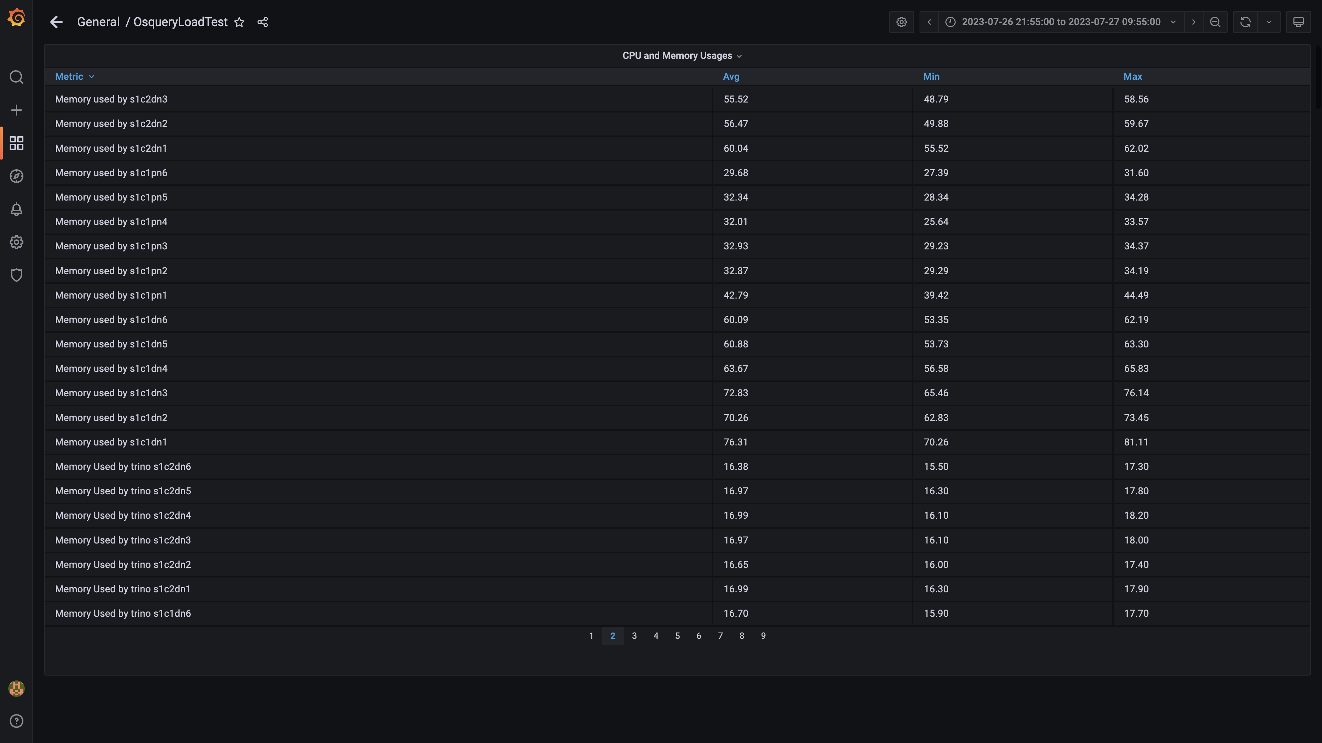

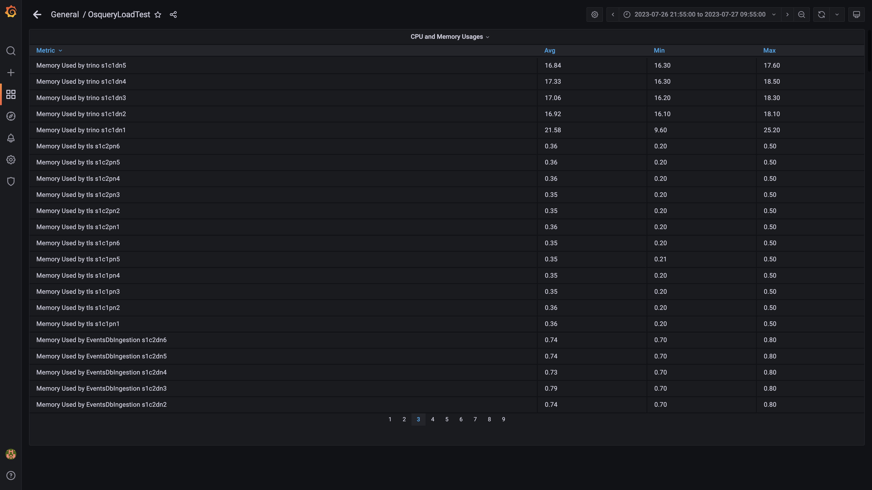

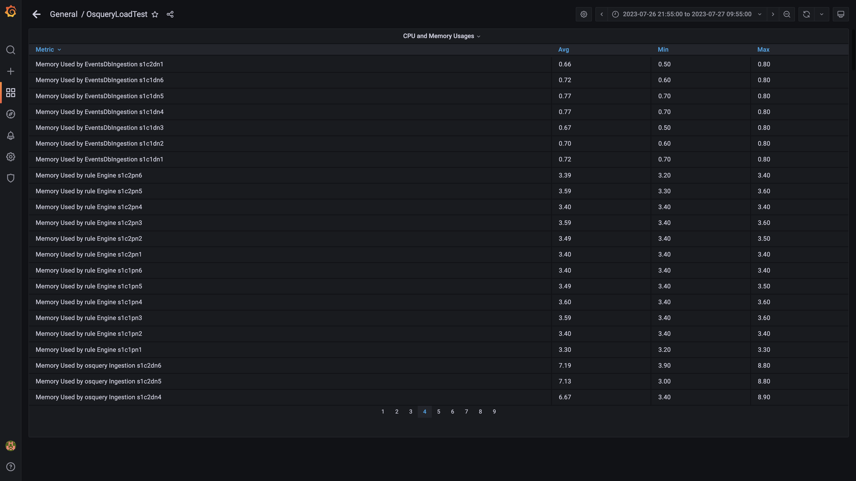

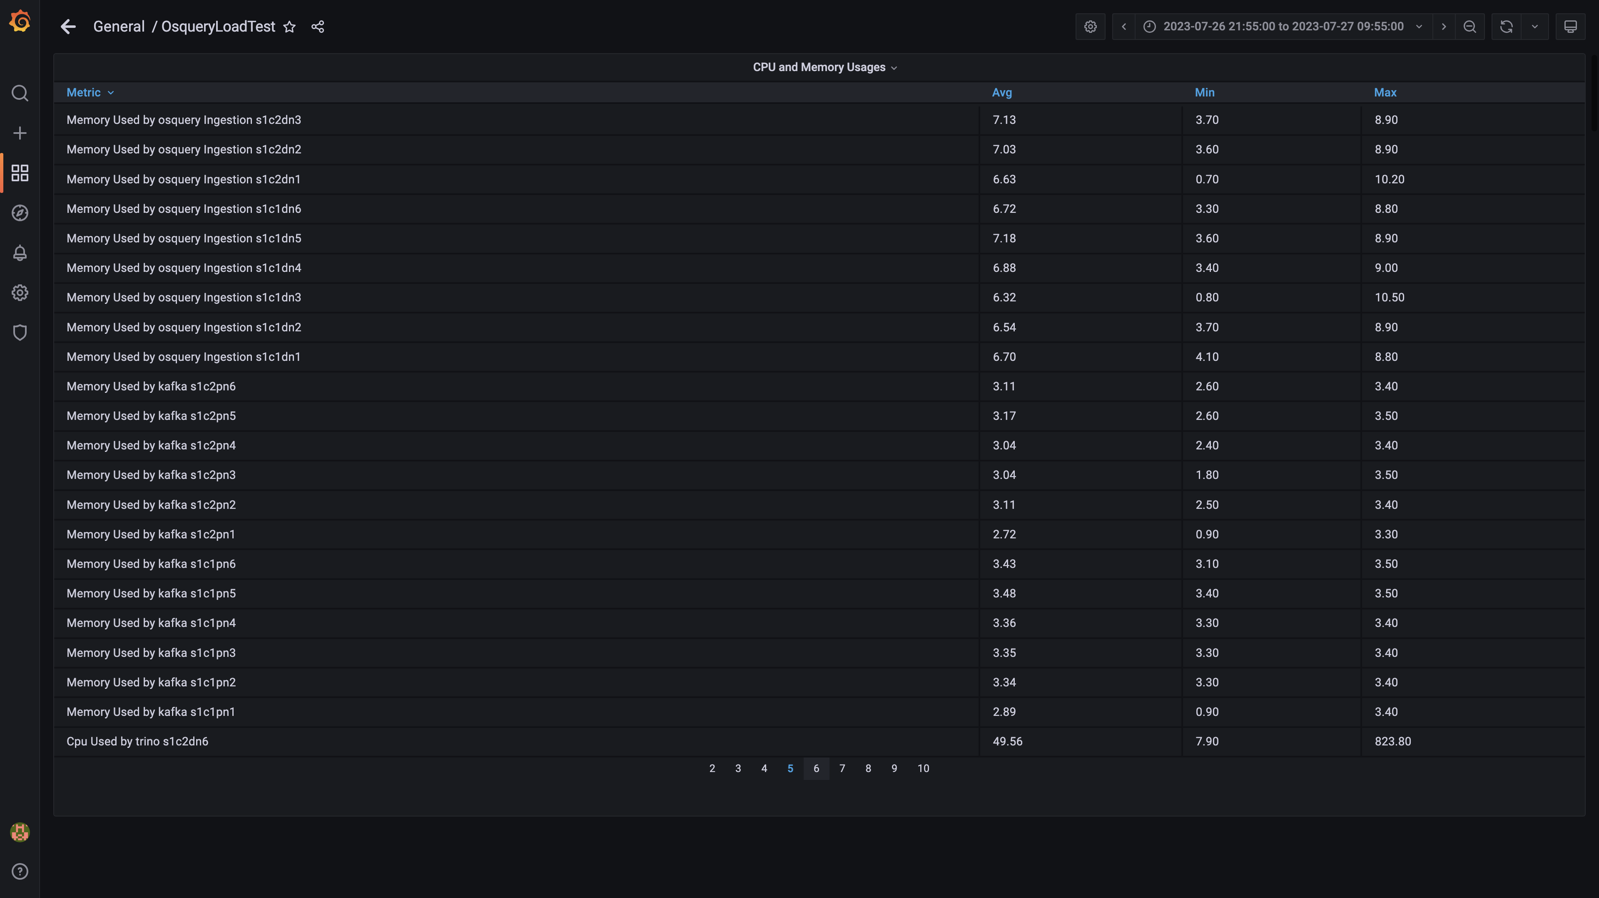

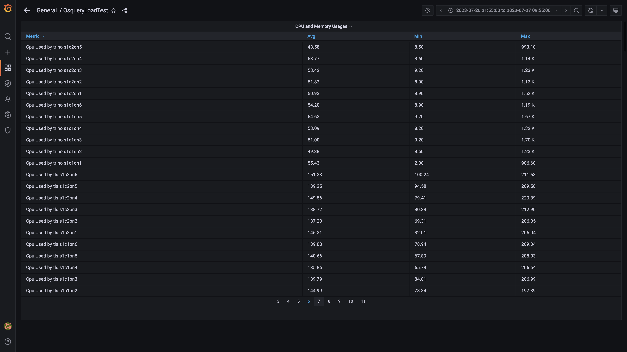

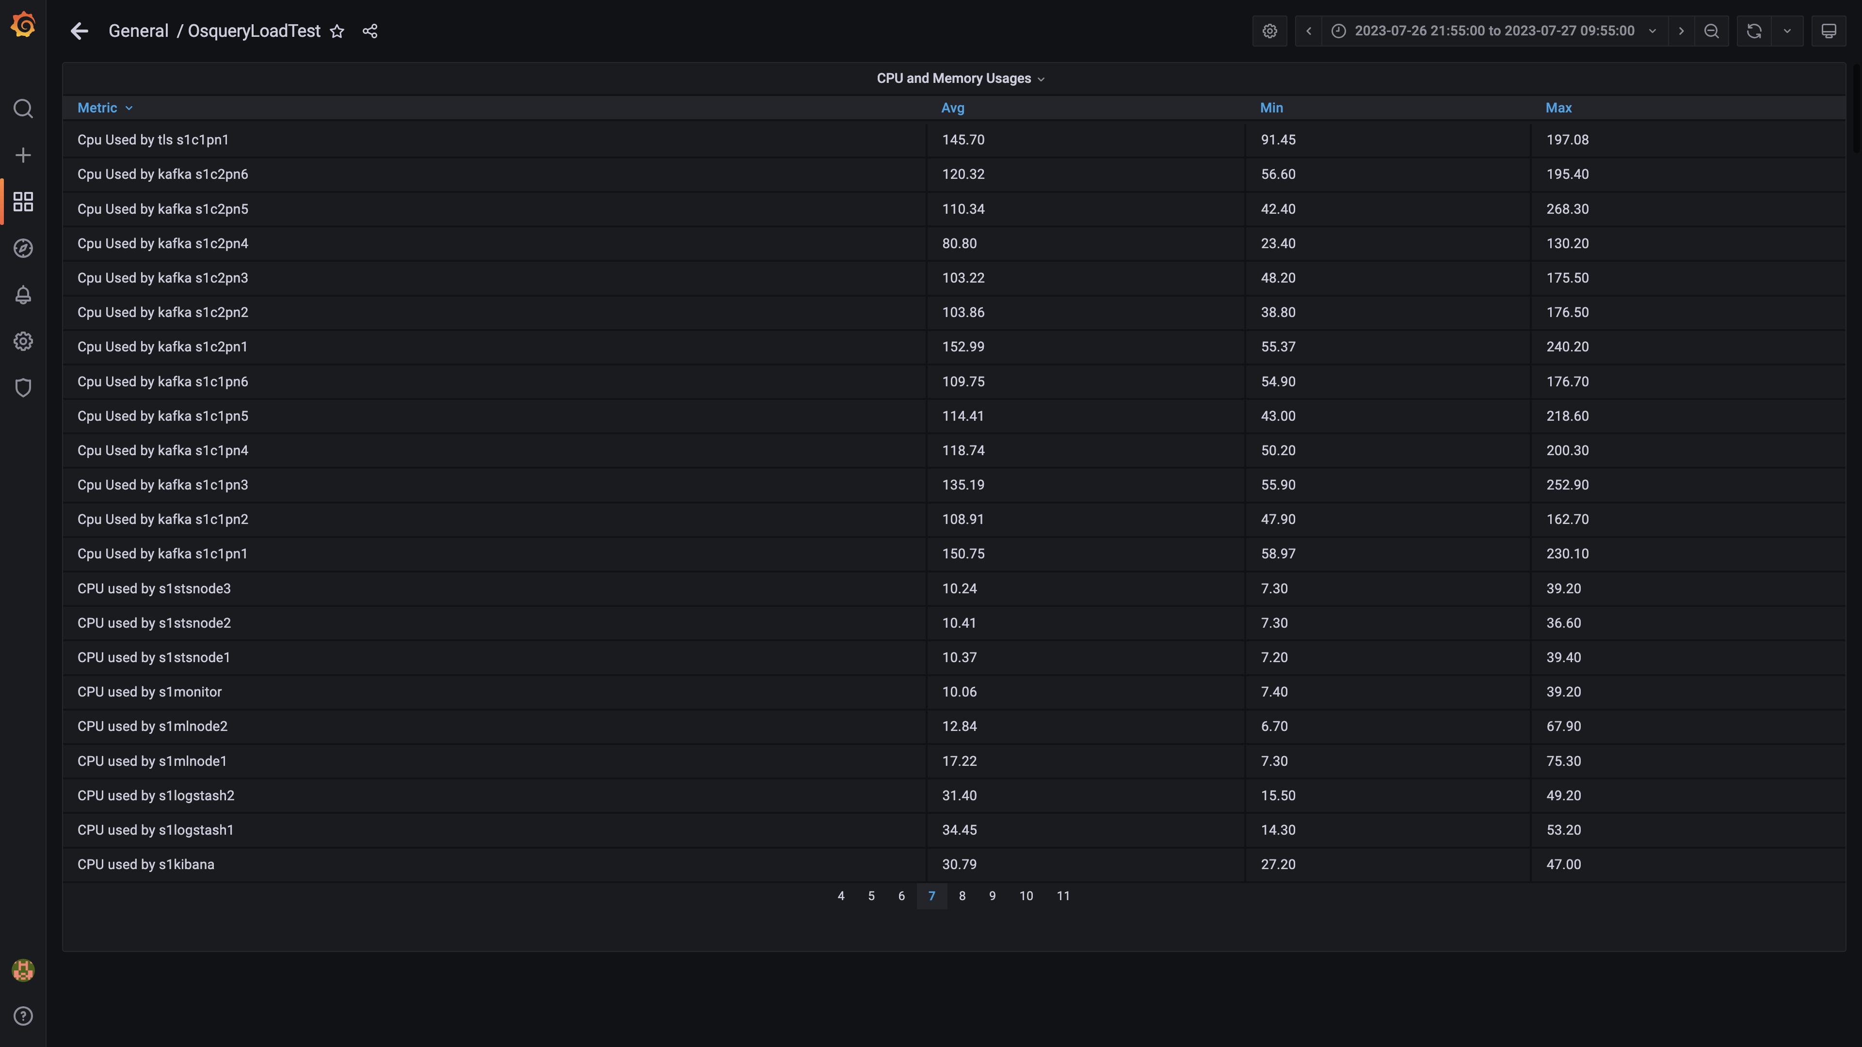

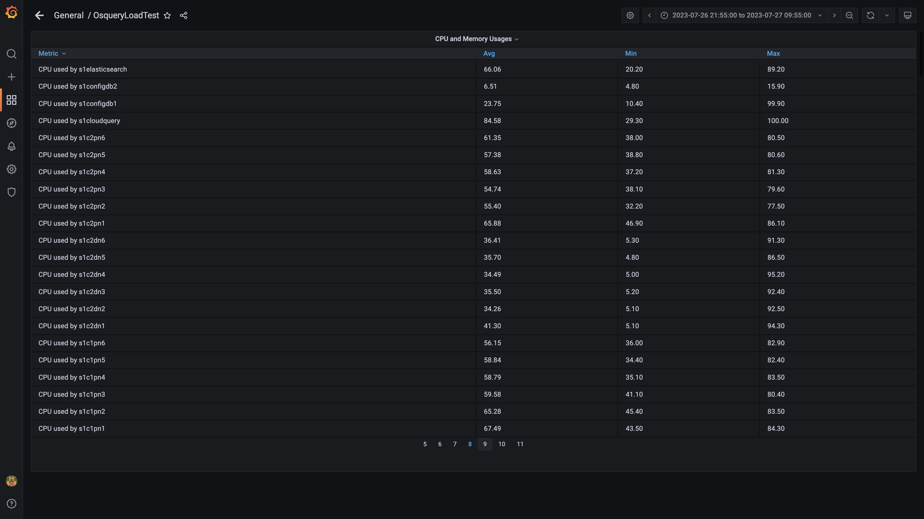

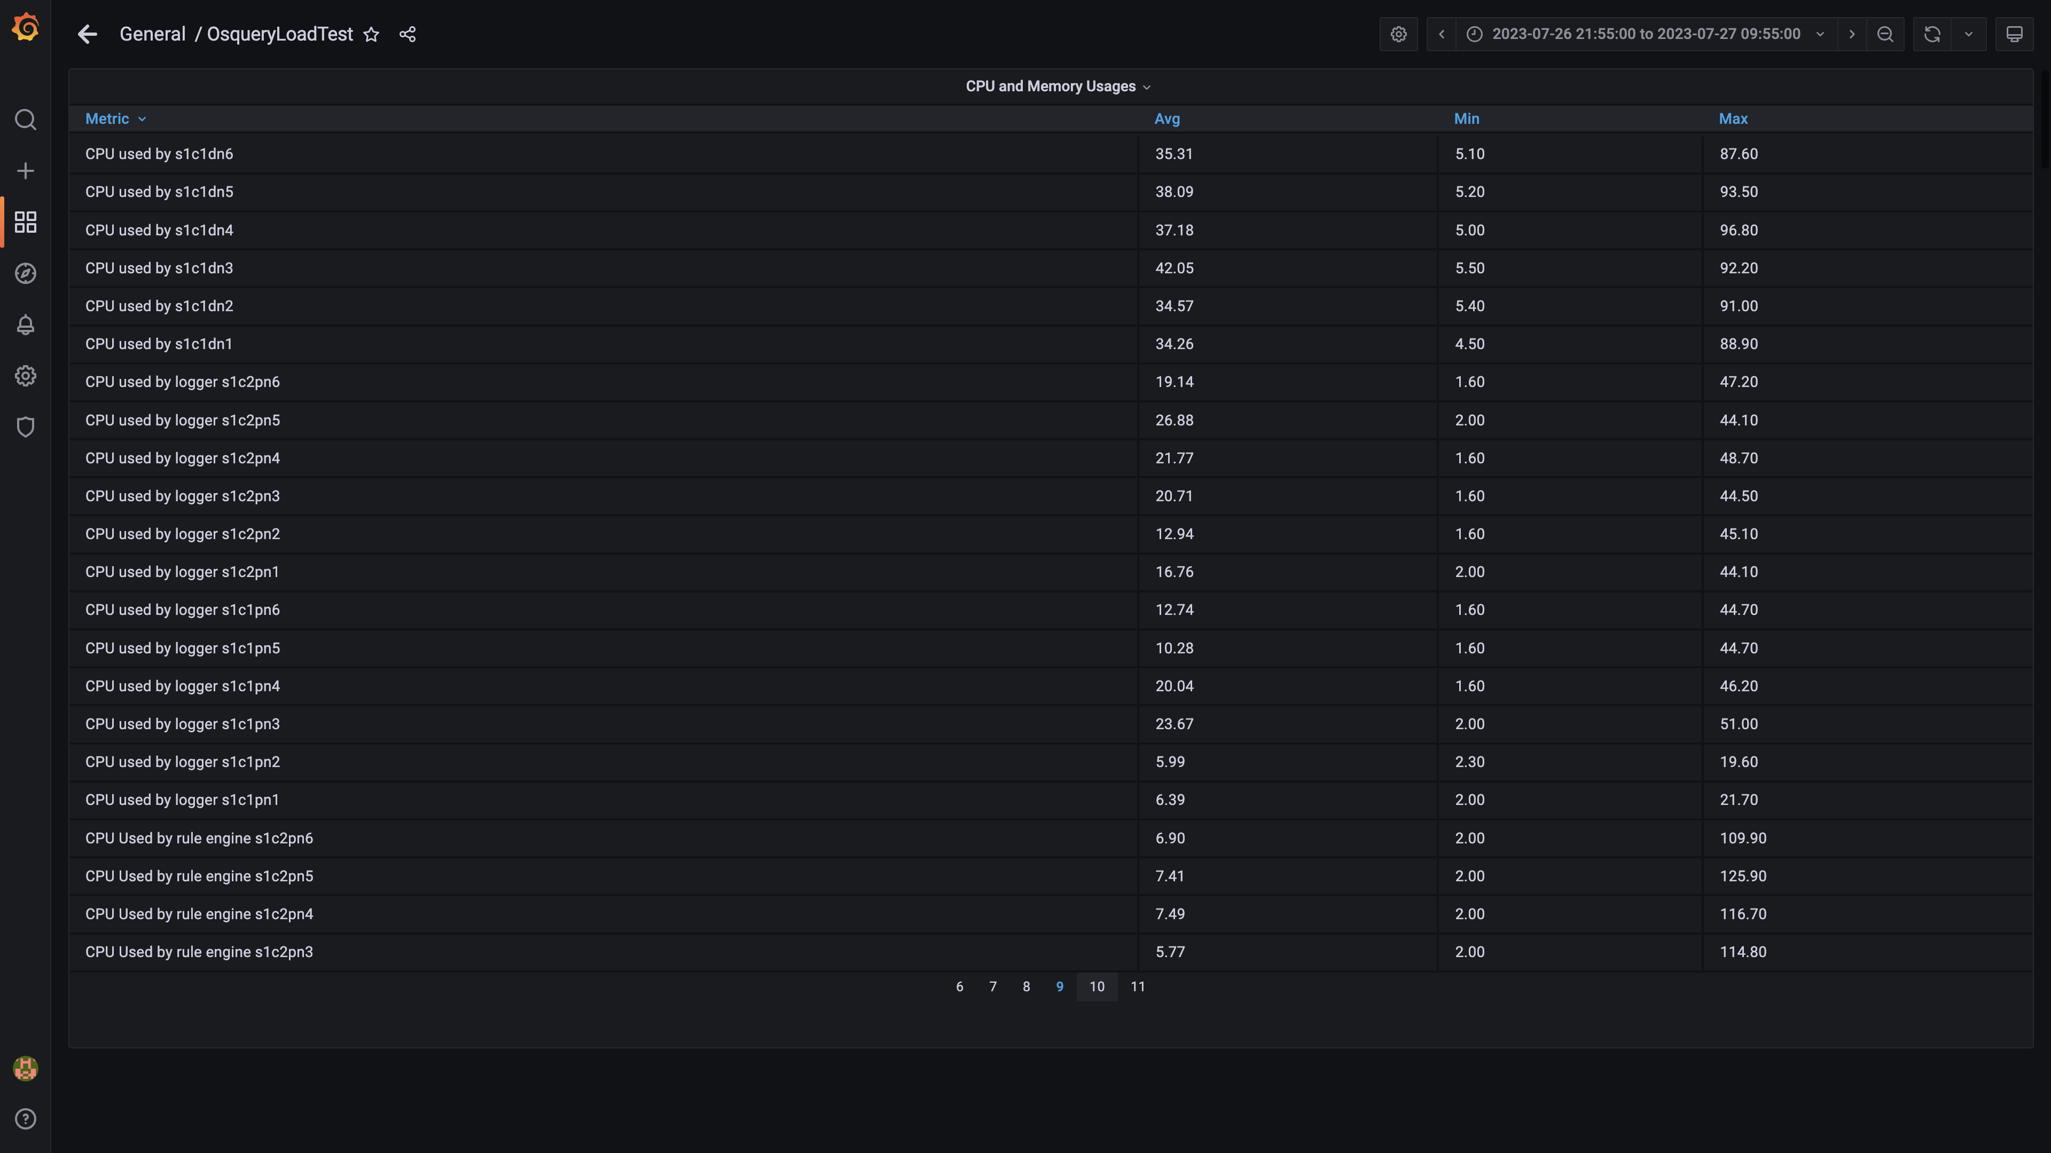

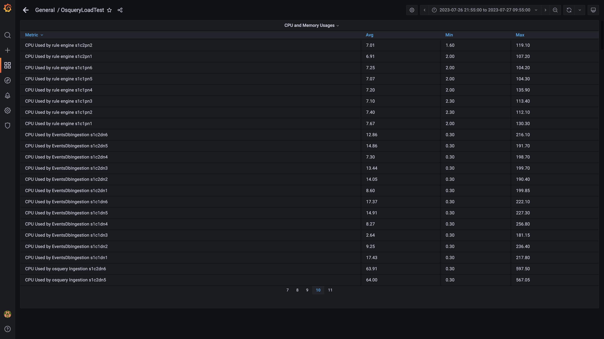

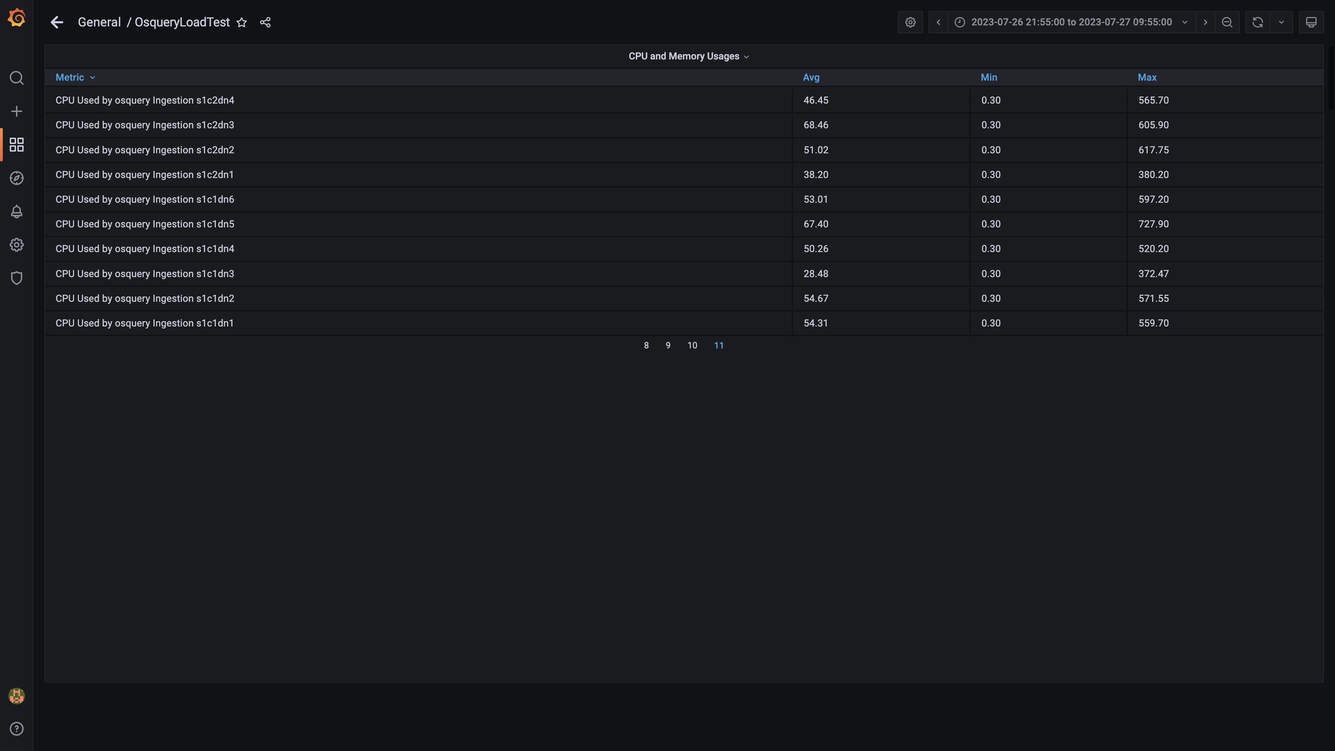

### Overall container memory and cpu usage

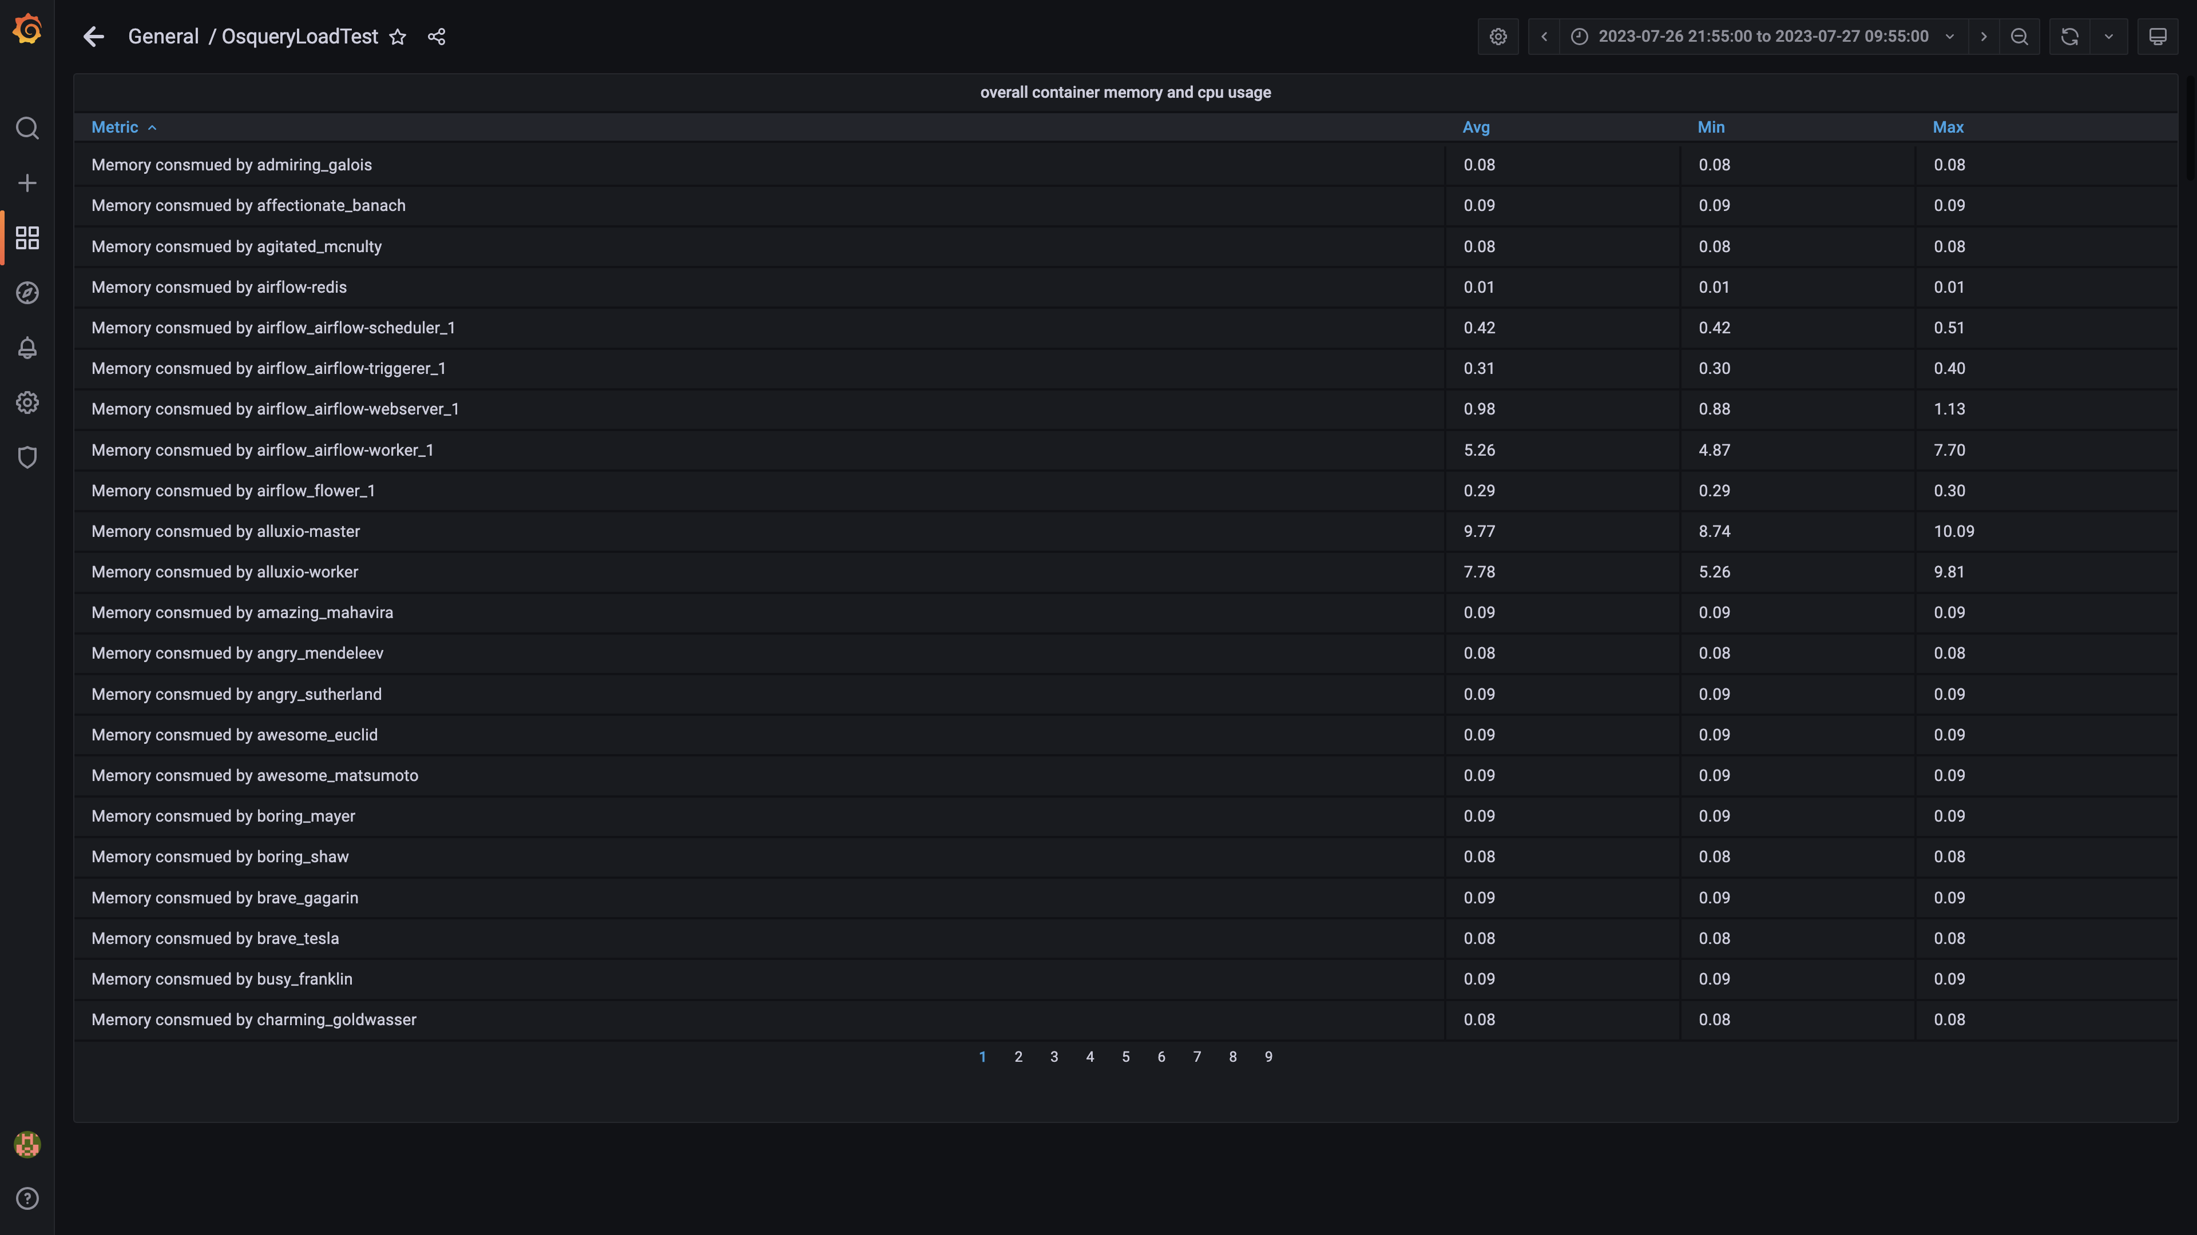

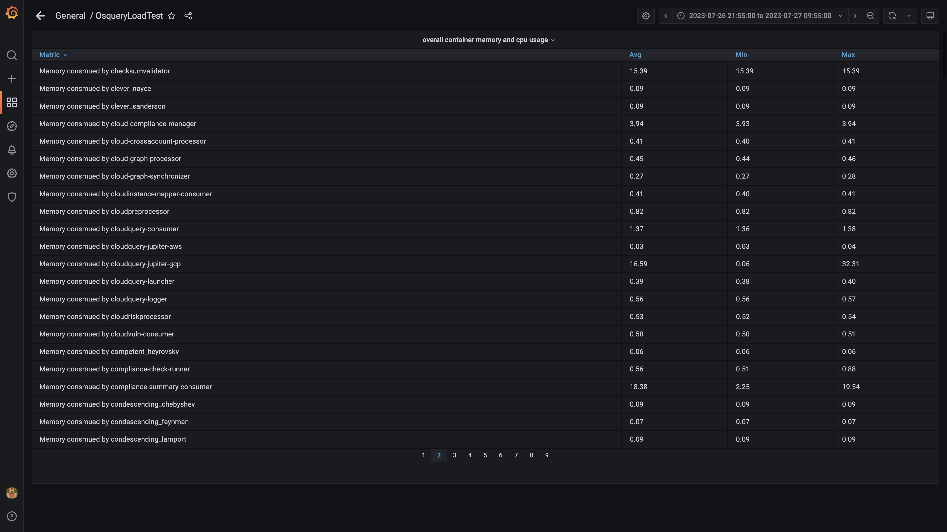

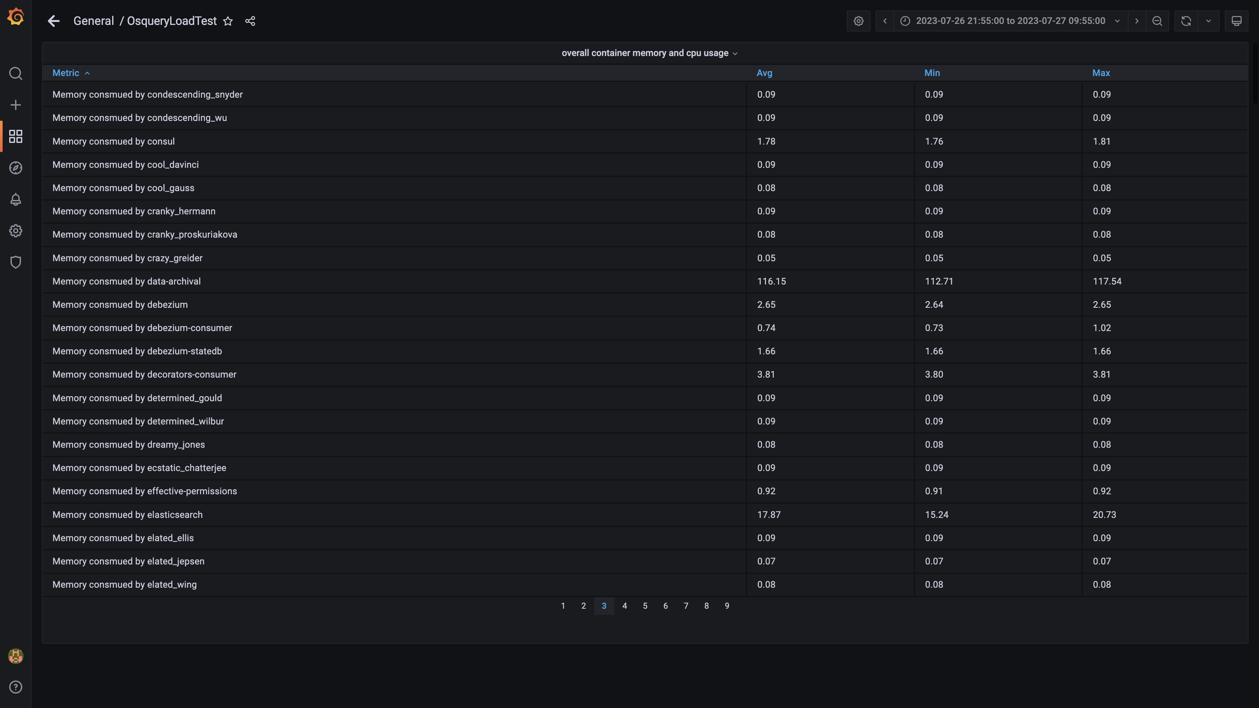

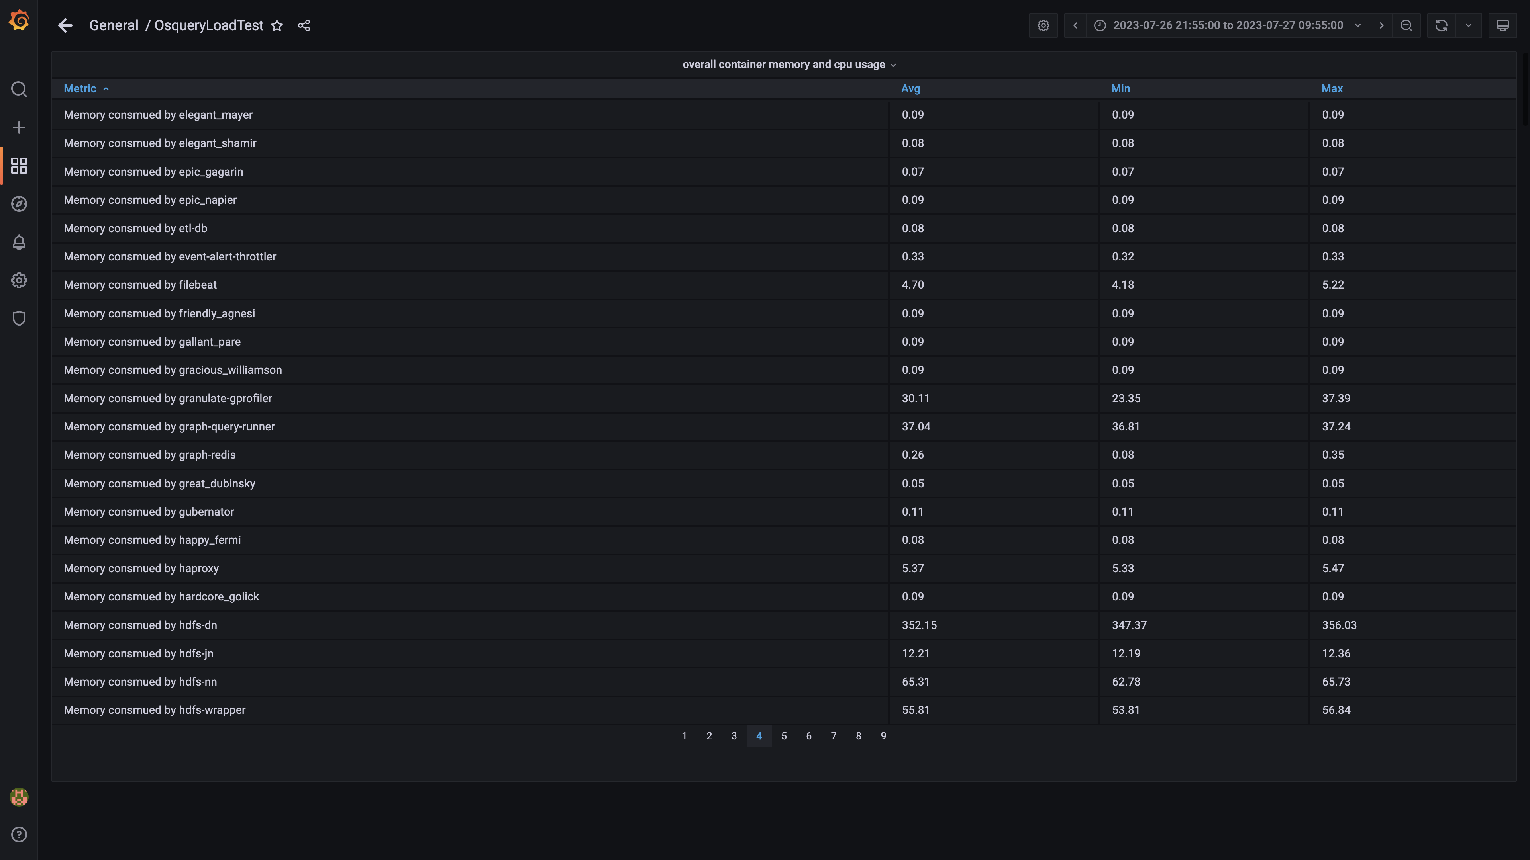

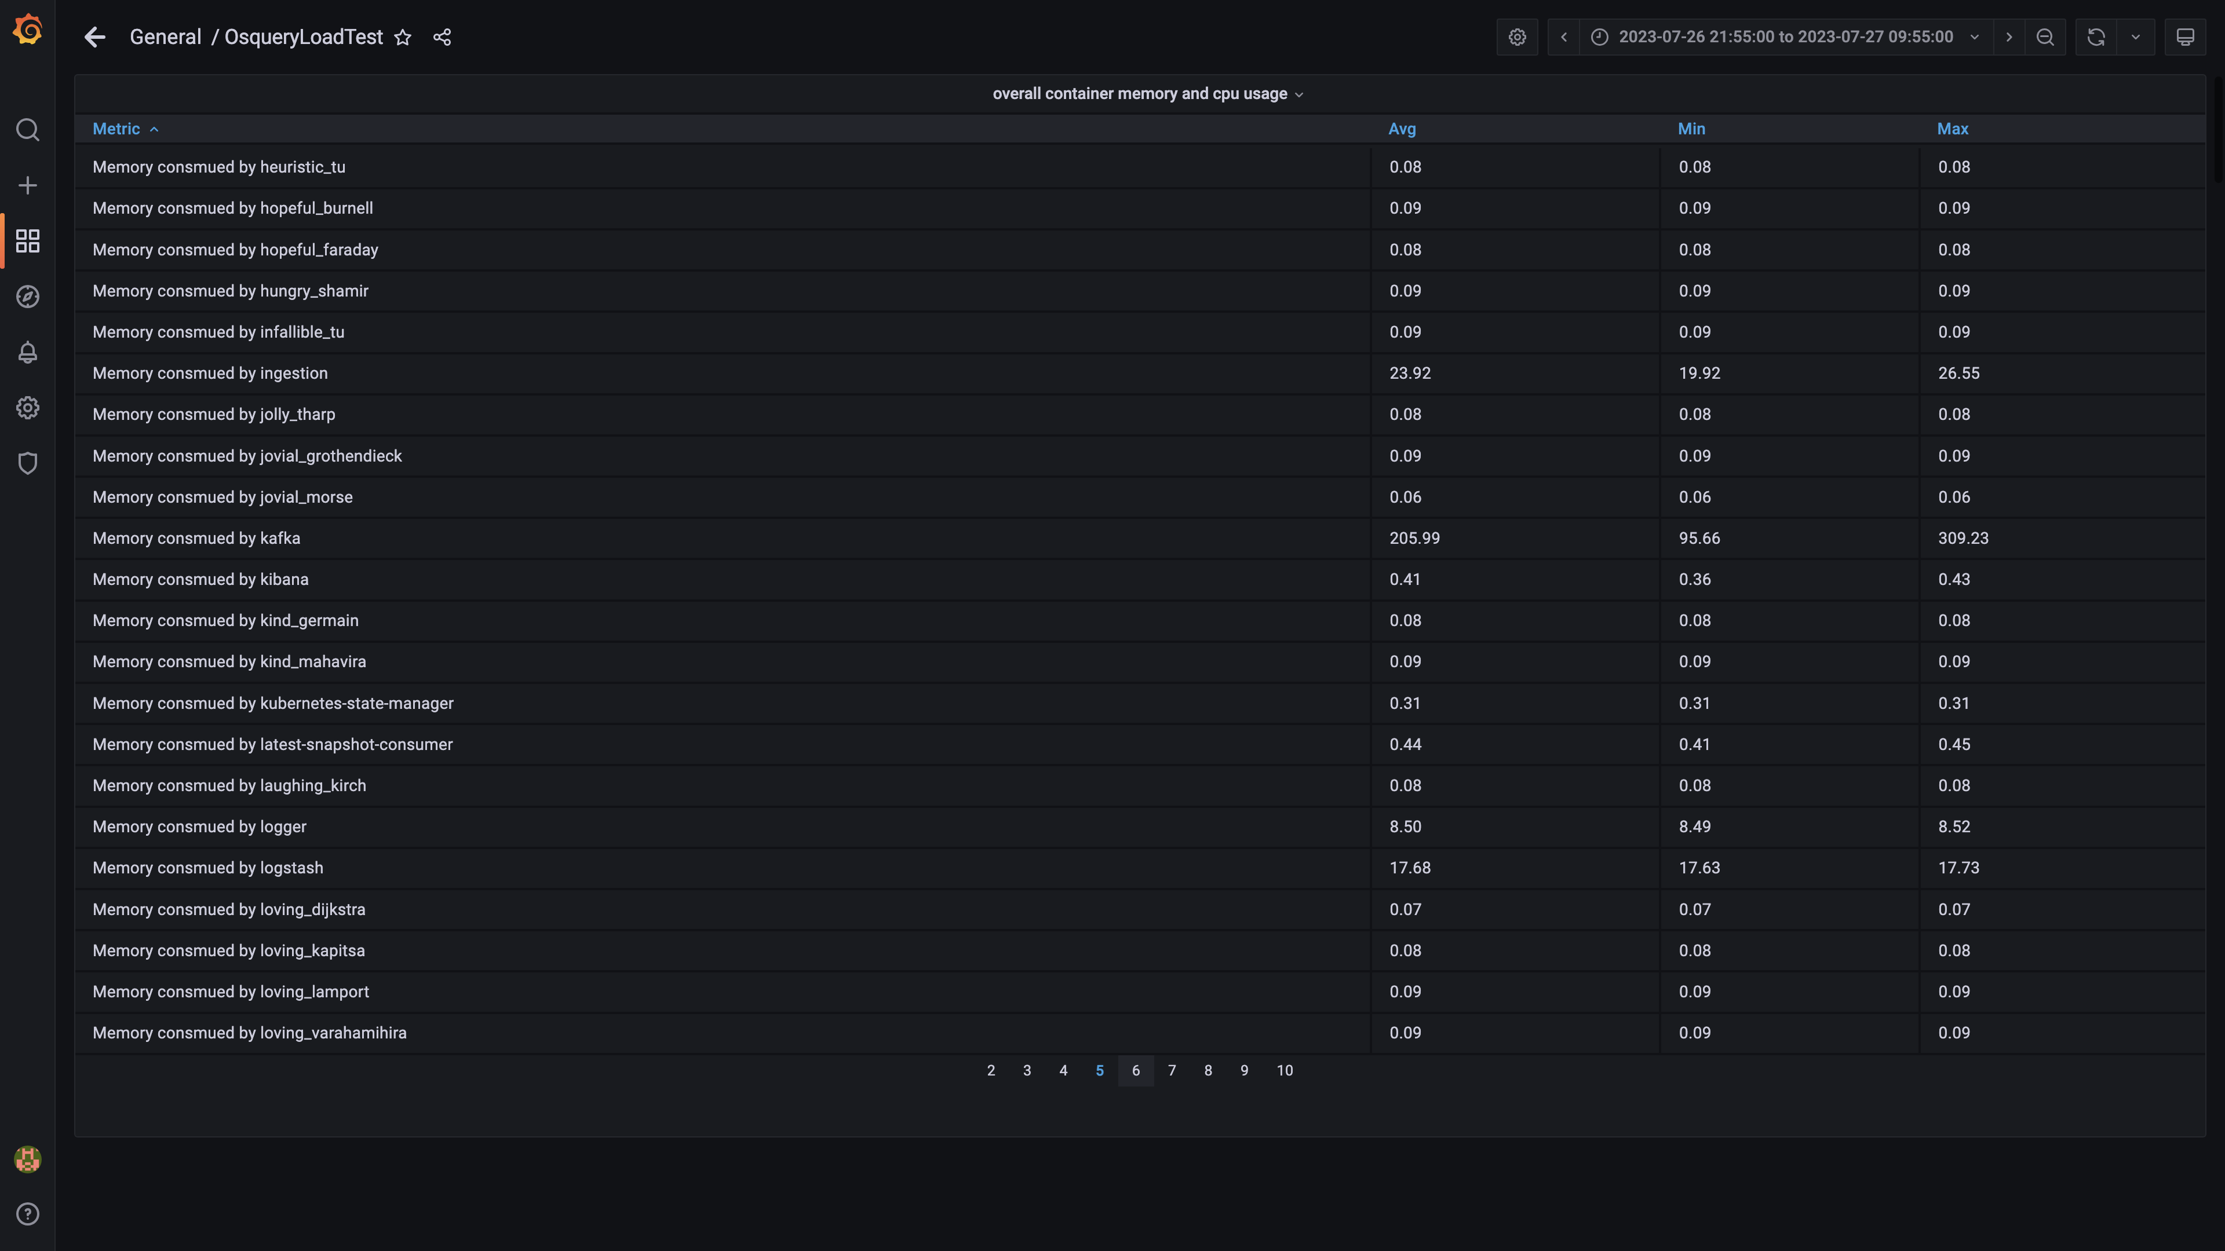

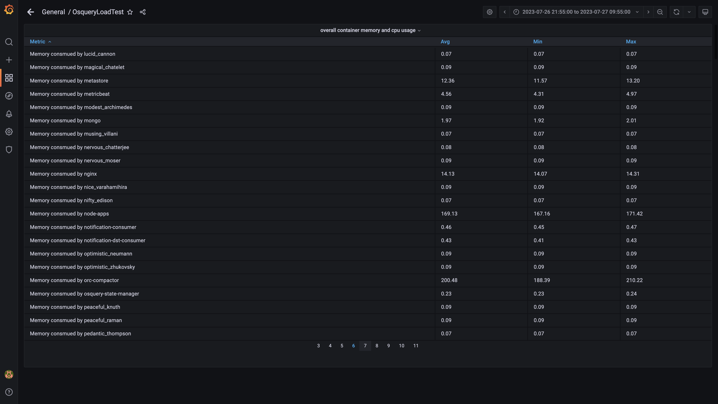

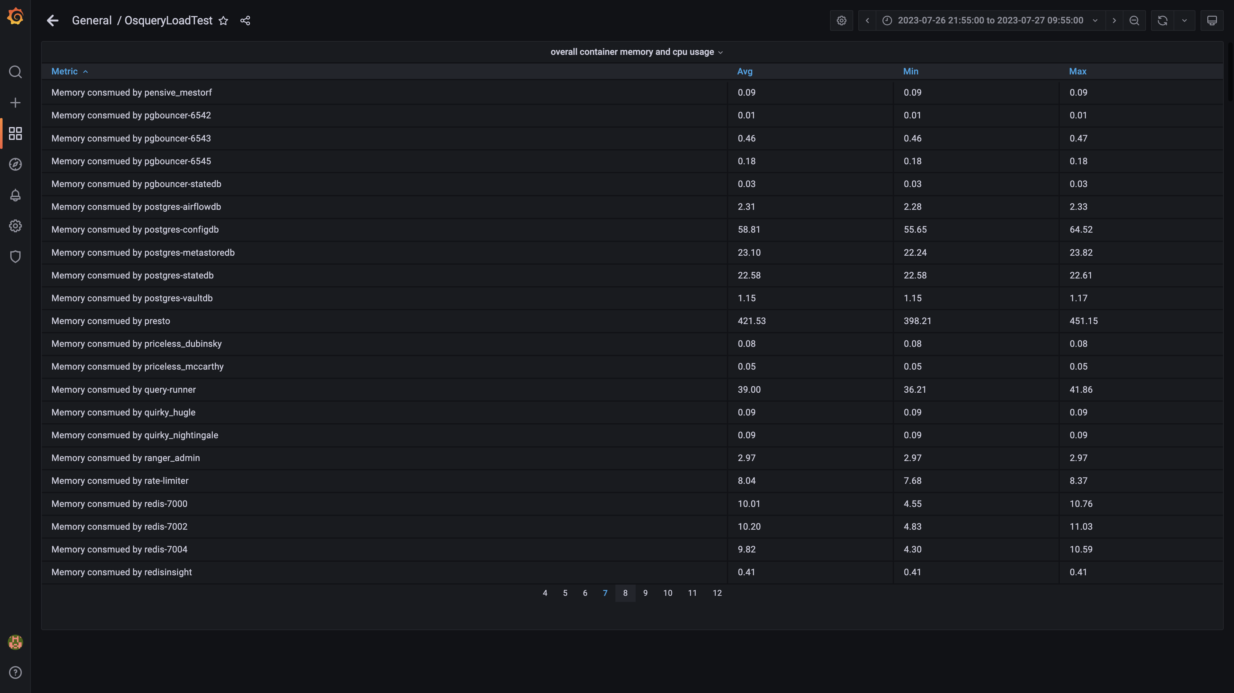

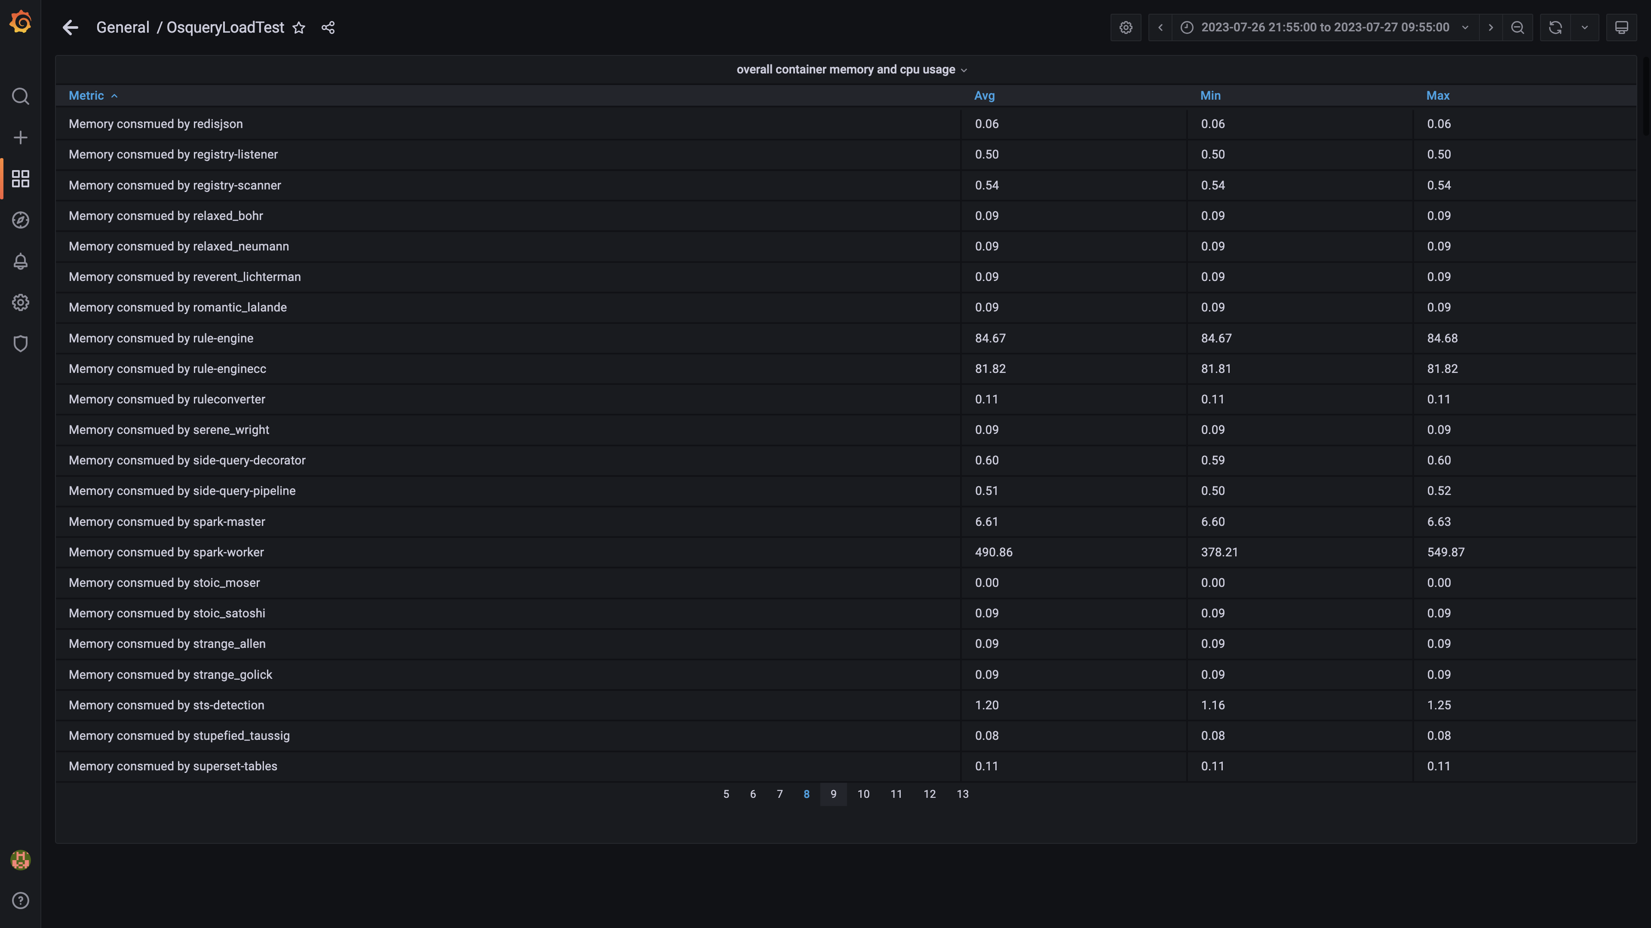

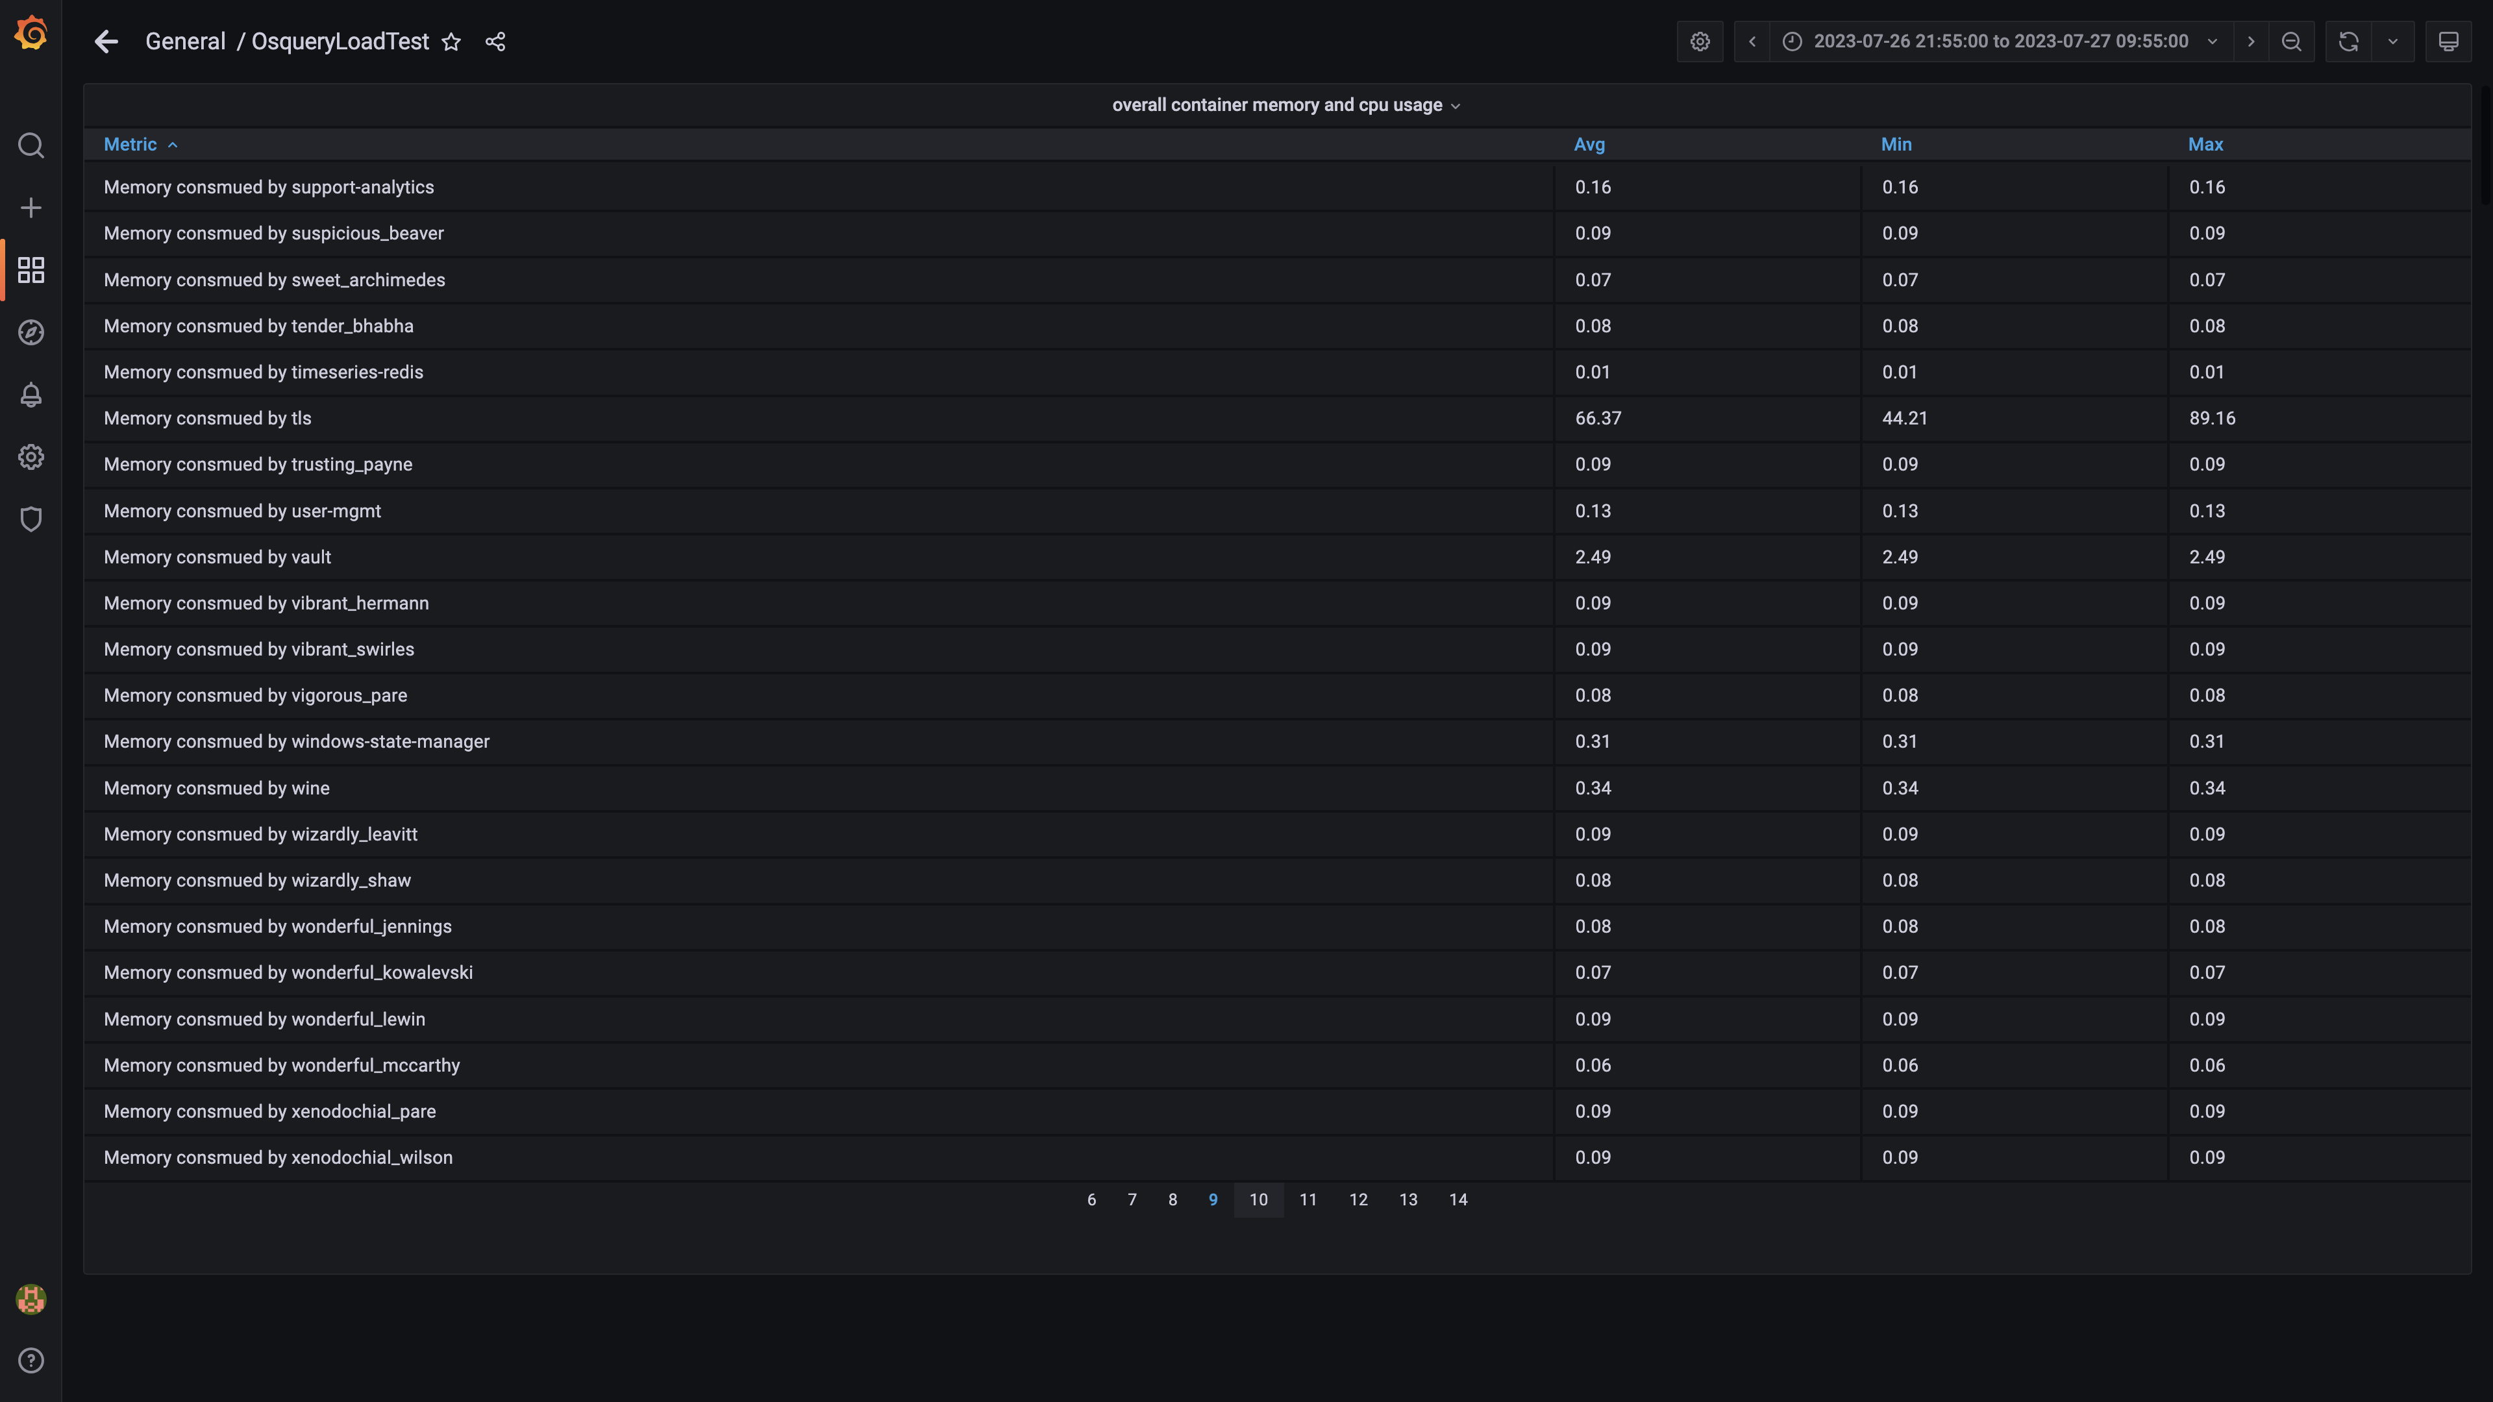

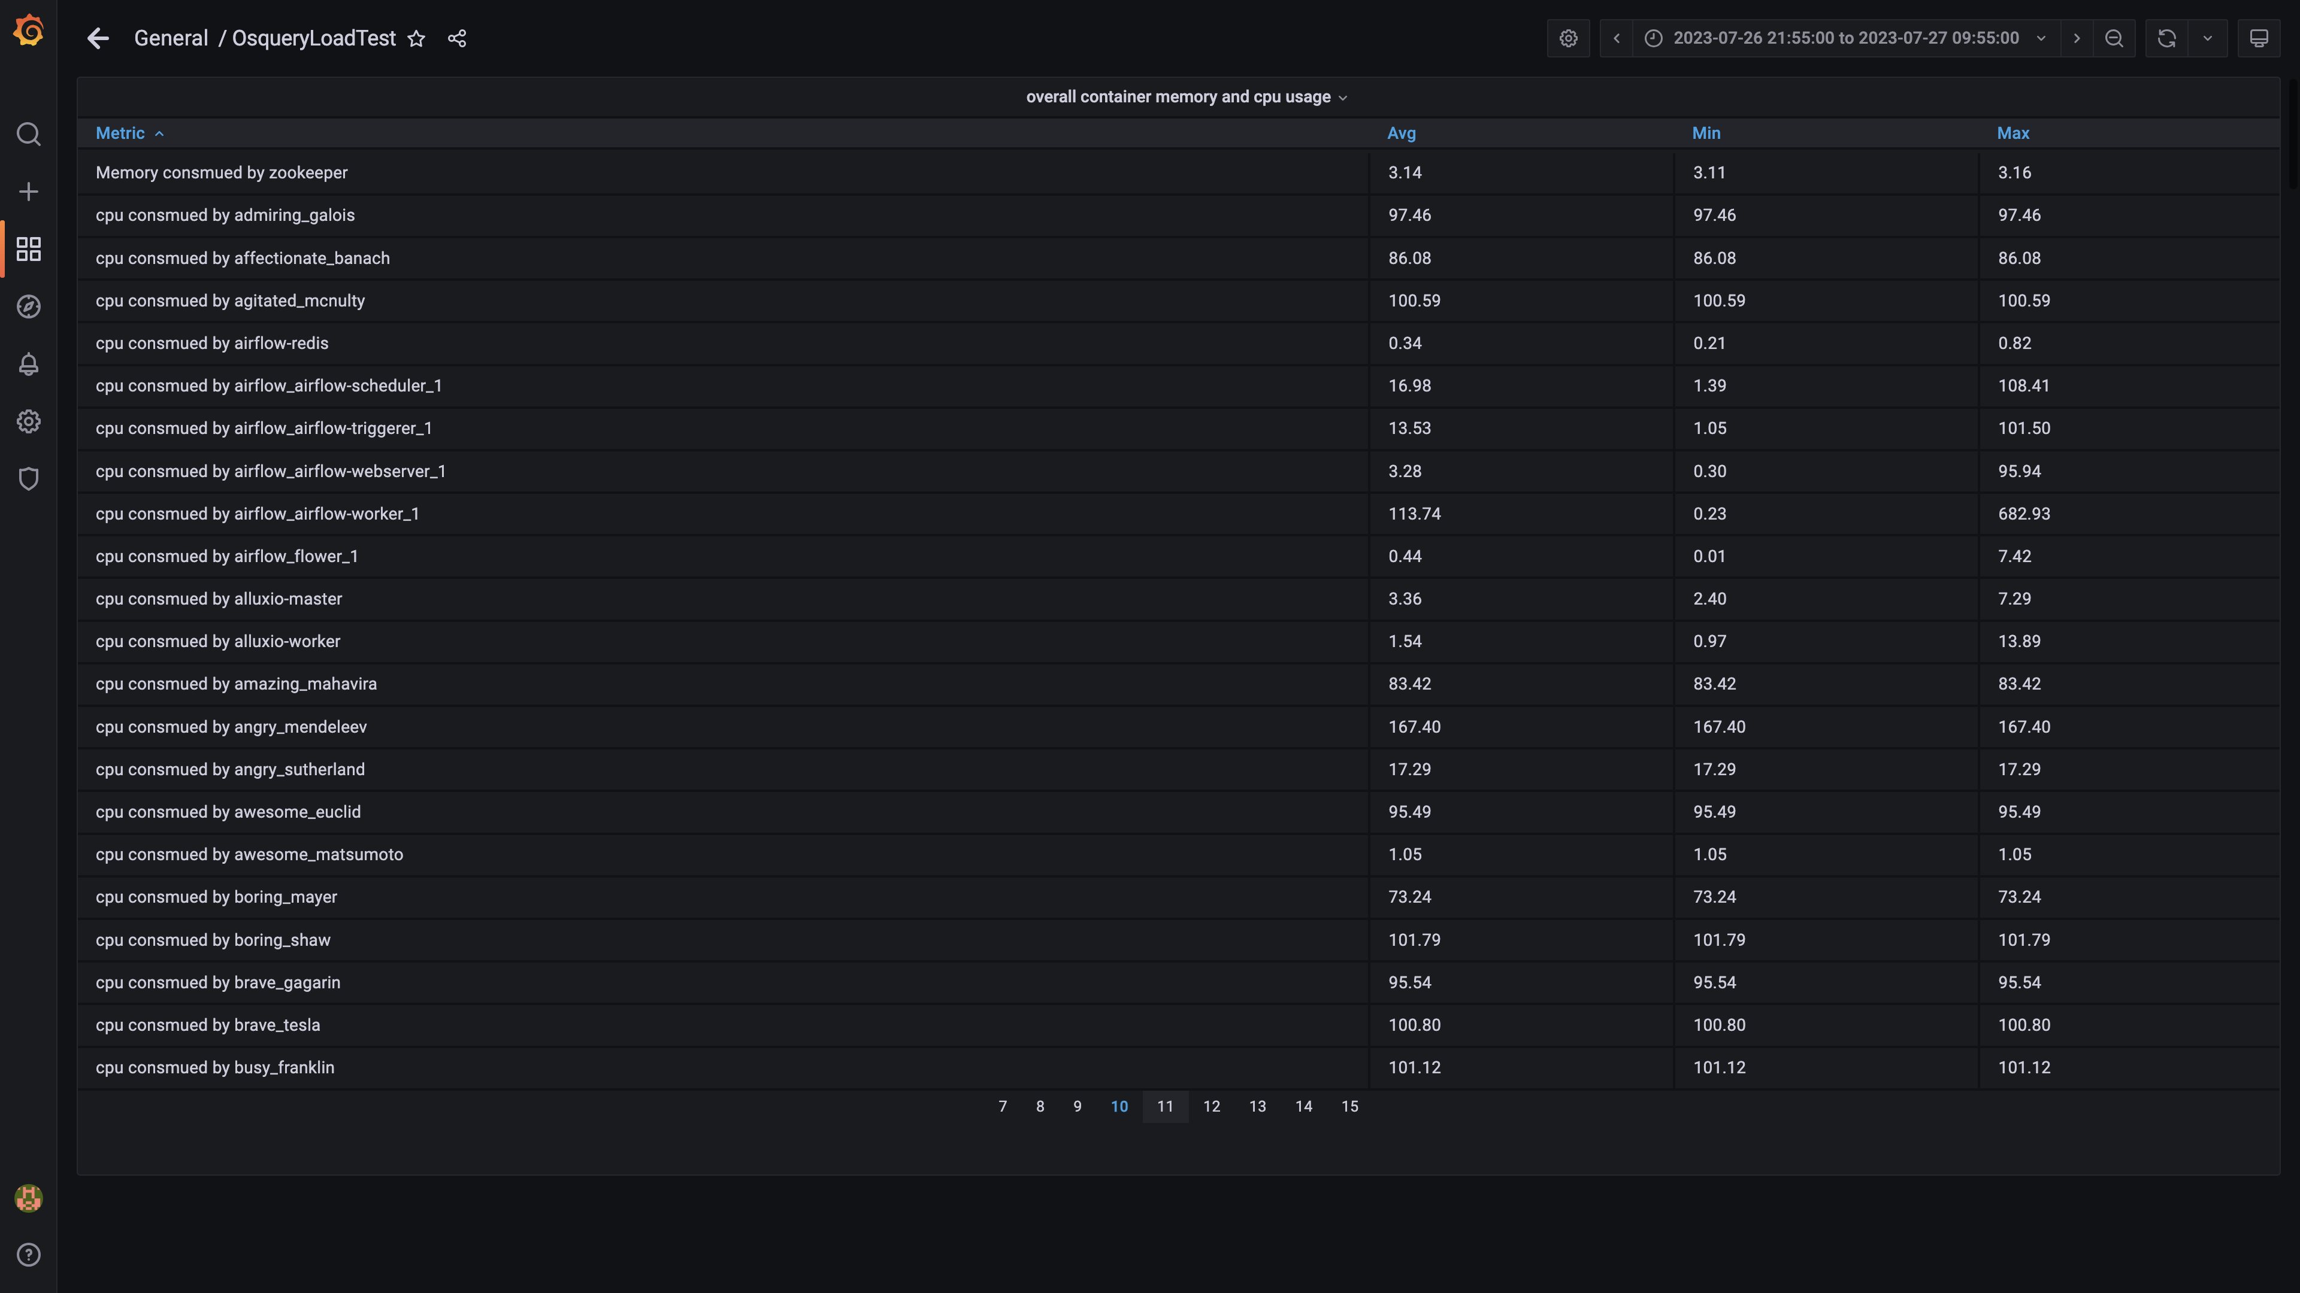

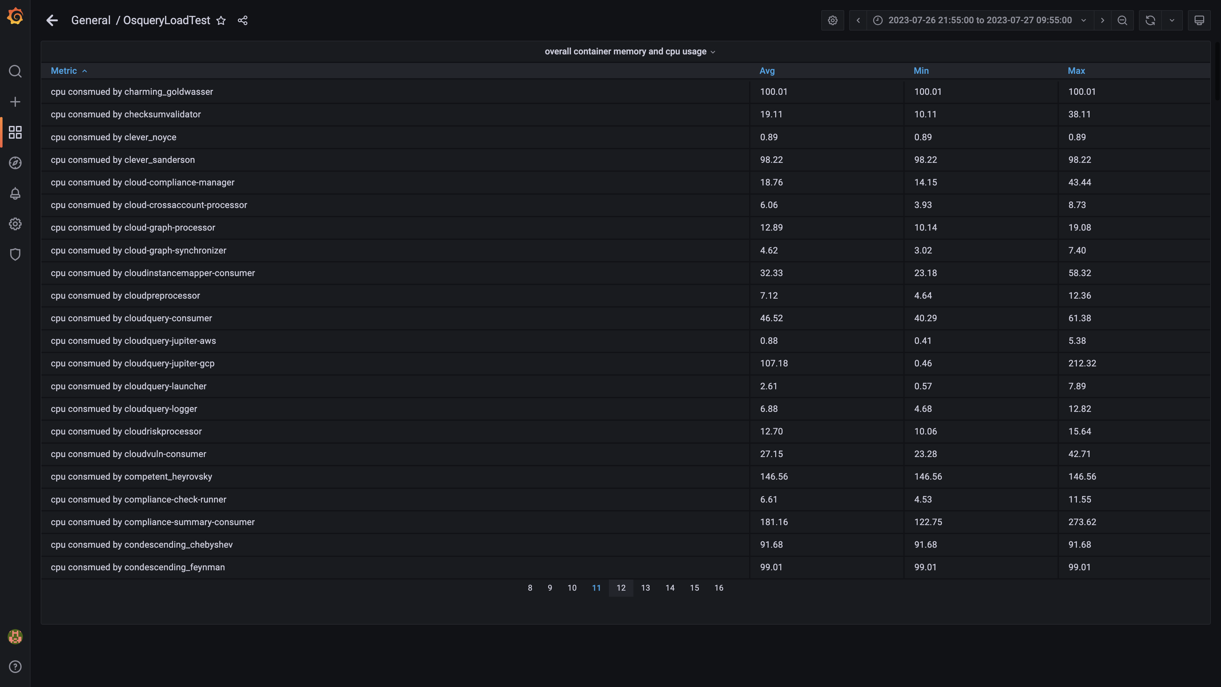

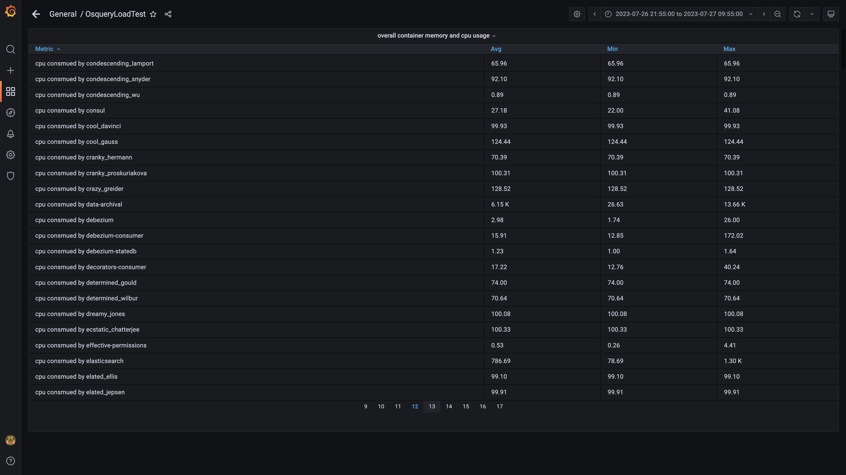

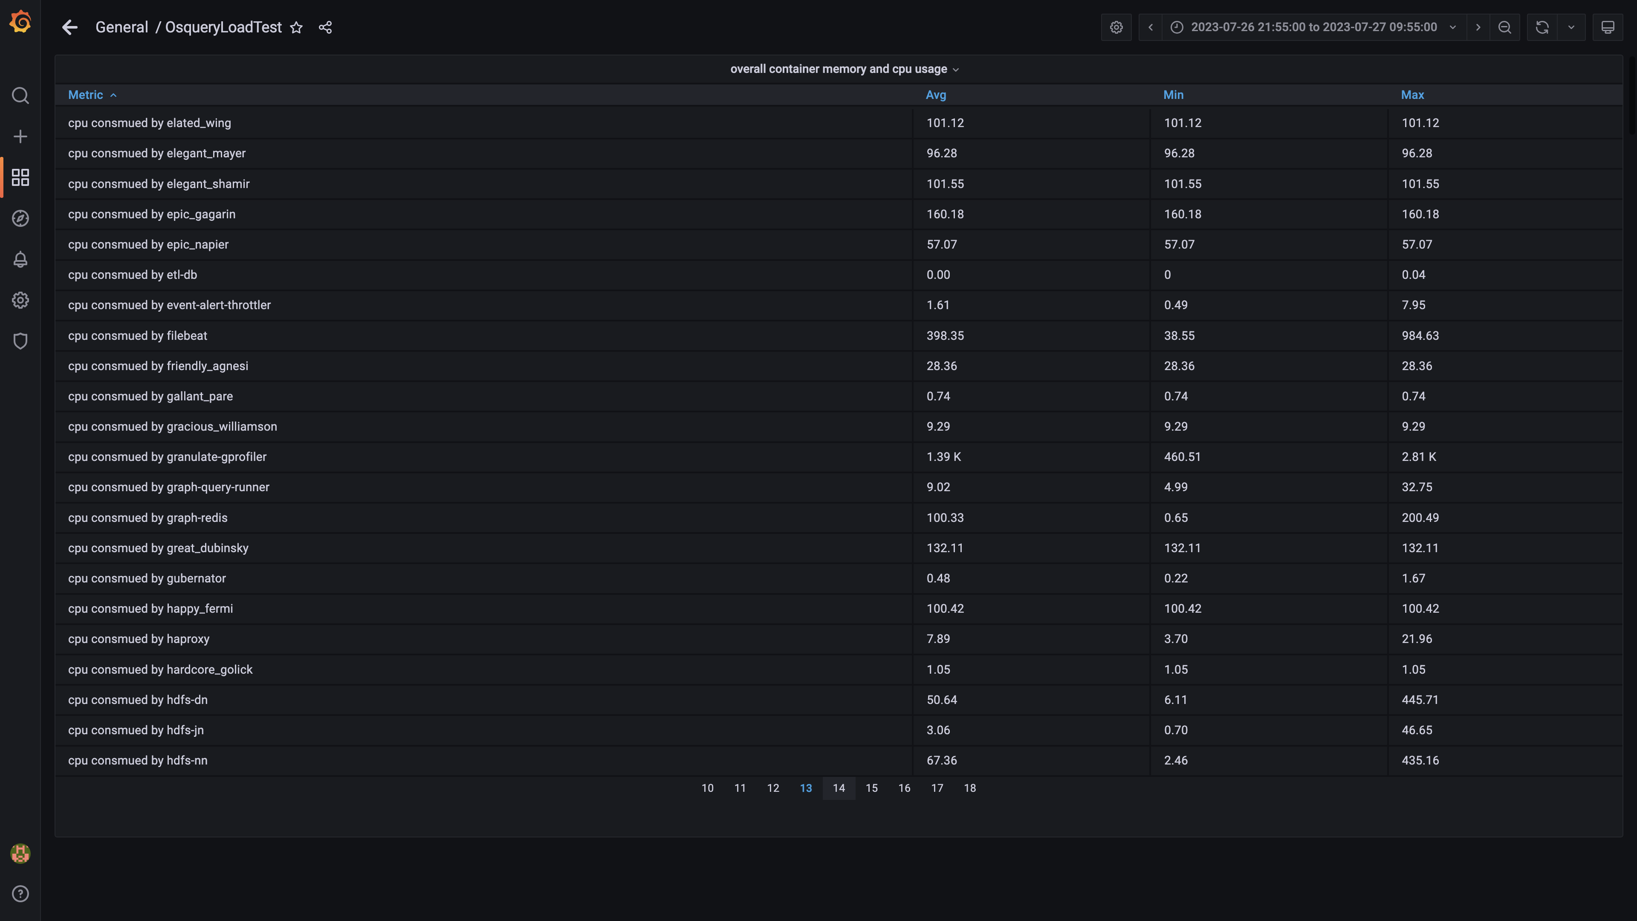

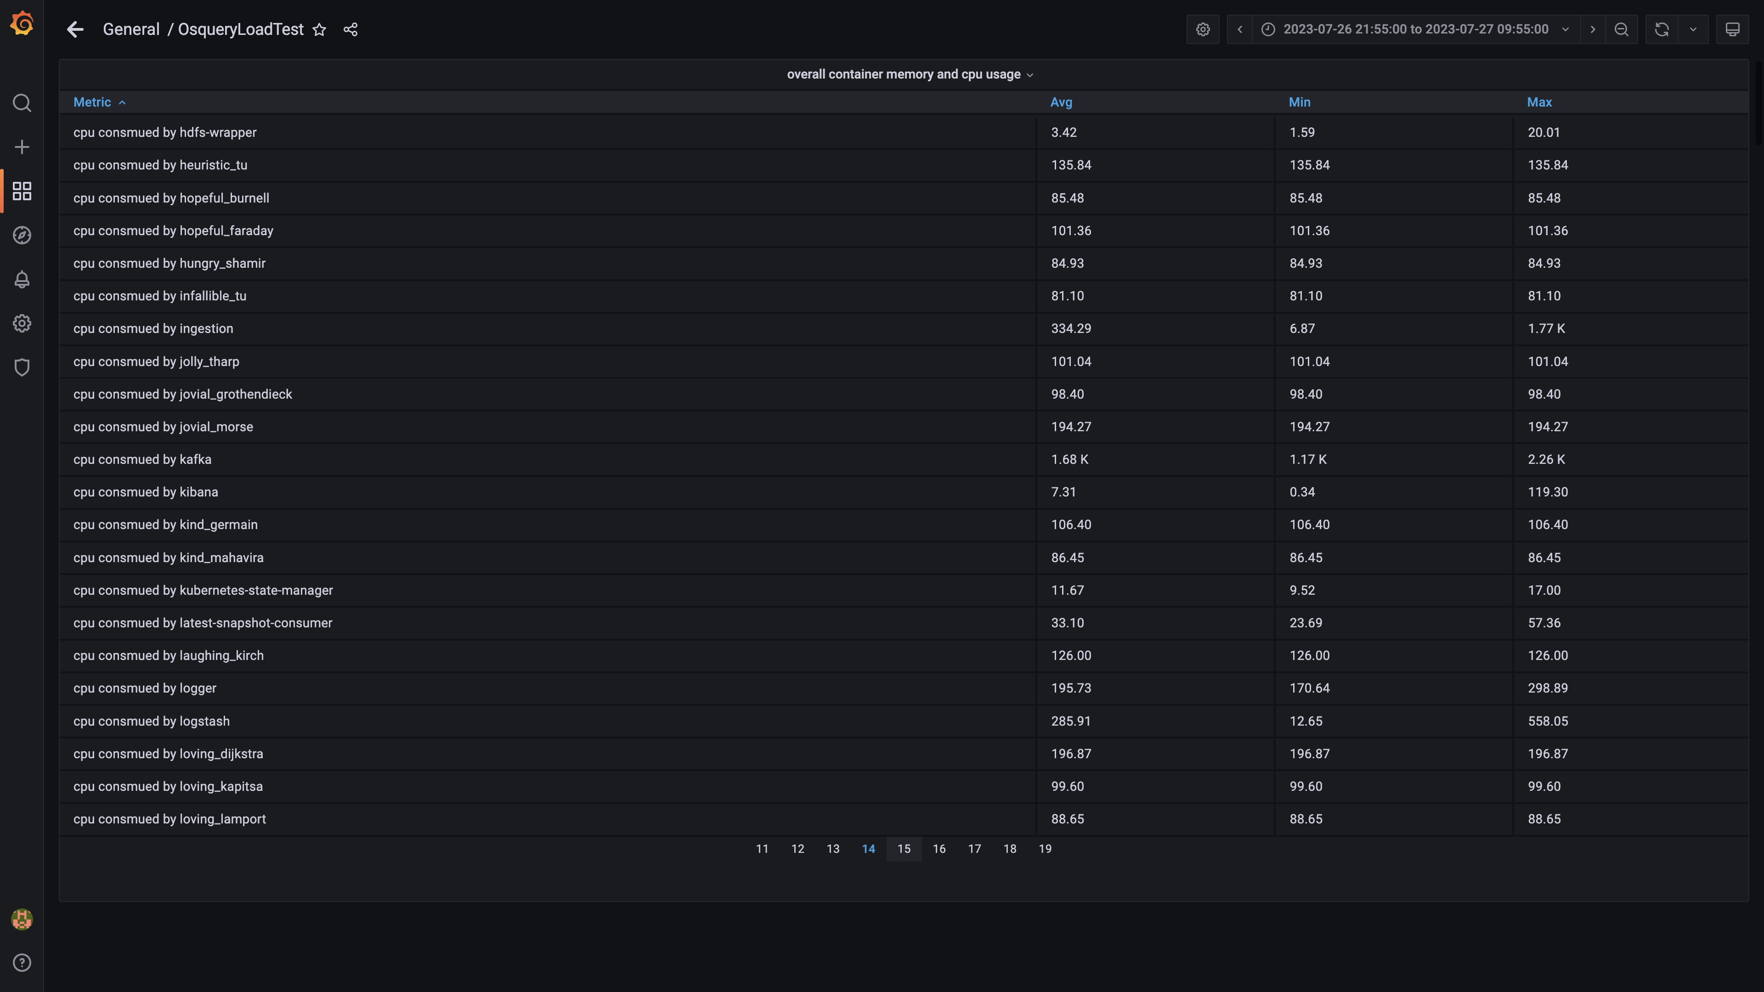

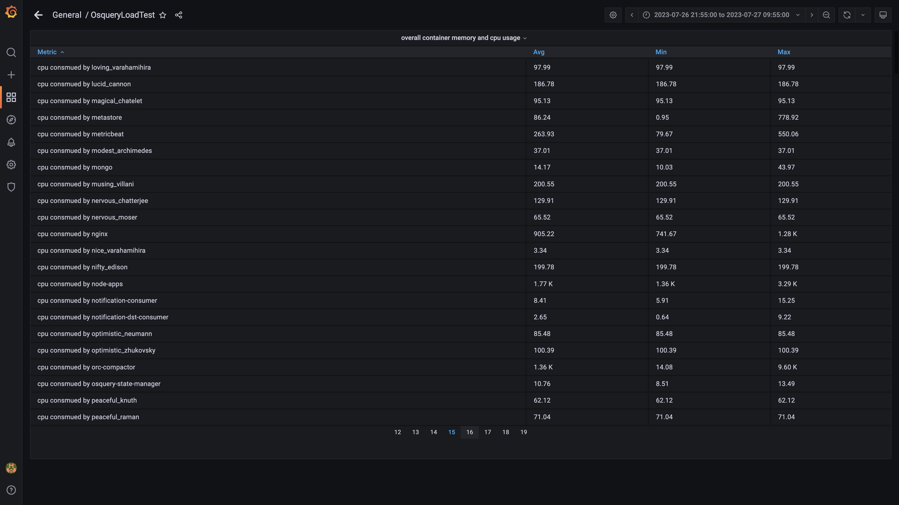

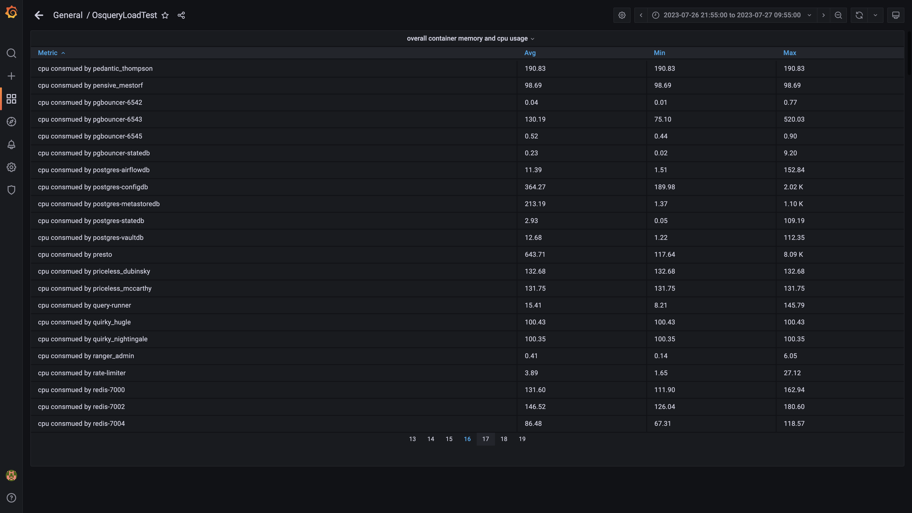

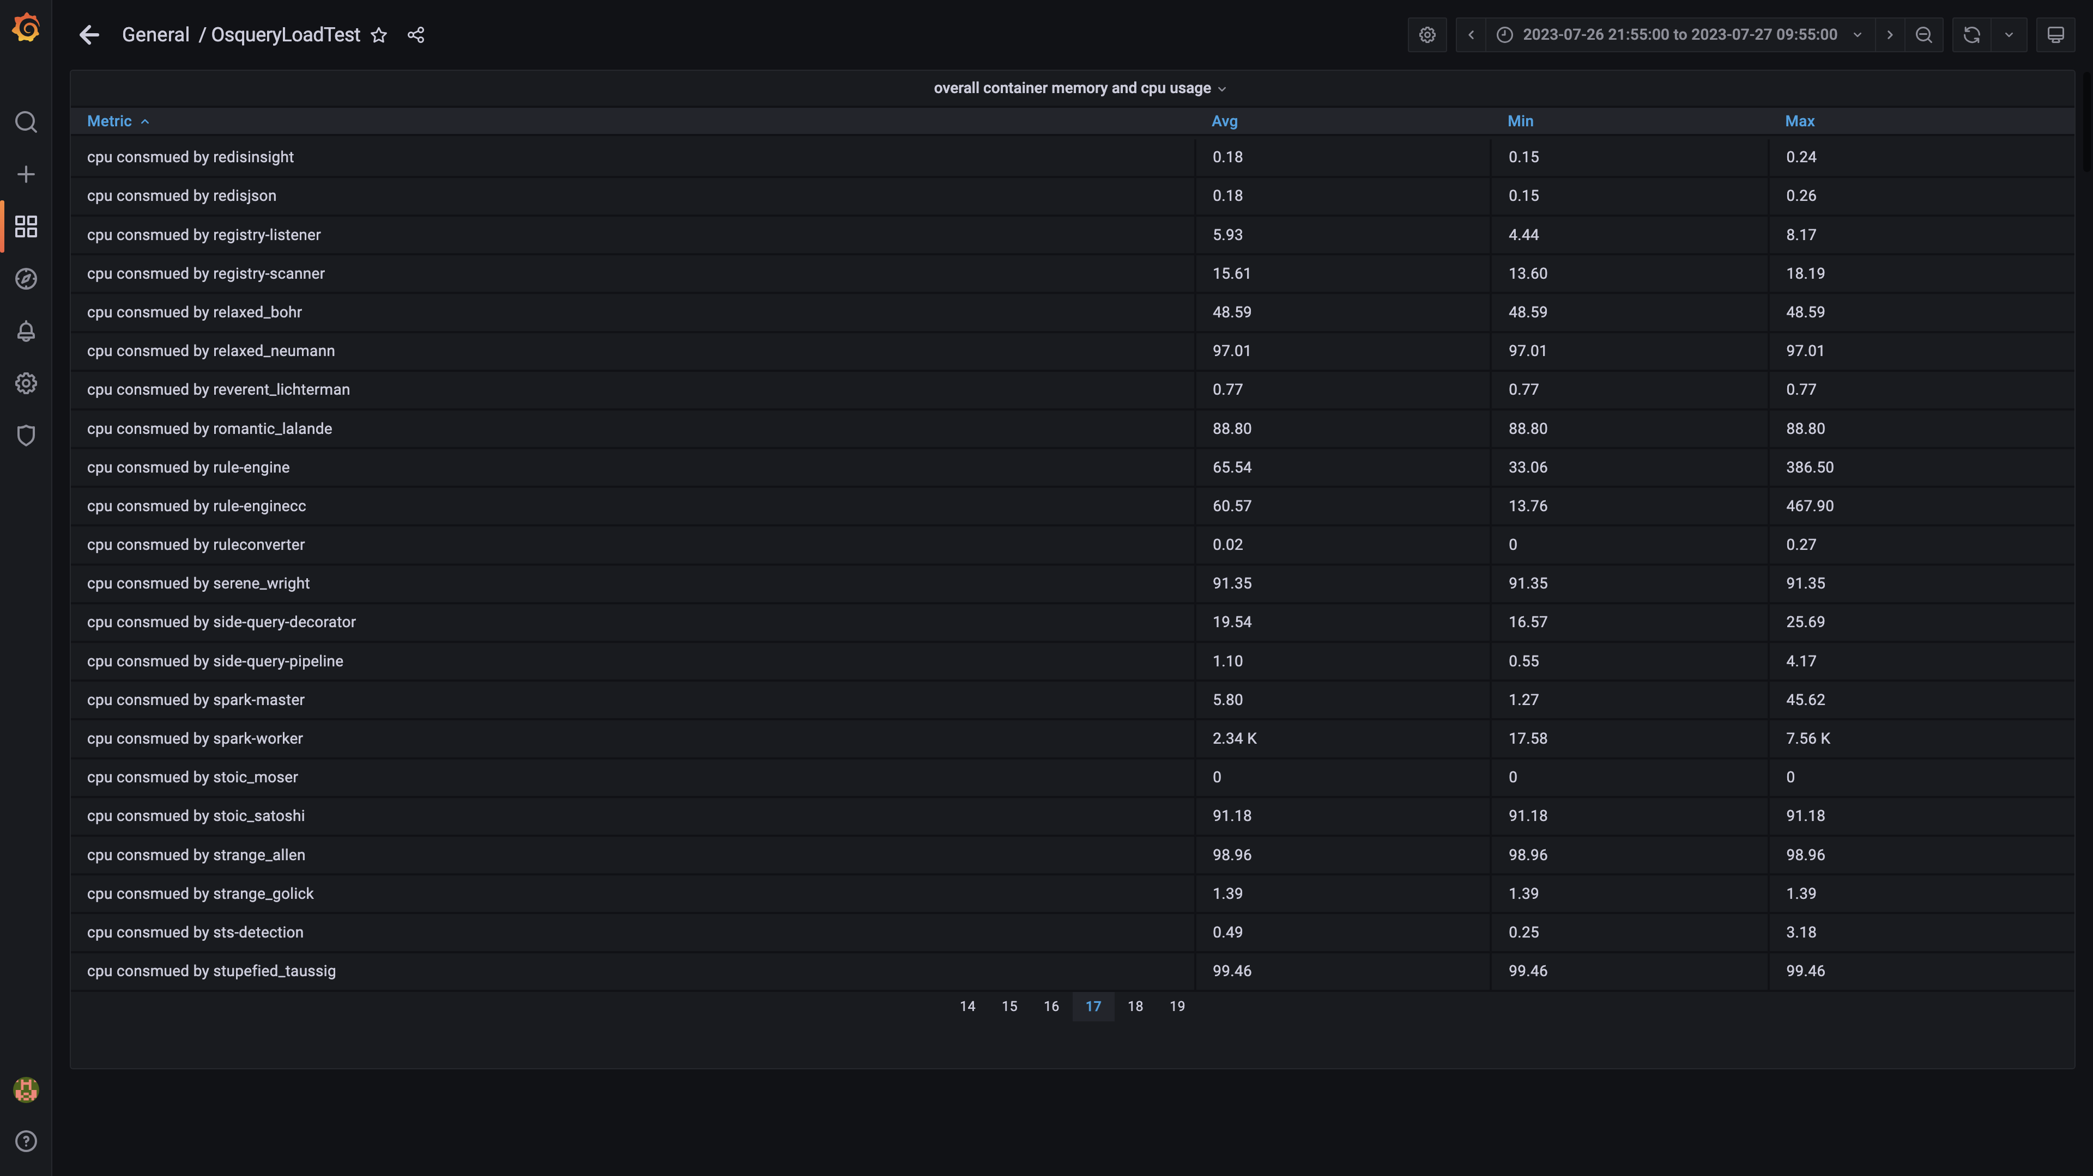

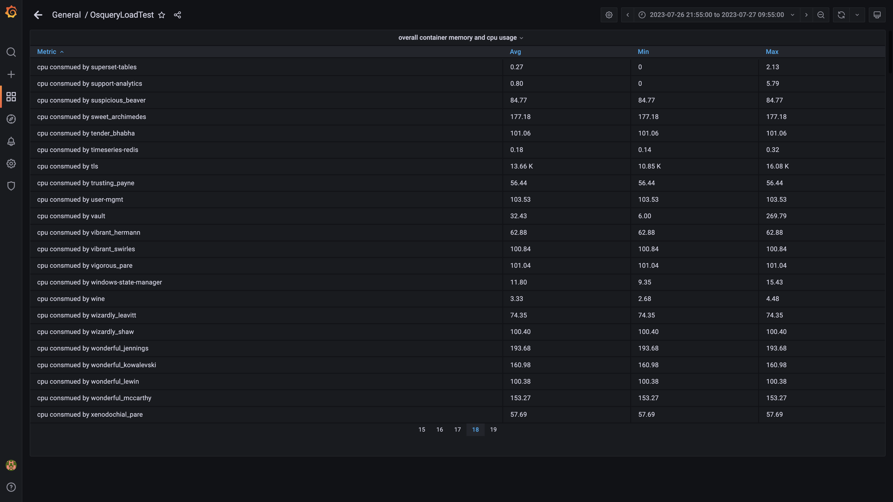

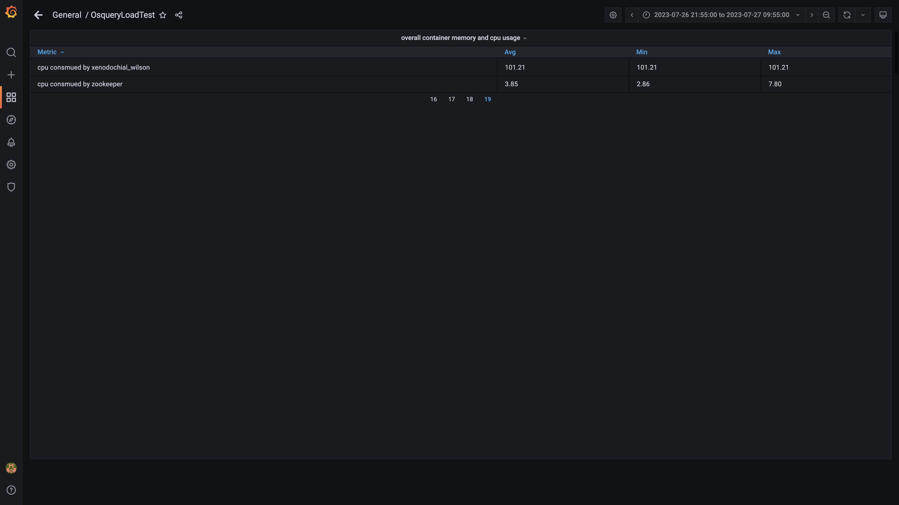

### Overall memory and cpu usages

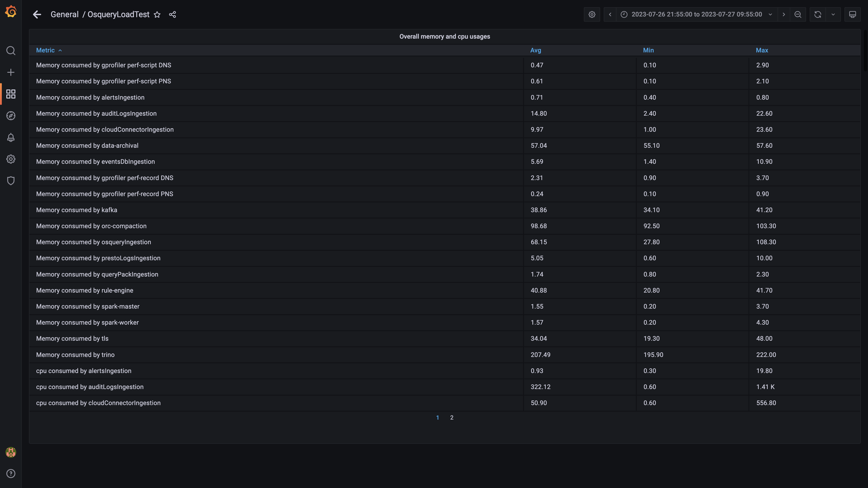

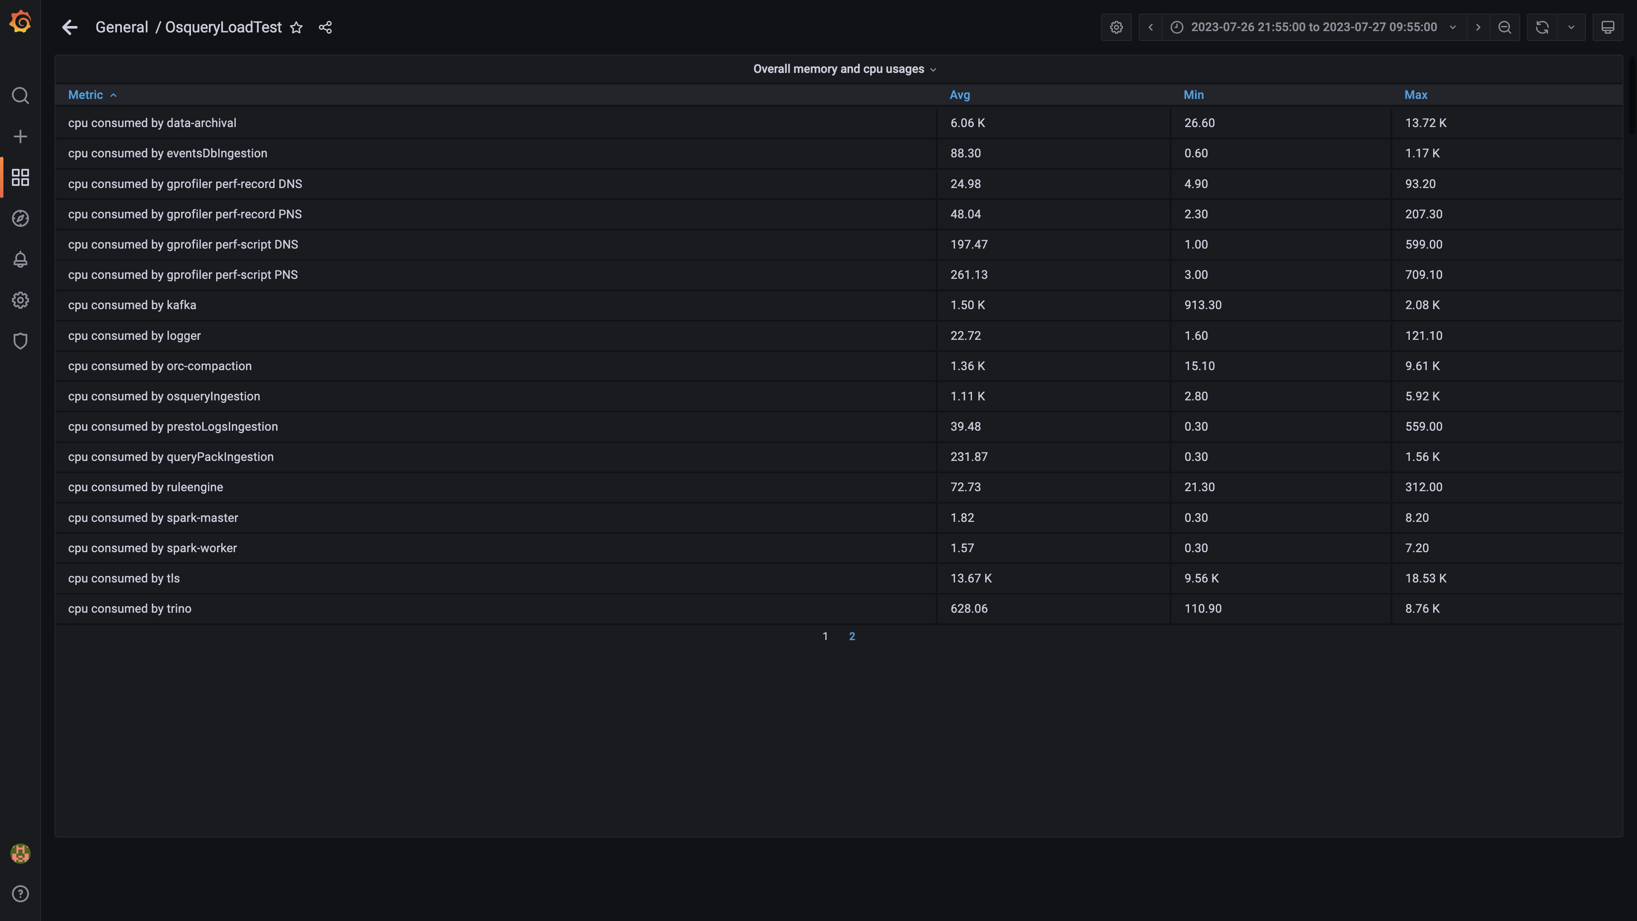

## Resource Utilization

### Comparison of average Memory utilization

|  |  |  |  |  |
| --- | --- | --- | --- | --- |
| Metric | previous | 136011 | Absolute diff(%) | Relative diff(%) |
| Memory consumed by Host s1c1dn1 | - | 76.31% | - | - |
| Memory consumed by Host s1c1dn2 | - | 70.26% | - | - |
| Memory consumed by Host s1c1dn3 | - | 72.84% | - | - |
| Memory consumed by Host s1c1dn4 | - | 63.67% | - | - |
| Memory consumed by Host s1c1dn5 | - | 60.88% | - | - |
| Memory consumed by Host s1c1dn6 | - | 60.09% | - | - |
| Memory consumed by Host s1c1pn1 | - | 42.79% | - | - |
| Memory consumed by Host s1c1pn2 | - | 32.87% | - | - |
| Memory consumed by Host s1c1pn3 | - | 32.93% | - | - |
| Memory consumed by Host s1c1pn4 | - | 32.01% | - | - |
| Memory consumed by Host s1c1pn5 | - | 32.34% | - | - |
| Memory consumed by Host s1c1pn6 | - | 29.68% | - | - |
| Memory consumed by Host s1c2dn1 | - | 60.04% | - | - |
| Memory consumed by Host s1c2dn2 | - | 56.47% | - | - |
| Memory consumed by Host s1c2dn3 | - | 55.52% | - | - |
| Memory consumed by Host s1c2dn4 | - | 56.20% | - | - |
| Memory consumed by Host s1c2dn5 | - | 56.83% | - | - |
| Memory consumed by Host s1c2dn6 | - | 55.59% | - | - |
| Memory consumed by Host s1c2pn1 | - | 28.22% | - | - |
| Memory consumed by Host s1c2pn2 | - | 27.31% | - | - |
| Memory consumed by Host s1c2pn3 | - | 28.41% | - | - |
| Memory consumed by Host s1c2pn4 | - | 27.28% | - | - |
| Memory consumed by Host s1c2pn5 | - | 28.82% | - | - |
| Memory consumed by Host s1c2pn6 | - | 27.61% | - | - |
| Memory consumed by Host s1cloudquery | - | 51.36% | - | - |
| Memory consumed by Host s1configdb1 | - | 8.02% | - | - |
| Memory consumed by Host s1configdb2 | - | 1.23% | - | - |
| Memory consumed by Host s1elasticsearch | - | 23.47% | - | - |
| Memory consumed by Host s1kibana | - | 4.09% | - | - |
| Memory consumed by Host s1logstash1 | - | 15.02% | - | - |
| Memory consumed by Host s1logstash2 | - | 14.47% | - | - |
| Memory consumed by Host s1mlnode1 | - | 7.53% | - | - |
| Memory consumed by Host s1mlnode2 | - | 4.28% | - | - |
| Memory consumed by Host s1monitor | - | 16.42% | - | - |
| Memory consumed by Host s1stsnode1 | - | 28.98% | - | - |
| Memory consumed by Host s1stsnode2 | - | 27.57% | - | - |
| Memory consumed by Host s1stsnode3 | - | 26.89% | - | - |
| Memory consumed by Rule Engine s1c1pn1 | - | 3.30% | - | - |
| Memory consumed by Rule Engine s1c1pn2 | - | 3.40% | - | - |
| Memory consumed by Rule Engine s1c1pn3 | - | 3.59% | - | - |
| Memory consumed by Rule Engine s1c1pn4 | - | 3.59% | - | - |
| Memory consumed by Rule Engine s1c1pn5 | - | 3.49% | - | - |
| Memory consumed by Rule Engine s1c1pn6 | - | 3.40% | - | - |
| Memory consumed by Rule Engine s1c2pn1 | - | 3.40% | - | - |
| Memory consumed by Rule Engine s1c2pn2 | - | 3.49% | - | - |
| Memory consumed by Rule Engine s1c2pn3 | - | 3.59% | - | - |
| Memory consumed by Rule Engine s1c2pn4 | - | 3.40% | - | - |
| Memory consumed by Rule Engine s1c2pn5 | - | 3.59% | - | - |
| Memory consumed by Rule Engine s1c2pn6 | - | 3.39% | - | - |
| Memory consumed by Osquery Ingestion s1c1dn1 | - | 6.77% | - | - |
| Memory consumed by Osquery Ingestion s1c1dn2 | - | 6.73% | - | - |
| Memory consumed by Osquery Ingestion s1c1dn3 | - | 6.48% | - | - |
| Memory consumed by Osquery Ingestion s1c1dn4 | - | 7.02% | - | - |
| Memory consumed by Osquery Ingestion s1c1dn5 | - | 6.92% | - | - |
| Memory consumed by Osquery Ingestion s1c1dn6 | - | 6.81% | - | - |
| Memory consumed by Osquery Ingestion s1c2dn1 | - | 6.21% | - | - |
| Memory consumed by Osquery Ingestion s1c2dn2 | - | 7.11% | - | - |
| Memory consumed by Osquery Ingestion s1c2dn3 | - | 7.01% | - | - |
| Memory consumed by Osquery Ingestion s1c2dn4 | - | 6.85% | - | - |
| Memory consumed by Osquery Ingestion s1c2dn5 | - | 6.92% | - | - |
| Memory consumed by Osquery Ingestion s1c2dn6 | - | 7.04% | - | - |
| Memory consumed by Kafka s1c1pn1 | - | 2.88% | - | - |
| Memory consumed by Kafka s1c1pn2 | - | 3.34% | - | - |
| Memory consumed by Kafka s1c1pn3 | - | 3.35% | - | - |
| Memory consumed by Kafka s1c1pn4 | - | 3.36% | - | - |
| Memory consumed by Kafka s1c1pn5 | - | 3.48% | - | - |
| Memory consumed by Kafka s1c1pn6 | - | 3.44% | - | - |
| Memory consumed by Kafka s1c2pn1 | - | 2.71% | - | - |
| Memory consumed by Kafka s1c2pn2 | - | 3.11% | - | - |
| Memory consumed by Kafka s1c2pn3 | - | 3.04% | - | - |
| Memory consumed by Kafka s1c2pn4 | - | 3.04% | - | - |
| Memory consumed by Kafka s1c2pn5 | - | 3.17% | - | - |
| Memory consumed by Kafka s1c2pn6 | - | 3.11% | - | - |
| Memory consumed by Trino s1c1dn1 | - | 21.60% | - | - |
| Memory consumed by Trino s1c1dn2 | - | 16.92% | - | - |
| Memory consumed by Trino s1c1dn3 | - | 17.06% | - | - |
| Memory consumed by Trino s1c1dn4 | - | 17.33% | - | - |
| Memory consumed by Trino s1c1dn5 | - | 16.84% | - | - |
| Memory consumed by Trino s1c1dn6 | - | 16.70% | - | - |
| Memory consumed by Trino s1c2dn1 | - | 16.99% | - | - |
| Memory consumed by Trino s1c2dn2 | - | 16.65% | - | - |
| Memory consumed by Trino s1c2dn3 | - | 16.97% | - | - |
| Memory consumed by Trino s1c2dn4 | - | 16.99% | - | - |
| Memory consumed by Trino s1c2dn5 | - | 16.97% | - | - |
| Memory consumed by Trino s1c2dn6 | - | 16.38% | - | - |
| Memory consumed by Tls s1c1pn1 | - | 0.36% | - | - |
| Memory consumed by Tls s1c1pn2 | - | 0.36% | - | - |
| Memory consumed by Tls s1c1pn3 | - | 0.35% | - | - |
| Memory consumed by Tls s1c1pn4 | - | 0.35% | - | - |
| Memory consumed by Tls s1c1pn5 | - | 0.35% | - | - |
| Memory consumed by Tls s1c1pn6 | - | 0.35% | - | - |
| Memory consumed by Tls s1c2pn1 | - | 0.36% | - | - |
| Memory consumed by Tls s1c2pn2 | - | 0.35% | - | - |
| Memory consumed by Tls s1c2pn3 | - | 0.35% | - | - |
| Memory consumed by Tls s1c2pn4 | - | 0.36% | - | - |
| Memory consumed by Tls s1c2pn5 | - | 0.36% | - | - |
| Memory consumed by Tls s1c2pn6 | - | 0.36% | - | - |
| Memory consumed by EventsDbIngestion s1c1dn1 | - | 0.72% | - | - |
| Memory consumed by EventsDbIngestion s1c1dn2 | - | 0.70% | - | - |
| Memory consumed by EventsDbIngestion s1c1dn3 | - | 0.67% | - | - |
| Memory consumed by EventsDbIngestion s1c1dn4 | - | 0.77% | - | - |
| Memory consumed by EventsDbIngestion s1c1dn5 | - | 0.77% | - | - |
| Memory consumed by EventsDbIngestion s1c1dn6 | - | 0.72% | - | - |
| Memory consumed by EventsDbIngestion s1c2dn1 | - | 0.66% | - | - |
| Memory consumed by EventsDbIngestion s1c2dn2 | - | 0.74% | - | - |
| Memory consumed by EventsDbIngestion s1c2dn3 | - | 0.79% | - | - |
| Memory consumed by EventsDbIngestion s1c2dn4 | - | 0.73% | - | - |
| Memory consumed by EventsDbIngestion s1c2dn5 | - | 0.74% | - | - |
| Memory consumed by EventsDbIngestion s1c2dn6 | - | 0.74% | - | - |

## Resource Utilization

### Comparison of average CPU utilization

|  |  |  |  |  |
| --- | --- | --- | --- | --- |
| Metric | previous | 136011 | Absolute diff(%) | Relative diff(%) |
| CPU consumed by Host s1c1dn1 | - | 35.05% | - | - |
| CPU consumed by Host s1c1dn2 | - | 35.39% | - | - |
| CPU consumed by Host s1c1dn3 | - | 42.89% | - | - |
| CPU consumed by Host s1c1dn4 | - | 38.10% | - | - |
| CPU consumed by Host s1c1dn5 | - | 36.44% | - | - |
| CPU consumed by Host s1c1dn6 | - | 36.25% | - | - |
| CPU consumed by Host s1c1pn1 | - | 67.46% | - | - |
| CPU consumed by Host s1c1pn2 | - | 65.20% | - | - |
| CPU consumed by Host s1c1pn3 | - | 59.60% | - | - |
| CPU consumed by Host s1c1pn4 | - | 58.87% | - | - |
| CPU consumed by Host s1c1pn5 | - | 58.84% | - | - |
| CPU consumed by Host s1c1pn6 | - | 56.09% | - | - |
| CPU consumed by Host s1c2dn1 | - | 38.94% | - | - |
| CPU consumed by Host s1c2dn2 | - | 35.29% | - | - |
| CPU consumed by Host s1c2dn3 | - | 35.02% | - | - |
| CPU consumed by Host s1c2dn4 | - | 35.07% | - | - |
| CPU consumed by Host s1c2dn5 | - | 34.15% | - | - |
| CPU consumed by Host s1c2dn6 | - | 35.20% | - | - |
| CPU consumed by Host s1c2pn1 | - | 65.85% | - | - |
| CPU consumed by Host s1c2pn2 | - | 55.33% | - | - |
| CPU consumed by Host s1c2pn3 | - | 54.73% | - | - |
| CPU consumed by Host s1c2pn4 | - | 58.60% | - | - |
| CPU consumed by Host s1c2pn5 | - | 57.33% | - | - |
| CPU consumed by Host s1c2pn6 | - | 61.41% | - | - |
| CPU consumed by Host s1cloudquery | - | 84.63% | - | - |
| CPU consumed by Host s1configdb1 | - | 23.72% | - | - |
| CPU consumed by Host s1configdb2 | - | 6.52% | - | - |
| CPU consumed by Host s1elasticsearch | - | 66.05% | - | - |
| CPU consumed by Host s1kibana | - | 30.80% | - | - |
| CPU consumed by Host s1logstash1 | - | 34.45% | - | - |
| CPU consumed by Host s1logstash2 | - | 31.38% | - | - |
| CPU consumed by Host s1mlnode1 | - | 17.32% | - | - |
| CPU consumed by Host s1mlnode2 | - | 12.93% | - | - |
| CPU consumed by Host s1monitor | - | 10.06% | - | - |
| CPU consumed by Host s1stsnode1 | - | 10.36% | - | - |
| CPU consumed by Host s1stsnode2 | - | 10.44% | - | - |
| CPU consumed by Host s1stsnode3 | - | 10.23% | - | - |
| CPU consumed by Rule Engine s1c1pn1 | - | 7.68% | - | - |
| CPU consumed by Rule Engine s1c1pn2 | - | 7.40% | - | - |
| CPU consumed by Rule Engine s1c1pn3 | - | 7.12% | - | - |
| CPU consumed by Rule Engine s1c1pn4 | - | 7.18% | - | - |
| CPU consumed by Rule Engine s1c1pn5 | - | 7.14% | - | - |
| CPU consumed by Rule Engine s1c1pn6 | - | 7.09% | - | - |
| CPU consumed by Rule Engine s1c2pn1 | - | 6.70% | - | - |
| CPU consumed by Rule Engine s1c2pn2 | - | 6.89% | - | - |
| CPU consumed by Rule Engine s1c2pn3 | - | 5.78% | - | - |
| CPU consumed by Rule Engine s1c2pn4 | - | 7.38% | - | - |
| CPU consumed by Rule Engine s1c2pn5 | - | 7.32% | - | - |
| CPU consumed by Rule Engine s1c2pn6 | - | 6.94% | - | - |
| CPU consumed by Osquery Ingestion s1c1dn1 | - | 61.29% | - | - |
| CPU consumed by Osquery Ingestion s1c1dn2 | - | 64.36% | - | - |
| CPU consumed by Osquery Ingestion s1c1dn3 | - | 34.53% | - | - |
| CPU consumed by Osquery Ingestion s1c1dn4 | - | 59.00% | - | - |
| CPU consumed by Osquery Ingestion s1c1dn5 | - | 52.86% | - | - |
| CPU consumed by Osquery Ingestion s1c1dn6 | - | 62.51% | - | - |
| CPU consumed by Osquery Ingestion s1c2dn1 | - | 29.36% | - | - |
| CPU consumed by Osquery Ingestion s1c2dn2 | - | 59.26% | - | - |
| CPU consumed by Osquery Ingestion s1c2dn3 | - | 61.39% | - | - |
| CPU consumed by Osquery Ingestion s1c2dn4 | - | 56.09% | - | - |
| CPU consumed by Osquery Ingestion s1c2dn5 | - | 50.84% | - | - |
| CPU consumed by Osquery Ingestion s1c2dn6 | - | 53.57% | - | - |
| CPU consumed by Kafka s1c1pn1 | - | 150.67% | - | - |
| CPU consumed by Kafka s1c1pn2 | - | 108.82% | - | - |
| CPU consumed by Kafka s1c1pn3 | - | 135.48% | - | - |
| CPU consumed by Kafka s1c1pn4 | - | 118.74% | - | - |
| CPU consumed by Kafka s1c1pn5 | - | 114.31% | - | - |
| CPU consumed by Kafka s1c1pn6 | - | 109.69% | - | - |
| CPU consumed by Kafka s1c2pn1 | - | 152.93% | - | - |
| CPU consumed by Kafka s1c2pn2 | - | 103.91% | - | - |
| CPU consumed by Kafka s1c2pn3 | - | 103.05% | - | - |
| CPU consumed by Kafka s1c2pn4 | - | 80.60% | - | - |
| CPU consumed by Kafka s1c2pn5 | - | 110.26% | - | - |
| CPU consumed by Kafka s1c2pn6 | - | 120.30% | - | - |
| CPU consumed by Trino s1c1dn1 | - | 53.86% | - | - |
| CPU consumed by Trino s1c1dn2 | - | 50.34% | - | - |
| CPU consumed by Trino s1c1dn3 | - | 52.54% | - | - |
| CPU consumed by Trino s1c1dn4 | - | 53.91% | - | - |
| CPU consumed by Trino s1c1dn5 | - | 55.13% | - | - |
| CPU consumed by Trino s1c1dn6 | - | 53.70% | - | - |
| CPU consumed by Trino s1c2dn1 | - | 50.76% | - | - |
| CPU consumed by Trino s1c2dn2 | - | 51.68% | - | - |
| CPU consumed by Trino s1c2dn3 | - | 52.43% | - | - |
| CPU consumed by Trino s1c2dn4 | - | 54.70% | - | - |
| CPU consumed by Trino s1c2dn5 | - | 48.61% | - | - |
| CPU consumed by Trino s1c2dn6 | - | 49.69% | - | - |
| CPU consumed by Tls s1c1pn1 | - | 145.87% | - | - |
| CPU consumed by Tls s1c1pn2 | - | 145.02% | - | - |
| CPU consumed by Tls s1c1pn3 | - | 139.83% | - | - |
| CPU consumed by Tls s1c1pn4 | - | 135.79% | - | - |
| CPU consumed by Tls s1c1pn5 | - | 140.64% | - | - |
| CPU consumed by Tls s1c1pn6 | - | 139.04% | - | - |
| CPU consumed by Tls s1c2pn1 | - | 146.37% | - | - |
| CPU consumed by Tls s1c2pn2 | - | 137.40% | - | - |
| CPU consumed by Tls s1c2pn3 | - | 138.62% | - | - |
| CPU consumed by Tls s1c2pn4 | - | 149.44% | - | - |
| CPU consumed by Tls s1c2pn5 | - | 139.24% | - | - |
| CPU consumed by Tls s1c2pn6 | - | 151.41% | - | - |
| CPU consumed by EventsDbIngestion s1c1dn1 | - | 13.75% | - | - |
| CPU consumed by EventsDbIngestion s1c1dn2 | - | 13.23% | - | - |
| CPU consumed by EventsDbIngestion s1c1dn3 | - | 3.54% | - | - |
| CPU consumed by EventsDbIngestion s1c1dn4 | - | 11.82% | - | - |
| CPU consumed by EventsDbIngestion s1c1dn5 | - | 11.49% | - | - |
| CPU consumed by EventsDbIngestion s1c1dn6 | - | 13.87% | - | - |
| CPU consumed by EventsDbIngestion s1c2dn1 | - | 7.06% | - | - |
| CPU consumed by EventsDbIngestion s1c2dn2 | - | 11.18% | - | - |
| CPU consumed by EventsDbIngestion s1c2dn3 | - | 10.58% | - | - |
| CPU consumed by EventsDbIngestion s1c2dn4 | - | 10.41% | - | - |
| CPU consumed by EventsDbIngestion s1c2dn5 | - | 12.67% | - | - |
| CPU consumed by EventsDbIngestion s1c2dn6 | - | 14.61% | - | - |
| CPU consumed by Logger s1c1pn1 | - | 6.30% | - | - |
| CPU consumed by Logger s1c1pn2 | - | 5.93% | - | - |
| CPU consumed by Logger s1c1pn3 | - | 24.58% | - | - |
| CPU consumed by Logger s1c1pn4 | - | 18.99% | - | - |
| CPU consumed by Logger s1c1pn5 | - | 12.18% | - | - |
| CPU consumed by Logger s1c1pn6 | - | 11.23% | - | - |
| CPU consumed by Logger s1c2pn1 | - | 15.21% | - | - |
| CPU consumed by Logger s1c2pn2 | - | 11.73% | - | - |
| CPU consumed by Logger s1c2pn3 | - | 19.54% | - | - |
| CPU consumed by Logger s1c2pn4 | - | 21.77% | - | - |
| CPU consumed by Logger s1c2pn5 | - | 26.20% | - | - |
| CPU consumed by Logger s1c2pn6 | - | 17.10% | - | - |

## Overall Usages

### Comparision of Overall Memory Usage

|  |  |  |  |
| --- | --- | --- | --- |
| Metric | previous | 136011 | Delta |
| Average Memory used by pnodes (GB) | 0.00 GB | 696.11 GB | - |
| Average Memory used by dnodes (GB) | 0.00 GB | 1400.02 GB | - |
| Average Memory used by pgnodes (GB) | 0.00 GB | 17.40 GB | - |

## Overall Usages

### Comparision of Overall CPU Usage

|  |  |  |  |
| --- | --- | --- | --- |
| Metric | previous | 136011 | Delta |
| Average CPU used by pnodes (cores) | 0.00 cores | 230.18 cores | - |
| Average CPU used by dnodes (cores) | 0.00 cores | 140.09 cores | - |
| Average CPU used by pgnodes (cores) | 0.00 cores | 9.68 cores | - |